


Speech and Language Therapy

Building Blocks for Communication

Workbook

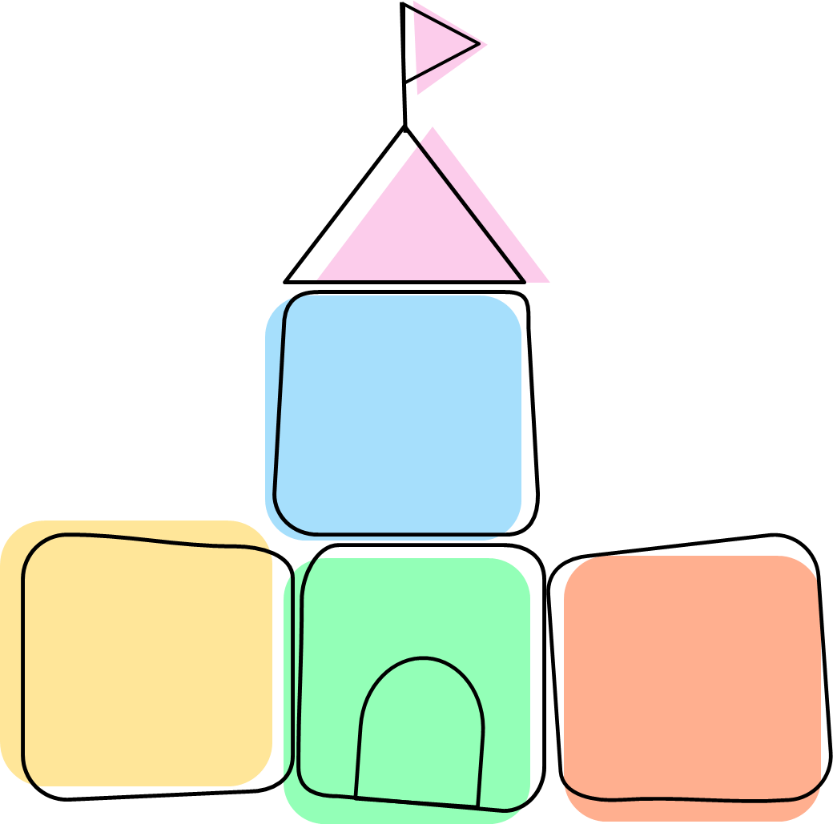
Attention & Listening
Play
Social Interaction

Introduction to the Workbook
The Aims of the sessions are:
- To provide an interactive space to share information, ask questions and time in-between sessions to practise strategies at home with your child at part of your normal routine.
- To provide an overview of communication development and explore where your child’s communication level is and their strengths to build further skills.
- To increase confidence in supporting your child’s communication needs at home.

Session 1

Have a look at the table below. Who do you think can make the biggest difference to your child?

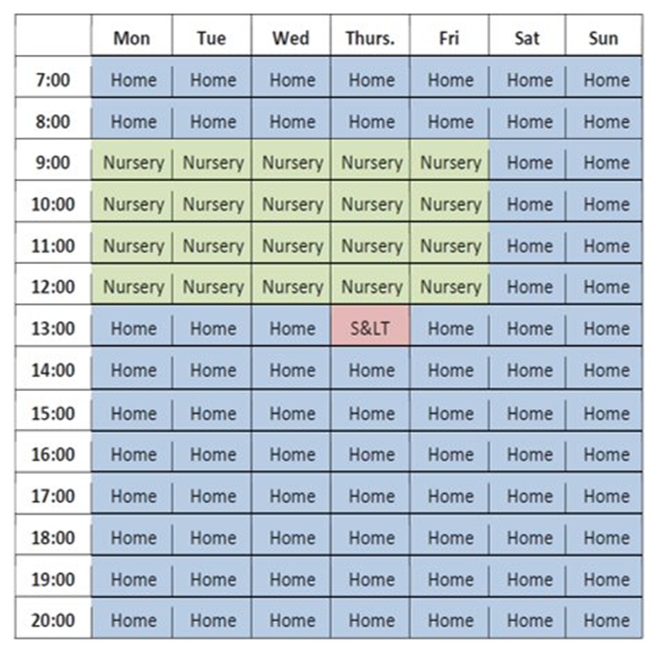

What does research show?
- Parent involvement is essential
- Parents are the best teachers

My Child’s Communication Development
Pyramid of Communication:

The Pyramid identifies the different skills needed for speech and language development. The foundation skills (along the bottom of the pyramid) are attention and listening, play and interaction. These skills are important and should be well developed before a child can move up the pyramid to the next stage.
Children tend to move up through the different stages identified in the pyramid and this will result in clear speech. Some children have more difficulty developing their foundation communication skills. These children often need extra help to ensure that the conditions and environment are right for them to learn to communicate effectively. These types of difficulties can often referred to as social communication difficulties. Children experiencing these types of difficulties/differences may:
- Have no spoken words
- Prefer to spend time on their own
- May copy words but not use functionally
- May find it difficult to understand information
- Little eye contact with people around them
- May find it difficult to interact with others

The Building Blocks for Communication

Attention, listening and play skills are the foundation skills for language development. Due to this, the information in these workshops has a large focus on developing Attention and Listening and play skills. In addition to this we will also be focusing on interaction skills, as communication starts with interaction.

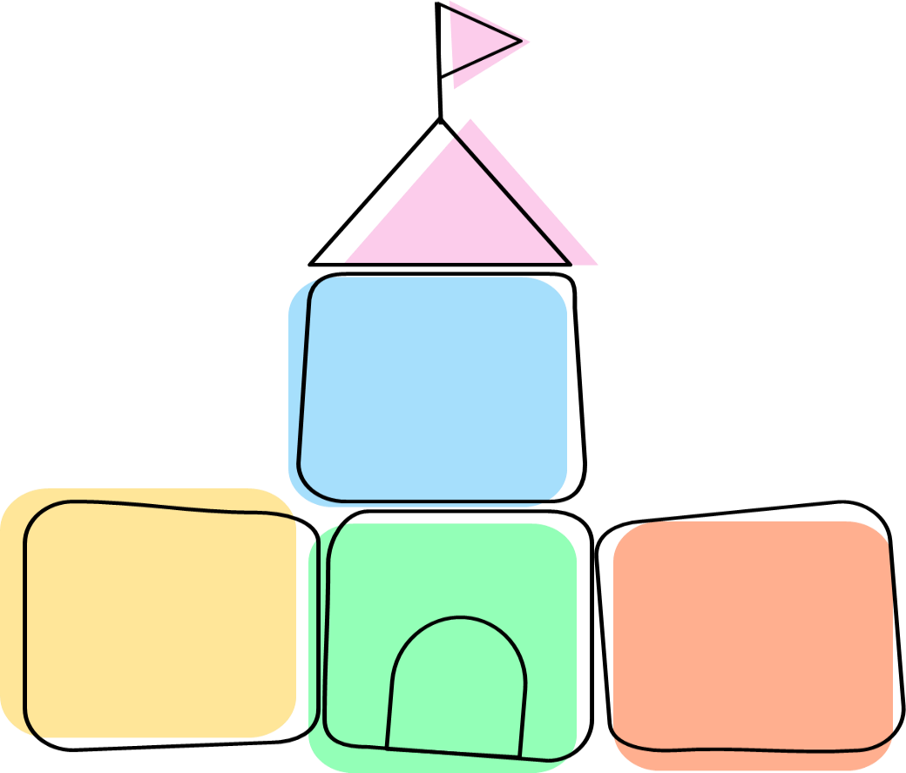
Attention & Listening
Play
Social Interaction

The Building Block skills help increase and improve a child’s communication skills in a huge range of areas.

We can work on all of these skills by adapting the environment and our own interaction style.

Activity:

How does your child communicate?

Crying | Body Movements | Words | Leading by the hand
Making sounds | Looking | Screaming | Gestures
Laughing | Vocalisations | Pointing | Reaching
Showing | Touch | Objects | Using pictures
Hitting | Facial expressions | Eye contact | Turning head away

Stages of Communication Development:

Children’s communication development is often referred to in different stages. Your child’s communication stage depends on who they interact with, how and why they interact and how much they understand. It can be helpful to describe this in 4 stages:
 | What is communicated? | What can you do to help?
  Level of Communication
Pre-intentional/Own Agenda    (Sound making without meaning) | Wants to play alone, appears uninterested in people around them.  Communication is largely pre-intentional and includes body movements, gestures, screams and smiles.  Doesn’t really understand any language. | Let them know their actions and sounds can have meaning.  Make yourself available in a playful and interesting way.  Watch for the child’s actions/vocalisations and mimic.  Extend the interactions, increasing content and length.  Animate objects of interest and wait for the child to respond.
Anticipatory/Requester    (Using sounds/ gestures/ movements showing anticipation of familiar events and routines) | Beginning to realise that their actions can have an effect on you and starting to make early request e.g. will pull and lead towards what they want, moves body, makes sounds/words.  Frequently enjoys physical games such as tickles and peek-a-boo.  Understands routines with cues. | Help the child by pausing during familiar routines so they can show you they know what’s next.  -Ready steady go games  -Nursery Rhymes  -People games  -Every day routines  Make yourself part of the process. Allow time for the expectation.  Lead and then pause/wait for the child to respond.  Interpret all communications.  Model key words.
Intentional/Early Communicator    (Using sounds/gestures/ movements to communicate a message) | Clearly communicating requests (mainly with adults) by reaching, pointing (and looking).  Starting to send adults messages to share interests and connect socially.  May use some words functionally.  May also echo and need pictures and/or signs to support their communication.  Understands simple familiar sentences. | Get the child’s attention first.  Label things.  Comment on what your child is doing/wants with one or two words.  Extend the child’s use of non-verbal communication by consistently modelling non-verbal communication.  Build on the child’s play, with you and others.  Turn take.  Use positive phrases.
Joining Words/Partner  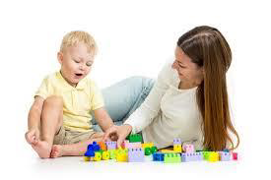  (Using words with meaning) | Can carry on a simple conversation but may struggle to come up with their own words so will use memorised phrases.  Will find the rules of conversation difficult and sticks with favourite topics.  Beginning to try to communicate with other children. | Comment on what the child is looking at/doing.  Keep your comments simple using 1-2 words.  Repeat repeat repeat.  Model single words that are useful for the child (e.g. drink, coat, shoes).  Model how to use/play with toys appropriately.  Avoid questions.

Activity:

My child is at stage:
______________________________________________________

Homework Activity:
• This week spend time observing your child and the ways they communicate. Also consider the reasons as to WHY they are communicating e.g. because they are hurt, to request something, to share an interaction etc.
• Look out for what they like doing and therefore what they might be motivated by to communicate
________________________________________________________________________________________________________________________________________________________________________________________________________________
____________________________________________________________________________________________________________________________________________________________________________________________________________________________________________________________________
________________________________________________________________________________________________________________________________________________________________________________________________________________
____________________________________________________________________________________________________________________________________________________________________________________________________________________________________________________________________

Session 2

Attention and Listening
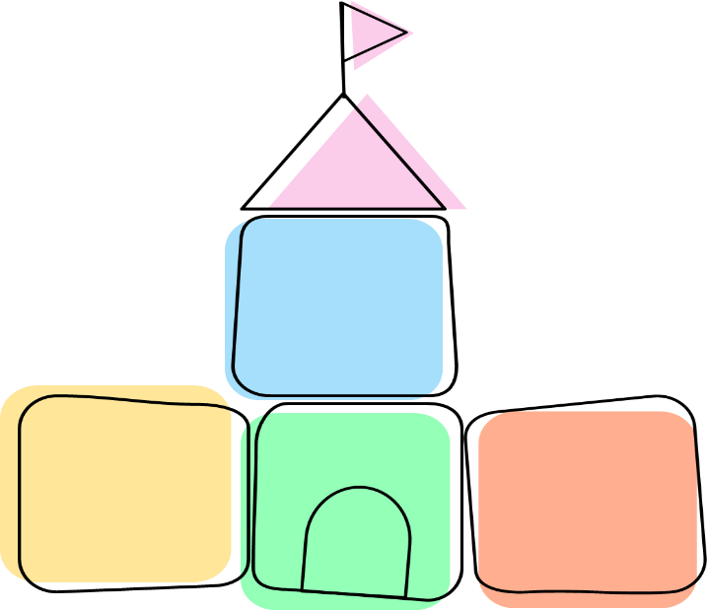
Attention & Listening

The ability to focus attention on something or someone is important for all types of learning. Children develop their attention and listening skills by listening to everyday sounds around them.

Babies and young children develop attention and listening skills through frequent opportunities to interact and play with others around them in quiet environments. Children also need to focus their listening on spoken language including single words and sentences before they can learn to speak for themselves and communicate effectively with others.

Activity:
My child is at stage:

To help my child’s attention, I am already:

I will keep doing this, when we are:
___________________________________________________________________

Stages of Attention Development

Level of Attention | What this looks like |  | Strategies to help
Level 1:  Fleeting | The child is easily distracted; they are highly distracted by other sounds and movements within the environment.  They will find it very difficult to focus on spoken messages. They will flit from one toy or activity to another. | •  •  • |   Use highly motivating toys the child likes. Turn off and remove distractions in the environment e.g. TV, washing machine, unused toys.  Increase enjoyment of joint attention to others through anticipation games.
Level 2:  Rigid | Child concentrates on a task or activity they like.  Difficult to listen to a spoken message while engaged. | • | Gentle physical and verbal prompts such as calling the child’s name and touching their hand, to gain attention and ‘look’ toward the adult.
 |  | • |   Use highly motivating activities such as ‘Bucket time’
Level 3:  Single  Channelled | The child can focus on one thing at a time.  They will find it difficult to listen to spoken messages if not part of the activity or item they are interested in.  If an adult wants to give an instruction, the child must be asked to stop their activity, listen to the adult and then return to the activity. | •  •  •  • | Verbal prompts, such as: calling the child’s name to gain attention and ‘look’ toward the adult.  Use gesture and show excitement in your  tone of voice to gain and maintain attention of the child.  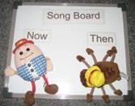  Extending time focused on a task by adding ‘one more turn’.  Use visual support to support understanding through ‘Now/Next Boards’ and ‘Visual Timetables’.
Level 4:  Two Channelled | The child can consistently focus on what they are interested in while also able to focus on and respond to the spoken message. | •  • | Praise the child for good ‘listening’.  Use reward systems/charts.

Whole Body Listening - Revised

Previously it was assumed that a person was only paying attention and listening to the other person if they were using ‘whole body listening’ e.g. making eye contact, keeping hands still etc. However, we know now, that people, particularly those with attention or social communication differences, may not appear this way when they are focusing on attending to a speaker.

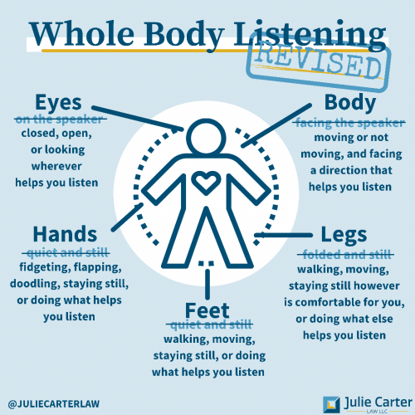

Useful strategies for helping a child develop Attention

- Make sure you carry out activities in distraction free environment – you need to be the most exciting thing in the room. Minimize all noise and visual distractors (e.g. turn TV off)

- Sit opposite the child, at the same level, facing each other

- Make sure to gain the child’s full attention before talking to them (e.g. by calling the child’s name, tapping their shoulder or making a loud noise).

- Keep instructions clear and simple – minimise to single key words.

- Use toys which you know will motivate the child. Highly motivating toys; these are toys that make noises or have flashing lights e.g. rainmakers; LED light spinners, mesh balls; or the child’s special interest, such as: Paw Patrol toys.

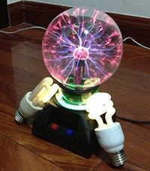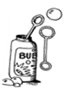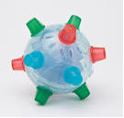


- Give the child praise and encouragement

- Show the child how to take a turn

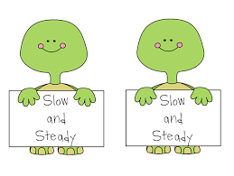
- Use a slow rate of speech and pause often to give your child time to process the language, and the opportunities to communicate themselves
- One toy available, put others out of sight
- Encourage the child to finish what they are doing
- Use a sing-song voice

Play
Play

Children’s play tends to progress through different stages, the same as attention & listening development. Play is a natural way for children to learn how to communicate and interact with others. Some children with social communication differences may prefer to play with objects than actual toys, they may continue to use unconventional play or sensory based play for longer, they may like rough and tumble play beyond the early years, they may prefer to play with the same toy or play routine over and over again, they may prefer visual activities as well as computers and puzzles due to them being logical and systematic.

Activity:

My child enjoys the following types of play:

______________________________________________________
To help my child’s play, I am already:

______________________________________________________
I will keep doing this, when we are:


Cause and effect light spinners, jack in the box, click clack cars, mirrors, dropping objects, wind up toys, push button toys

Some ways that children play




Creative play
playdough, painting, sand, water
Cause and effect light spinners, jack in the box, click clack cars, mirrors, dropping objects, wind up toys, push button toys
Exploratory
Lining up, grouping, throwing, mouthing, banging, splashing
Constructive play
Building, knocking down, blocks, other items
People play
Tickles, chase, rough and tumble
People play
Tickles, chase, rough and tumble
Pretend play
Drink from an empty tea cup, pretend to be an animal
Cause and effect light spinners, jack in the box, click clack cars, mirrors, dropping objects, wind up toys, push button toys
Completion play
Puzzles, stacking, shape sorters
Physical Play
Running, jumping, climbing

All play is okay!

- Some children’s play is led by their sensory preferences, such as movement, touch, sound, sight and smell.
- They may be over or under sensitive to certain sensations, which means they may seek or avoid these
- When we recognise and work with a child’s sensory preferences we can create situations that make it easier and more fun for them to interact with us!
 | Over Sensitive | Under Sensitive
Movement | - shows fear of steps or escalators  - fear of swings or see-saws | - enjoys jumping  - enjoys running  - enjoys spinning  - tip-toe walking
Touch | - dislike of messy play or sticky things  - only tolerating certain clothing textures  - dislikes getting hair washed  - dislikes crunchy or chewy foods | - wanting long hugs  - clapping  - grinding their teeth
Sound | - covers their ears  - can hear the faintest sounds  - cries when using hoovers or hair-dryers | - likes music and certain sounds
Sight | - prefers the dark  - avoids the sun  - blinks often | - lining things up  - looking at things from unusual angles or from the corner of their eyes
Smell | - prefers bland food  - sensitive to certain smells such as perfumes | - enjoys licking things

Useful strategies for helping a child develop Play

Strategies to try when playing with the child:
- The area you are playing in needs to be as quiet as possible. Try to limit the amount of distractions by reducing the amount of toys you have out at one time.
- Try and get down on the floor with the child or to their level, so that you can be face-to-face for the activity.
- Watch what interests the child and join in. Don’t worry if the child doesn’t want to do what you had planned.
- Praise and recognise all attempts on the child’s part ‘Good building’.
- Don’t ask too many questions. Instead, comment on what the child is doing rather than interrupting their play by asking questions e.g. ‘dolly’s having a drink’ NOT ‘what is dolly doing?’
- Play alongside the child. Copy what they do, this will show the child that you are interested in what they are doing. Your child may start to include you in their play. Don’t force the child to do something different.
- After some time copying the child, you can start to suggest new ideas to extend their play further e.g. the child is pushing a train up and down; the adult gets another train and makes this go through the tunnel. The child is more likely to copy if they don’t feel forced to change what they are happy doing

What’s in The Bag?
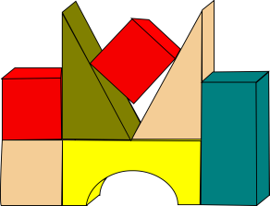
Collect items such as: spoons, shiny paper, ribbons, bricks, empty pots. Put the materials in boxes or drawstring bags and take out one at a time to explore. Crumple up the bits of paper to make interesting noises.
Ball Games
Rolling back and forth, throwing/kicking the ball to another person.

Construction Toys
Stacking bricks, toys or beakers. Putting in and taking out of boxes – small objects and containers.
Messy Play
Painting with hands, fingers, and feet; or large wax crayons for mark making.
Pop up Books
Let the child enjoy pressing the buttons.

Everyday objects
Use everyday objects to pretend with e.g. an empty cup, brush or flannel. Carry out actions e.g. pretending to have a drink, brushing your hair, brushing teeth, drying hands. Encourage the child to copy you.

Miniatures
Using miniature toys e.g. animals, farms and dolls; children can learn to relate objects together. Put the animals on the trailer or the driver on the tractor, and then begin to act out a range of actions.

Everyday routines
Involve a doll, teddy or toy figure in everyday situations and provide appropriate matching objects; for example, the child can wash teddy’s hands, brush hair, make teddy tidy up, or brush spider man’s teeth.

Ready Steady Go Games


The aim of Ready Steady Go games is to do a single simple action.
Before doing the action, the adult says ‘Ready, Steady, Go’ and once ‘Go’ has been said the action is performed. Examples of RSG games are:
- Blowing bubbles
- Rolling a ball to one another
- Skittles
- Pushing a car or train along a track
- Jumping up from behind something
- Throwing bean bags in to a bucket
- Turn music on to dance to

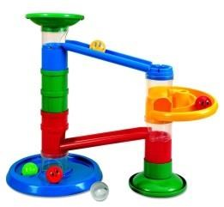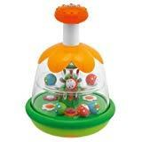

How do you use a Ready Steady Go Game?
- Decide on the activity that you are going to use with your Ready Steady Go sequence.
- Say ‘Ready…(pause)…Steady… (pause)… Go’. When you say ‘go’ the action is completed e.g. blow the bubbles. The game continues like this.
- In this activity you can encourage your child to communicate also. You say ‘Ready … (pause) … Steady … (Pause) … encouraging your child to indicate ‘Go’.
- You can add variation to the game by increasing the length of the pause between Steady and Go to make your child wait longer and longer… remember to always follow through with the action if the child indicates ‘go’ in some way e.g. eye contact, body movement, vocalisation, word.

Strategies to Ensure Success:
  - Ensure the child is motivated by the activity/ game.
  - Provide a variety of different opportunities to practice (different activities)
  - Get down to the child’s level and follow what they are interested in.

Shared Attention and Anticipation Games

What is shared attention?
- Some children may have difficulties seeking out others when playing, and do not appear to understand the pleasure that comes from sharing attention with another person.
- When children play people games, they aren’t distracted by toys, they focus on the adult.

People Games
These activities aim to help the child develop a skill known as ‘shared’ or ‘joint’ attention. The aim is to make you (and your activity) the most exciting thing in the room, so the child cannot resist engaging and focusing on you.

Physical Play
- Bounce the child up and down on your lap or play swinging and rocking games on the floor.
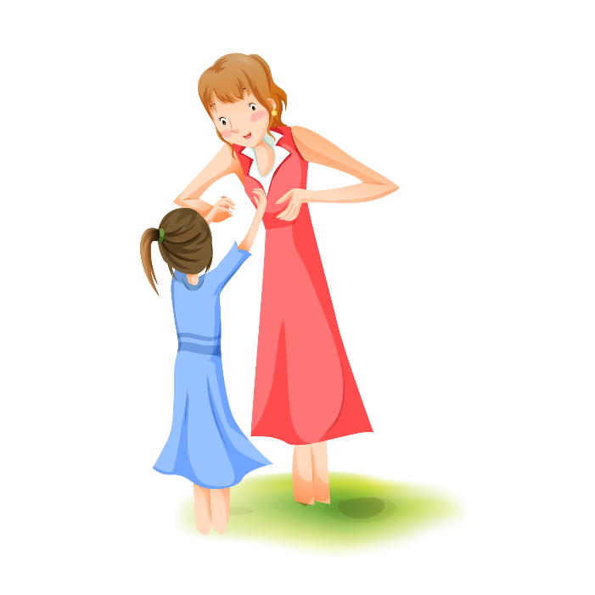
- Play tickle games with the child.
- Play ‘peek a boo’ or hide and seek games.

Actions and Rhymes
Any games that have a song and actions e.g.
- Row row row your boat
- Round and round the garden
- Zoom zoom zoom we’re going to the moon

Feely Bag Activities
- Fill bags with a range of toys/objects
- Encourage the child to take the toy out one by one
- Make a sound or name the item (moo, woof)

Toy ideas for People Toy Games
  Bumble Ball |   Pull-string animals |   Flashing windmill |   Balloon
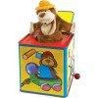  Jack-in-the-Box toys | 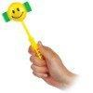  Giggle stick | Musical spinning top | 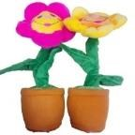  Singing/Dancing toys
  Light toy |   bubbles |   Jumping man | 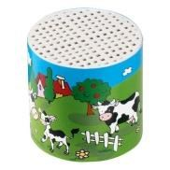  Noise maker
  Mesh ball | 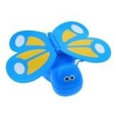  Wind up toys |   Maraca | 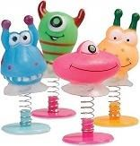  Spring toy

Strategies to Ensure Success:
- Making the song and actions lively and animated is important because it will help to keep the child’s attention and make the game interesting.
- Pause and wait for the child to indicate that they want you to keep going – they might do this with a movement, a look, a smile or a sound.

Homework Activity:

- You will already be doing lots of things to support your child’s communication without realising it.

- Prior to the next workshop choose 3 strategies to try. You can use the notes box to write how the strategy is going and any questions you have about it to support your advice session with the Speech and Language Therapist.
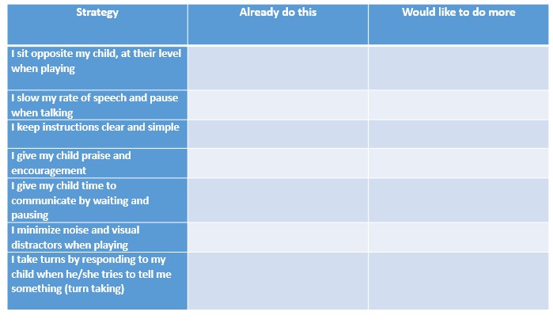

Session 3

Social Interaction

Interaction skills develop in stages and related to play. Firstly, interaction skills start with unoccupied; this is when the child is discovering themselves and how the body works, so there is lots of movement. Then interaction is solitary; they are content to play alone and may not be aware of others around them. Then they are an onlooker; they are aware of others around them and watch them, but don’t join in. Parallel play; this is when they play alongside others but don’t join in. Then it is associative; they start to interact with others in play. Finally it is cooperative; they show a clear interest in activity and others in play.
Activity:

My child is at stage:

______________________________________________________
To help my child’s interaction, I am already:

______________________________________________________
I will keep doing this, when we are:

______________________________________________________

Stages of Social Interaction Development

Level of Social Interaction | What this looks like |  | Strategies to help
Unoccupied | The child discovers how the body works and starts exploring a range of movements.
Solitary | The child will be happy to play on their own, directing their own play without being concerned about others around them. | • | Use the ‘intensive interaction’ strategies.
Onlooker | The child continues to be happy to play on their own. The child watches other playing but does not join in.
Parallel | The child will play beside other children rather than with them. | • | Use ‘people games’ to encourage interest in others.
 |  | • | 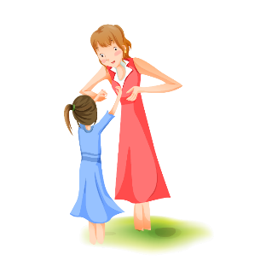  See ‘Ready Steady Go’ games.
Associative | The child my talk to another and share materials, but does not yet take on a role in a shared goal or work towards the same goal as another child. | • | See early turn taking strategies.  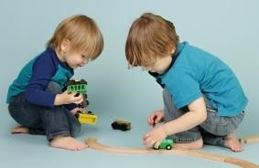
Cooperative | The child will now engage in formal game, social pretend story and work towards the same goal as another child e.g. building a model aeroplane together. | • | Implement ‘eye contact’, and ‘body language’ activities to develop understanding and awareness of others.  

Intensive interaction

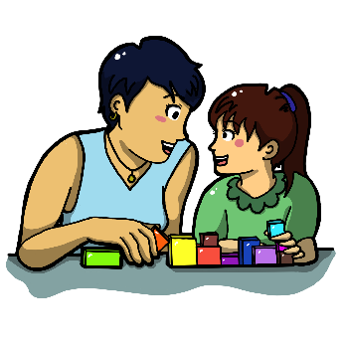
What is Intensive interaction?
- Intensive Interaction is an approach that works on early interaction abilities; understanding eye contact, using facial expression, giving attention to another person, understanding physical contact and personal space.
- It focuses on interactions that happen naturally throughout the day.
- It is individual and focuses on the interaction that the child can already do.
- It aims to support understanding and enjoyment in interacting with others.
How do I carry out ‘intensive interaction’?

- BE AVAILABLE: - Make yourself available. Get down to the child’s eye level. Position yourself at the level the child is at, if they are sitting sit opposite them, if they are lying down, lay down next to them. Capture the interest and attention of the child by ensuring you have face-to-face contact.
- LET THE CHILD LEAD: - Be completely attentive to your child, waiting for them to start the interaction. Don’t rush; make the experience relaxed and enjoyable. What to look out for:
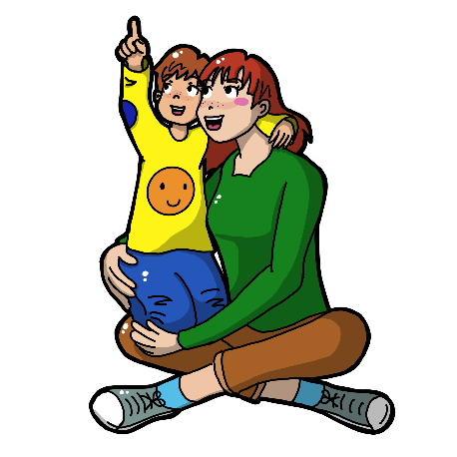
  - Vocalisations
  - Other noise made with the mouth (e.g. blowing, tongue waggling).
  - Other noises (e.g. tapping parts of the body, slapping or tapping furniture or walls, foot tapping or stamping, clapping or hand rubbing).
  - Movements (e.g. hand movements, rocking, swaying, movements of the legs and feet, head bobbing, reaching out).
  - Facial expression changes.
  - Physical contacts (e.g. pats, taps, reaching to hold you).

- RESPOND:- Respond instantly to the things the child does. Start by doing a similar thing as them, perhaps copying their play, actions, sounds or movements.

If the child tries out new noises or movements or facial expressions, you respond by doing it again, imitating or joining in. Celebrate the child’s responses and behaviours.

- PAUSING :- Pause and wait for the child to interact with you before you join in again.

Look for any reaction. The child’s face may change. They may stop what they are doing to watch you or listen. This will tell you if they are interested and enjoying what you are doing. Give them time to respond to you and see what they do next. The child might indicate that they want you to react differently, or want you to repeat what you’re doing.

- EXTENDING :- Build up a shared knowledge of things that you and the child do together – you may end up repeating these activities many times.

When repeating familiar interaction routines, new things happen. The child may experiment, then you may extend the interaction, add faces and voices.
As you start to notice the child becoming more aware of you joining in with them, change the way you respond to extend the interaction and see if they respond to this e.g. you could vary your vocalisation, you could do something different with the toys your might have been playing with.
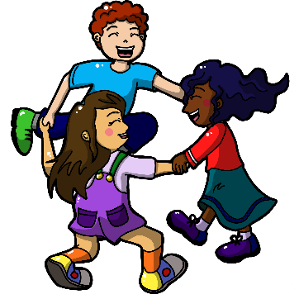
Strategies to ensuring success:

- Respond instantly to signals of negativity – If you feel the child is not enjoying what you are doing or moves away or reacts negatively, interpret this communication and respond to it appropriately. Perhaps you were too close to them, or they need a break from the Intensive Interaction.

- If the child doesn’t appear to respond- Try doing less of everything. Respond with less behaviour (reduce the noise, excitement or intensity). Go back to a ‘quiet’ period, spending time sharing space to help the child to become more comfortable.

- If the child is highly active- Join in with them and move around with them in order to create shared activities.

- If the child is interested for a short amount of time- Try doing less, you may be putting too much into the interaction.

- If the child keeps moving away. The child may not be ready to take part in interactions yet, may need to share space and time instead to build a sense of security. Increase the distance between you and the child.

Special Time
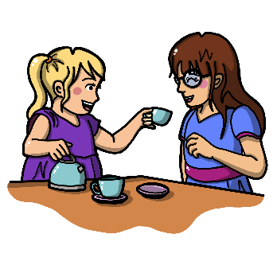
‘Special time’ is a time for you and a child to play together in addition to the times you already have, and not instead of. It is a time for you to help your child develop their speech and language skills through play.

How to have a ‘special time’:

Before you start:
- Allow the child to select the activity, toy or game e.g. cars, dolls, puzzles. Note, this should not be reading a book, watching TV or playing a lively outdoor game as it can be difficult to practise language strategies during these types of activities.

During special time:
- ‘Special time’ lasts for 5 minutes only and should not be extended.
- When the child has chosen what to do, go to a room or space where you will not be disturbed.
- Remove any obvious distractions such as radio or TV.
- The adult should follow the child’s lead, commenting on what they are doing with short simple sentences and adding ideas to their play where appropriate.
- Play for five minutes, giving the child your undivided attention.

When you have finished:
- At the end of the special time make it clear to the child that ‘special time is finished’.
- The child can carry on playing if they wish, however this is no longer ‘special time’.

How often do I do ‘special time’?
- Try to do at least four ‘special times’ a week. Don’t do more than 6 in a week. Don’t try doing more than one a day.
- It is important to keep to only 5 minutes because it makes it easier for you to have the ‘special time’ more often. If you spend a long time on it, you are more likely to miss a day when you are busy.

Strategies to consider:
- Be on the child’s level/face to face. ​
- Follow the child’s lead (e.g. let the child choose what to play with and how to play with it).​
- Observing, Waiting, Listening (OWL)
- Wait/use pause to provide opportunities for the child to express themselves.​
- Copy the child’s actions and sounds during play
- Use more comments than questions.​
- Use short, simple sentences (appropriate for child’s understanding).

Activity:

What strategies does the adult use to support the child's communication?
________________________________________________________________________________________________________________________________________________________________________________________________________________________________________________________________________________________________________________________________________________________________________

What strategies could the adult do that are more helpful?
________________________________________________________________________________________________________________________________________________________________________________________________________________________________________________________________________________________________________________________________________________________________________

Homework Activity:

- You will already be doing lots of things to support your child’s communication without realising it.

- Prior to the next workshop choose 3 strategies to try. You can use the notes box to write how the strategy is going and any questions you have about it to support your advice session with the Speech and Language Therapist.

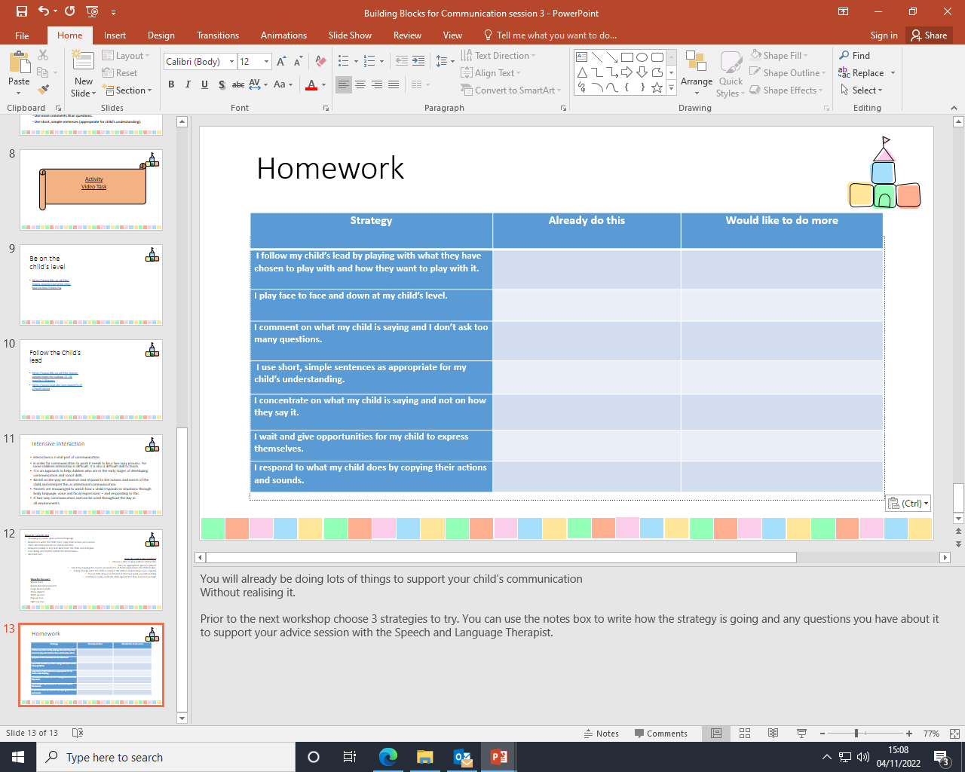

Session 4

Creating Opportunities

A child requires opportunities to communicate their needs with others in order to develop communication skills. It is important to create an environment which encourages communication throughout the day.

When we predict or anticipate what a child needs, they don’t have a reason to communicate. Instead, it is important that we set up a situation that the child has an opportunity and reason to communicate with people in their environment. It is important to create situations which encourage communication.

What are opportunities?
- This is the process of making situations for the child to need to communicate.

- Often as adults, we are prepared and able to interpret child’s needs. However, this takes away the need for a child to communicate.
- By creating opportunities you can create more need for a child to need to communicate and learn that communication is useful and enjoyable.

Activity ideas:

Place Items Out of Reach
Choose an activity that the child cannot do without your help (i.e. toy in a container, wind-up toys), and then wait. Place a wanted piece of clothing somewhere where the child cannot reach it. See if the child comes to you to gain help.

Pause and wait
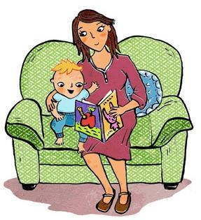
Complete a familiar activity, such as in a familiar song story or routine. Pause and wait for the child’s reaction. Stop half way through singing their favourite nursery rhyme. See if the child completes the sound or indicates for you to continue.

Offer bits, not all
Offer the child small pieces or part of an activity, rather than all of a toy or snack, so they need to ask for ‘more’. Instead of giving your child a big cup of juice, give them a little bit, then wait for your child to initiate that they would like more.

Choices
Offer a choice of two by asking ‘orange or grapes’? Holding out each item, see if the child reaches or labels the one they want.
If the child reaches for both items, release and name the item you think they would prefer. If the child persists with reaching for both, offer them one you think they would prefer and say ‘First grapes and then banana’.

Activity:
What are your child’s reasons to communicate?
______________________________________________________________________________________________________________________________________________________________________________________________
_______________________________________________________________________________________________
_______________________________________________________________________________________________

How could you give them extra reasons to communicate and extra things to communicate about?
______________________________________________________________________________________________________________________________________________________________________________________________
_______________________________________________________________________________________________
_______________________________________________________________________________________________

Objects of reference (OOR)


What are ‘objects of reference’ and why use them?
- OOR are objects that have particular meanings assigned to them. They can represent anything:
a word, sign or symbol e.g. lunch is represented by a spoon, bath time represented by a sponge, home is represented by a key.
- They are multi-sensory e.g. they may be tactile, visual, or have a distinctive smell, sound or movement.
- They can help a child to develop awareness and understanding of the environment, e.g. signalling what is about to happen.
- OOR can reduce an individual’s level of frustration and confusion about what is happening, as they can provide the child with a clear and consistent routine.

How do you use OOR?
- Present the OOR when you are moving to a new activity, place or event e.g. keys alongside your verbal communication saying ‘Home time’.
- Encourage the child to look and explore the OOR with both hands.
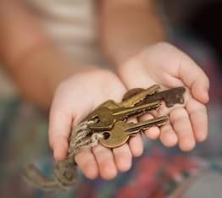
- Allow and encourage the individual to hold the OOR whilst moving to the place/ activity.
- As soon as the OOR has been presented ensure that the child is taken to that place/ activity.

Strategies to Ensure Success:
- Use the OOR regularly and consistently - think about what activities the child does regularly.

- OOR’s should be individual to the child. When choosing an OOR it is important to observe the child and note down how they interact with the environment and what things are important or meaningful to them.

- Motivating- It must be motivating to the child, e.g. if the child becomes animated during a regular game with a parachute then find an object to represent this.

- Real objects are the most concrete (easiest) to understand, such as swimming trunks for swimming. Miniatures of real objects, such as a toy bed are much harder to understand developmentally. The hardest of all to understand are words.

Gesture and Pointing



Before children learn to communicate using words, they use gestures, e.g. waving, pointing, etc. Some children find understanding non-verbal communication difficult. They may not respond to an adult pointing at an object or picture in a book because they do not realise that the adult is trying to direct their attention to something. They may not wave ‘goodbye’ or ‘hello’ or use pointing as a means to support their communication skills.

Gestures and speech go hand-in-hand. By encouraging gestures, you promote your child’s overall communication development. Gestures will provide a child with a way to express themselves before they are able to use verbal language.

Strategies to Ensure Success:

- Make gestures part of your everyday interactions. No special time or place is needed to use gestures. Using simple gestures when you talk with the child throughout the day will help to build their communication skills.
- Use a range of gestures, description e.g. acting out an action brushing teeth, information e.g.
holding three fingers up to indicate ‘3’, social e.g. thumbs up for ‘good job’, holding your hands in the shape of a ball while you say “ball” or doing a throwing action while you say “ball” are helpful gestures.
- Be sure to use the gesture and the word at the same time – This helps reinforce the meaning of the word for the child.
- When the child uses a gesture, acknowledge it by copying it and saying the word that matches the gesture.

Activity ideas to encourage use of pointing and gestures:

Out of reach

Put motivating items/ toys out of reach from the child (in a clear box for the child to see), to encourage them to point to it.

Nursery Rhymes
Sing nursery rhymes with the child, one’s that have actions e.g. Wind the bobbin up; the wheels on the bus, twinkle twinkle little star, if your happy and you know it etc.



Hello/ Goodbye Songs
Support the child to wave ‘goodbye’ or ‘hello’ in a familiar song.



Following the workshops
- Continue to use the strategies with your child. They are the most effective way of progressing your child’s interaction and communication skills.
- If your child is attending a pre-school setting or receiving input at home please share your workbook with them so they can reinforce the same strategies as you.
- An adapted ‘Building Blocks for Communication’ training has also been developed and offered to pre-school settings and key practitioners working with children in the Early Years.

When to re-refer for further support
It is important for your child to be re-referred to the service when they are starting to intentionally communicate. Examples of intentional communication include:
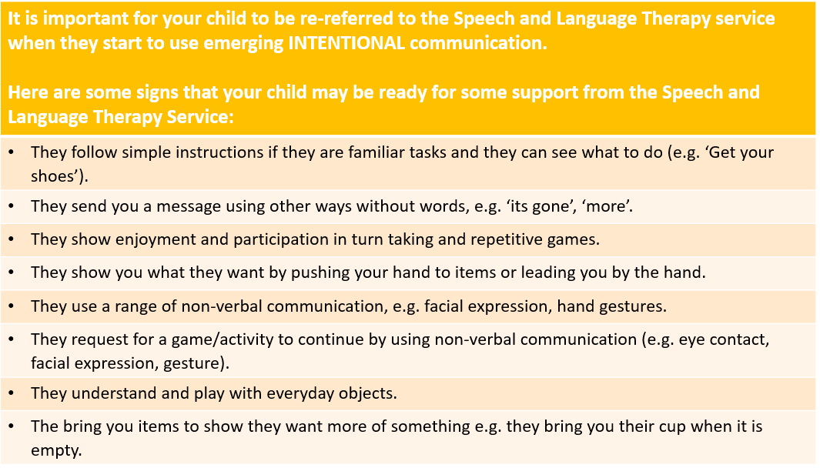
If you are unsure of whether it is the right time for your child to be re-referred you can always contact the department for advice.

Links to other services
Our service focusses on communication, which may not necessarily be your current priority. Please see below for a list of organisations who can provide support around other areas your child may be experiencing difficulties with.
Need | Service | Contact Details
School | SNAP Cymru | 0808 801 0608  www.snapcymru.org
Toileting | Health Visitors & Specialist Health Visitors | Contact your Health Visitor or GPs
 | Young Minds  Behaviour Support Hub  Resilient families (RCT)  Early Help (Bridgend) | https://www.youngminds.org.uk/  https://behavioursupporthub.org.uk/support-for-parent-carers/  https://www.rctfamilies.co.uk/LanguageChoice.aspx

Video Links
Copy and paste the link below into your internet browser, or scan the QR code with your smart phone camera
Session Two
Wait/Pause  https://www.youtube.com/watch?v=BaCjpah8Btw     | Peekaboo  https://www.bbc.co.uk/tiny-happy-people/i-see-you/znvw382  
Ready, Steady, Go  Using "Ready Steady Go" to develop communication skills - YouTube  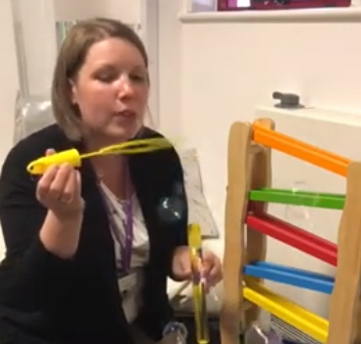  Top Tips - Ready, Steady, Go Games (youtube.com)  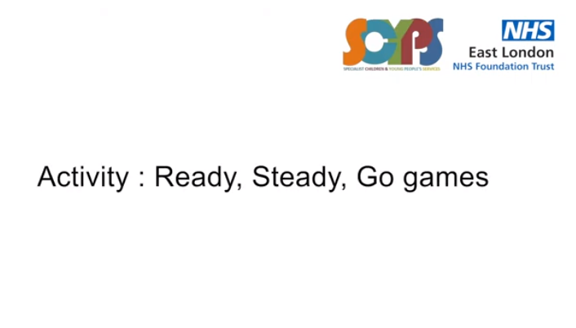  Ready steady go with Bubbles - Look for go. (youtube.com)  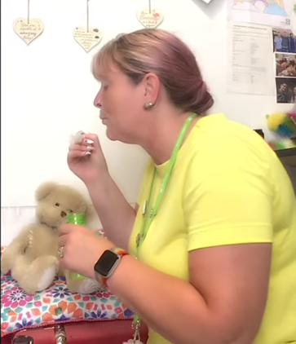 | Feely Bag  What's in the Bag?- Fun Language Development Game - BBC Tiny Happy People  
Attention and Listening  How to improve your child's attention span (youtube.com)  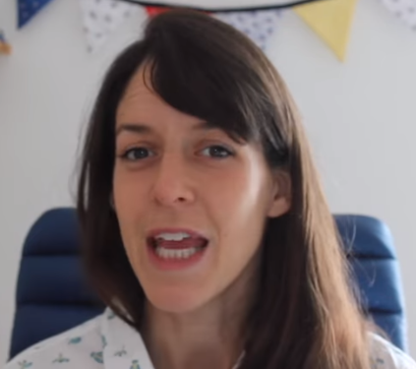  All Talk - Building Attention and Listening - YouTube  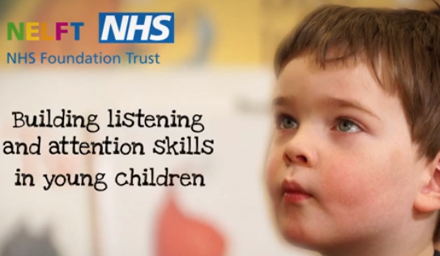 | Commenting  Commenting - Child Language development (youtube.com)  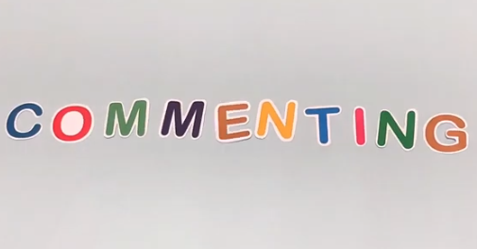

Copy and paste the link below into your internet browser, or scan the QR code with your smart phone camera
Session Three
Follow your child’s lead  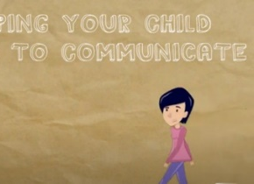    https://www.youtube.com/watch?v=OqG3E7e-190 | Adult Child Interaction  Adult Child Interaction (ACI) - YouTube  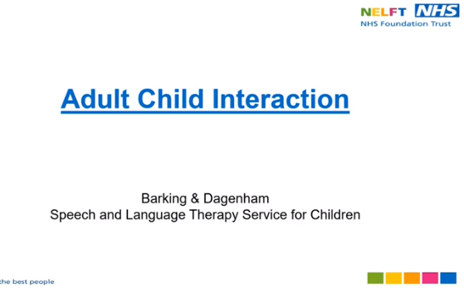
Intensive Interaction
Therapy strategies: Intensive Interaction (youtube.com)

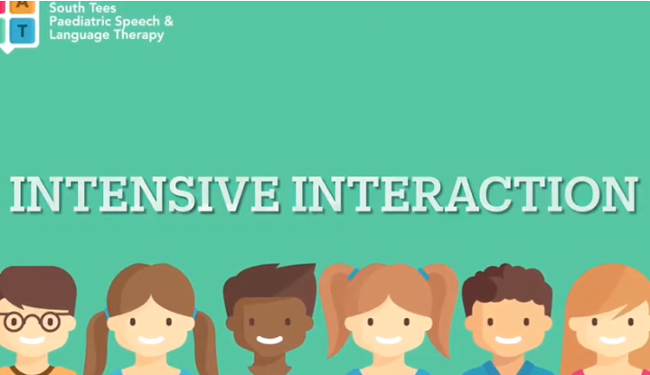

Session Four
Choices  Offering choices creating opportunities for communication (youtube.com)  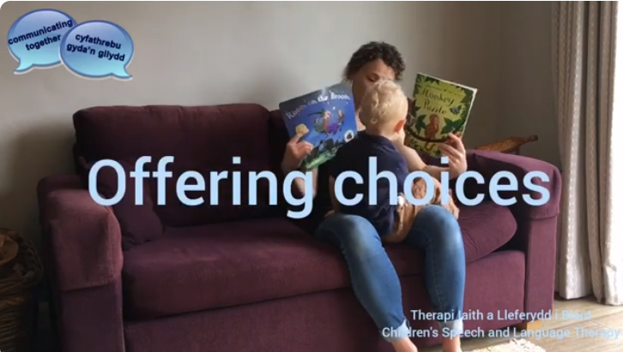   | Creating Opportunities  Communicative Temptations (youtube.com)  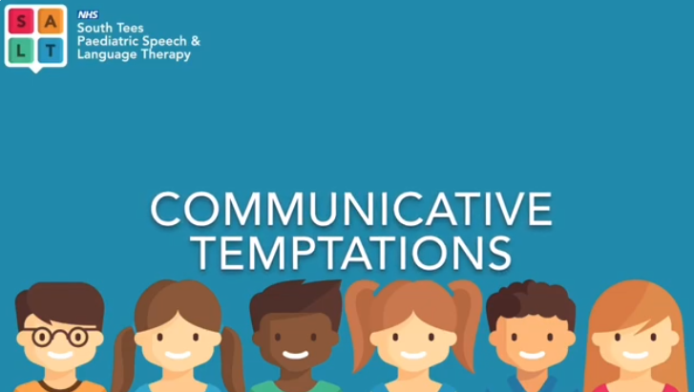   | Objects of Reference  Objects of Reference (youtube.com)  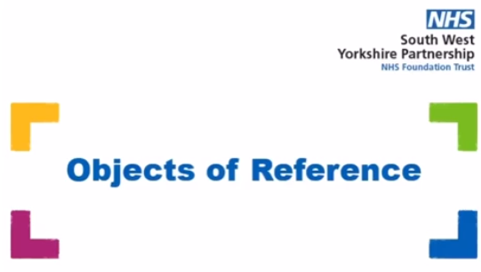  

Additional video links for Cruise into Communication
6 videos which summarise a lot of the strategies and information we covered in the workshops
Copy and paste the link below into your internet browser, or scan the QR code with your smart phone camera
  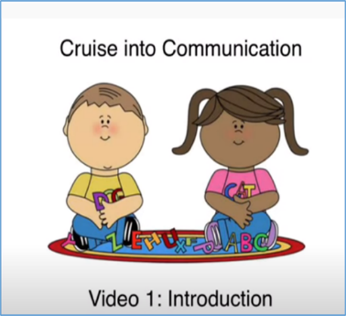  https://youtu.be/EhKTUjEhv60 |   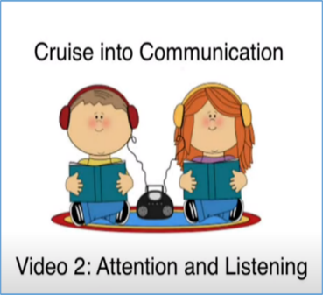  https://youtu.be/QzO8-28yteM
  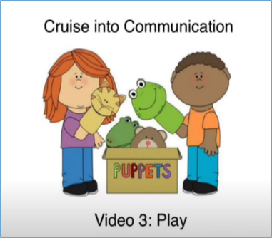  https://youtu.be/dWjEFQuMzdo |   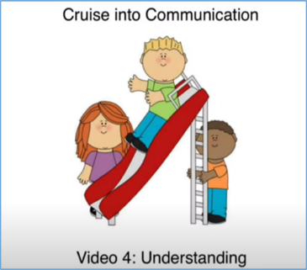  https://youtu.be/MMIaEIueeAs
  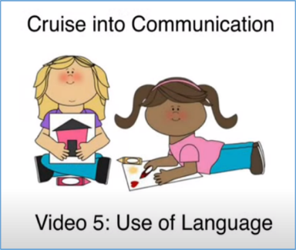  https://youtu.be/jsZIEV4aFeI |   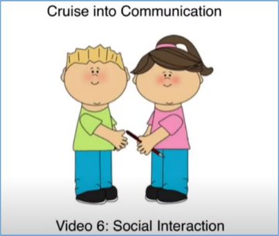  https://youtu.be/d8-MIFoxtaM

Service Information Contact Details

please contact;
Speech and Language Therapy Department
Pontypridd & District Cottage Hospital
The Common
Pontypridd
CF37 4AL

01685 351 300

Attention & Listening
Play
Social Interaction

