


Speech and Language Therapy

Building Blocks for Communication

Resource Pack

Part 1
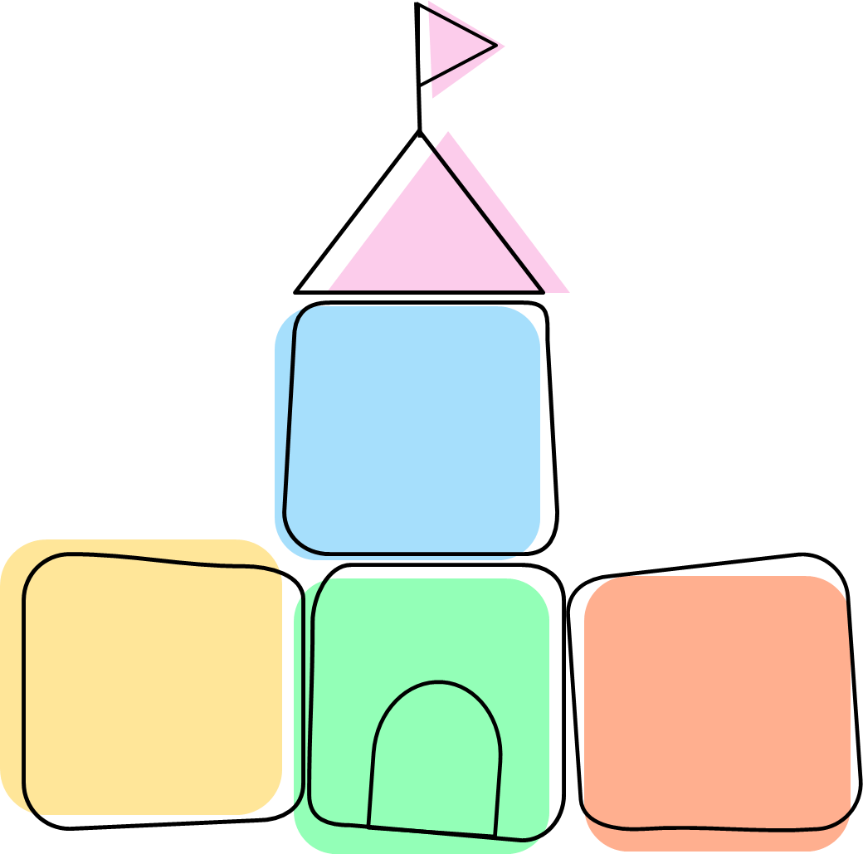
Attention & Listening
Play
Social Interaction

Contents

- Introduction to the Resource Pack
- Understanding Communication Development
- Instructions for using the flowcharts
- How children with social communication difficulties present and flowcharts in the following areas;
  - Attention and Listening
  - Play
  - Interaction
  - Receptive Language (Understanding)

- Examples of targets for each area

- Service Information Contact Details

Introduction to the Resource Pack
Early Years Settings are key in ensuring children receive the support they need prior to starting school. The purpose of this resources pack is to give you the key resources to help you identify and support children who are presenting with social communication differences and may have Additional Learning Needs.

The aim of the resource pack is:

- To give Early Years Practitioners an understanding of how and when to refer to the Speech and Language Therapy Service.

- To give a better understanding of the developmental communication pyramid and social communication differences.

- To provide a tool to assist with target setting for children who are presenting with social communication differences and may have Additional Learning Needs.

- To provide a range of advice sheets containing activity ideas to allow you to support a child’s attention and listening, play and interaction skills.

- To provide flow charts to identify children’s needs and link these with the relevant advice sheets in part 2.

Understanding Communication Development
The sounds
Pyramid of Communication:

Talking, signing, typing, writing etc

The Pyramid identifies the different skills needed for speech, language and communication development. The foundation skills (along the bottom of the pyramid) are attention and listening, play and interaction. These skills are important and are usually developed before a child can move up the pyramid to the next stage.
Typically developing children will move up through the different stages identified in the pyramid and this will result in clear speech. Some children have more difficulty developing their foundation communication skills or develop them differently. These children often need extra help to ensure that the conditions and environment are right for them to learn to communicate effectively. We often refer to this different way of development as social communication differences. People who experience these types of difficulties/differences may:
- Have no spoken words
- Prefer to spend time on their own
- Not initiate communication very often
- Prefer not to use, or to use less eye contact
- Not use facial expression or gesture as compensatory ways to communicate

Stages of Communication Development:
Children’s communication can be identified across 4 stages:
 | What is communicated? | What can you do to help?
  Stage of Communication
Pre-intentional    (Sound making without meaning) | Prefers to play alone, appears uninterested in people around them.  Communication is largely pre-intentional. Does not direct communication towards others.  Doesn’t appear to understand any language. | Always respond back- Let them know their actions and sounds can have meaning.  Make yourself available in a playful and interesting way.  Watch for the child’s actions/vocalisations and mimic.  Extend the interactions, increasing content and length.
Anticipatory    (Using sounds, gestures or movements showing anticipation of familiar events and routines) | Beginning to realise that their actions can influence you and starting to make early request e.g. will pull and lead towards what they want, moves body, makes sounds/words.  Frequently enjoys physical games such as tickles and peek-a-boo. Anticipates parts of the song  Understands routines with cues. | Give opportunities by pausing during familiar routines so they can show you they know what’s next.  -Ready steady go games  -Nursery Rhymes  -People games  -Every day routines  Lead and then pause/wait for the child to respond.  Interpret all communications, responding appropriately.  Model different types of communication e.g. pointing, photographs, objects.
Intentional    (Using sounds/gestures/ movements to purposefully communicate a message) | Clearly communicating requests by reaching, pointing, looking.  Starting to send adults messages to share interests and connect.  May use some spoken words.  May use photos, pictures, symbols, or signs to support their communication.  Understands simple familiar sentences. | Work with the child’s interests.  Label things.  Comment on what your child is doing or is interested in.  Extend the child’s use of non-verbal communication by consistently modelling non-verbal communication.  Build on the child’s play by joining them and following their lead.  Take turns in play, copy them, and watch how they respond.  Use song to model communication.
Words and ideas  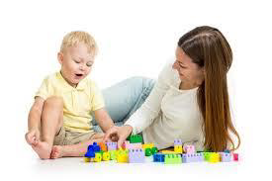  (Using words with meaning) | Can turn take in a simple conversation.  May use memorised phrases.  May enjoy talking about a favourite topic.  Beginning to try to communicate with other children. | Comment on what the child is looking at/doing.  Keep your comments simple, following the child’s interests.  Repeat, repeat, repeat.  Model language useful for the child (e.g. let’s have a drink, coat on, time to go home, don’t like it).  Avoid asking questions.

  - Development of the Building Blocks for Communication
  - Attention and Listening
Typically, children move through the below stages, as their attention and listening skills develop. However, this is not linear. A person’s ability to attend will be impacted by the environment around them, therefore a child may display different levels of attention in different settings, situations and tasks.
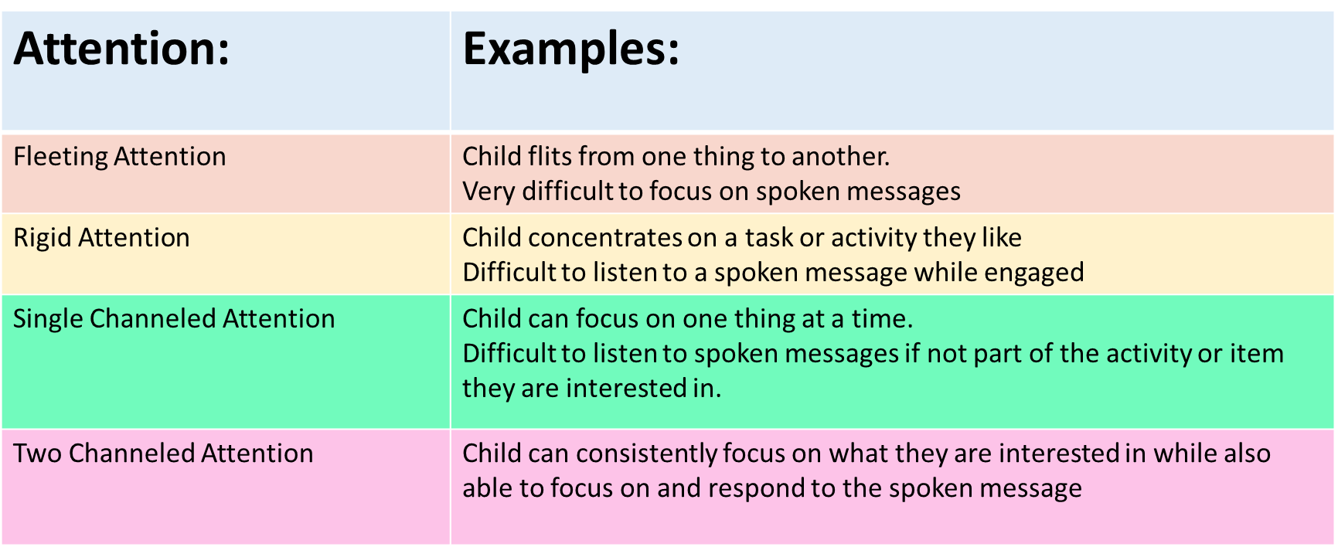
How do developing attention and listening skills present in the earning environment? The child may...
- Appear to ignore you when focused.
- Cannot tell you what you have been talking about.
- Do not appear to know what to do and can have difficulty following instructions.
- Can only concentrate on one thing at a time.
- Are easily distracted.
- Do not settle with one activity but tend to flit from activity to activity.
- Fidgety.
- Require a high level of support to complete tasks.
- May be passive and quiet.
- Doesn’t look at adult speaking.
- Find transitions between activities or events distressing.
- Find finishing activities distressing.

Remember that all children find it difficult to attend for long periods of time, particularly for less interesting tasks. Be mindful that expectations and targets are age and stage appropriate.
How can attention and listening look different for children with social communication differences?
Children with social communication differences need us to work hard to earn their attention as they are usually taking in more information about their environment, and it can be difficult to move their focus from this.

Monotropism is a theory that suggests some neurodivergent people have their attention focused on a smaller number of interests at any given time. This in turn leaves fewer resources and attention for other processes. Remember not to make harmful assumptions about a child’s attention. The child with listening and attention difficulties/differences is not choosing to present this way, their brains may be developing differently.
You can learn more about monotropism by following the QR code to the right.

Joint attention
Joint attention involves two people paying close attention to the same thing, intentionally and for social reasons. It
can be misunderstood that children must look or present a particular way to be attending and listening. This usually involves looking at the speaker, sitting, being still and being quiet. This is often referred to as “whole body listening”.

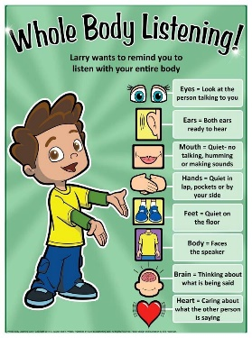
However, there is no one size fits all. Active listening and processing can look many ways. Some people listen best when they move around, look away, fidget with their hands, or have a quiet space.

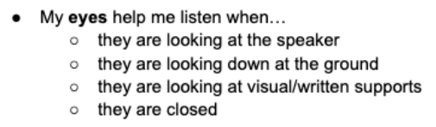
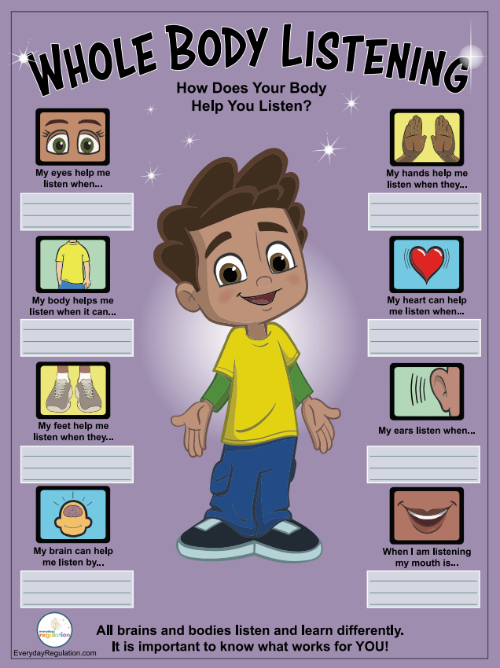
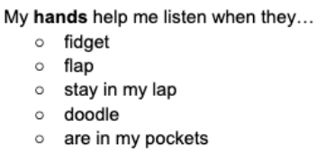

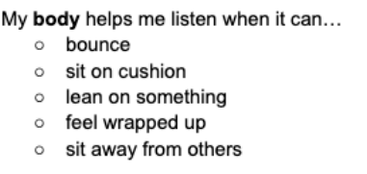
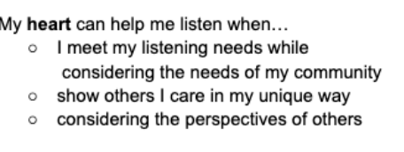

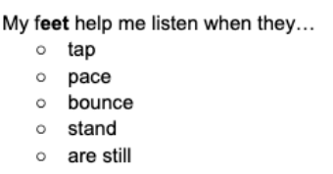
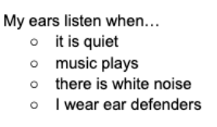

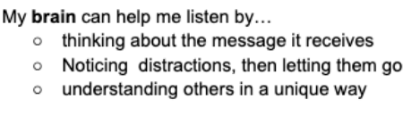
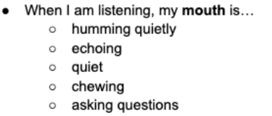

These various forms of listening and learning needs are not deficits–they are differences. Try not to assume a child isn’t attending because they are not able to sit, stay still or look at the speaker. A child focusing on sitting, staying still, or looking at the speaker is unlikely to also be able to attend to what is being said.

Play
Play is to engage in activity for enjoyment and recreation. It’s how children learn. All children play in different ways – there’s no right or wrong way to play, all play is okay! There are lots of different types of play, more than what are listed below. Play doesn’t have to involve toys or people to be a meaningful learning experience. Play is a natural way for children to learn how to communicate and interact.
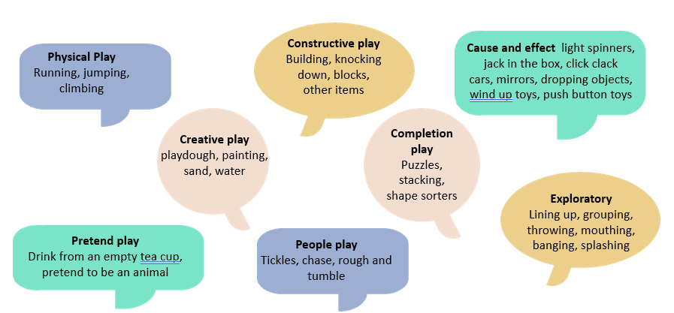

How do developing play skills present in the learning environment? The child may...
- Be passive, quiet and sit and watch what other children are doing.
- Not initiating their own play situations.
- Put the different toys / objects in their mouth – exploratory play.
- Throw toys rather than use them as you might expect – cause and effect play.
- Always seek the same activity they are familiar with or have fewer, more intense interests in play activities
- Demonstrate unusual or atypical play e.g. lying on the floor and watching the moving parts of a toy, lining up toys – exploratory play
- Have their own personal ideas of the goal of the play and become distressed when others intervene and change this.

- Have difficulties sharing toys and taking turns with peers when highly engaged.
- Prefer solitary play (away from peers) or parallel play (around but not with peers) with limited interest in what other children are doing.
How can play development look different for children with social communication differences?
Play is the vehicle of learning. As listed above, children with social communication differences may play differently however... all play is okay!
Some children with social communication differences may prefer to play with objects than actual toys, they may continue to use unconventional play or sensory based play for longer, they may like rough and tumble play beyond the early years, they may prefer to play with the same toy or play routine over and over again, they may prefer visual activities as well as computers and puzzles due to them being logical and systematic.
Some children’s play is led by their sensory preferences, such as movement, touch, sound, sight, and smell. They may be under or over sensitive to certain sensations, which means they may seek or avoid these. When we recognize and work with a child’s sensory profile, we can create situations that make it easier and more fun for them to interact with us!
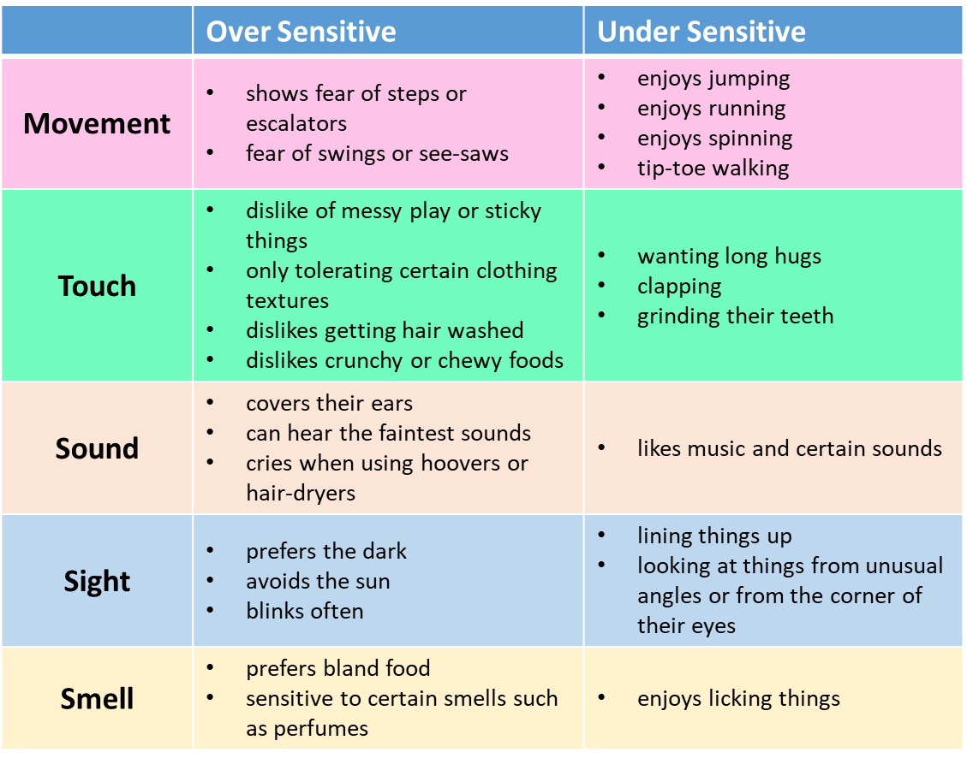

Children have a need to play, their own way. Taking away, controlling, or sabotaging children’s play is impacting their learning. To best support a child’s play skills, you can:
- Honour their play interests – observe their play, try to see the play activity from the child’s view and avoid placing your own expectations on the play.
- Add opportunities by observing their play, following their lead, and imitating their play.
- Affirm the child’s play, follow their lead, make comments, and allow them to engage in self-directed play.
- Provide opportunities for different types of play by following their lead and including any special interests in different play opportunities e.g. including numbers in outdoor/physical play etc.
- When a relationship has been built you may be able to introduce one new item/toy/idea to a familiar activity. Observe how they respond and following their lead.
- Embrace their sensory preferences and provide safe opportunities for these.
It is important to remember not to:
- Withhold special interests.
- Sabotage particular play activities.
- Try to lead or change their play.
- Place your own expectations on their play.

Pressure to play according to another’s expectations interferes with our development. Instead, become curious about children’s play and what they are learning about the world. All play is okay!
You can learn more about play for neurodivergent children by following the QR code to the right.

Interaction
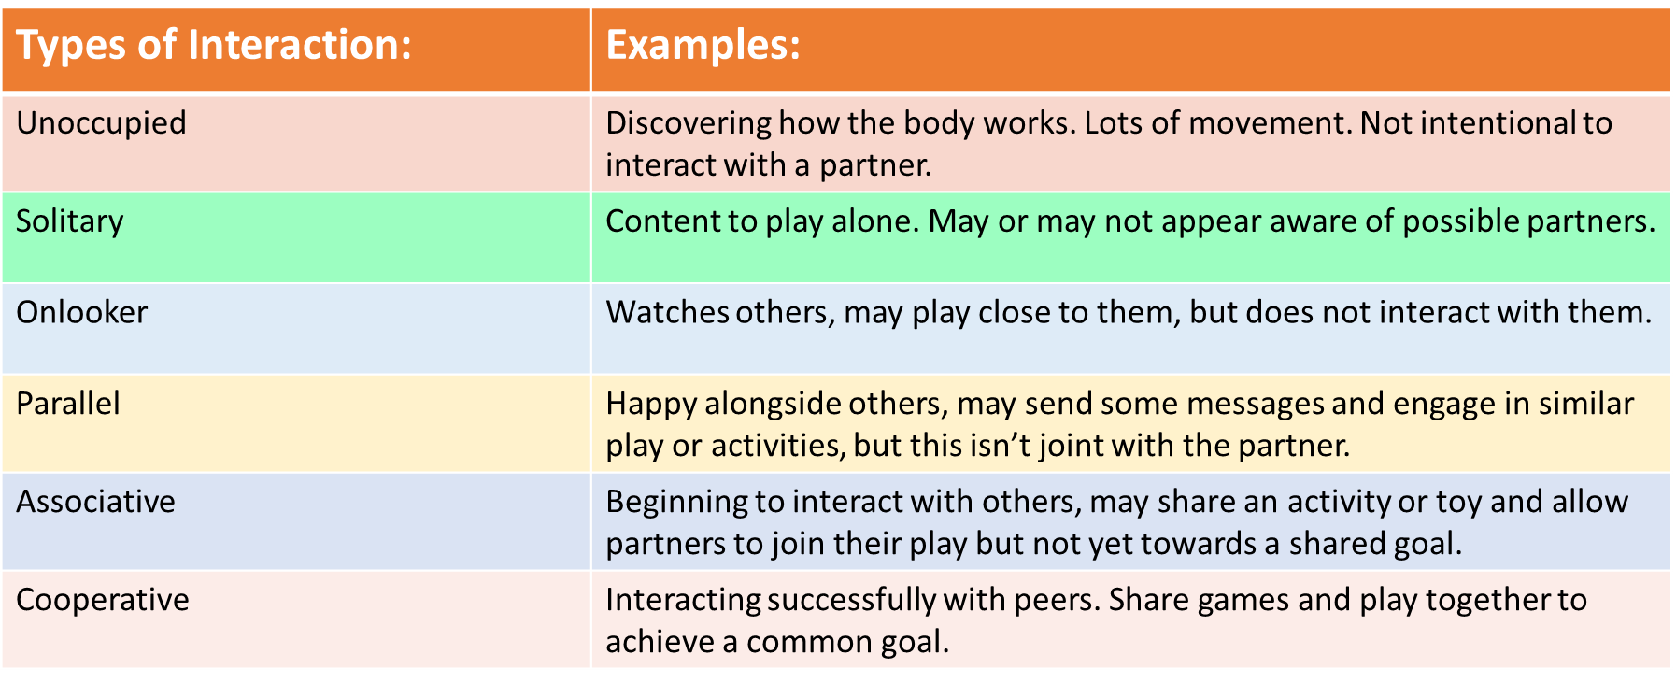
Interaction gets communication started. Communication is the act of sending a message to another person, through a means for a range of different reasons. For communication to be successful, there must be available opportunities for this, such as a responsive communication partner. When two partners are responsive to each other, this is an interaction. Interactions are defined according to play:

How might children with interaction difficulties present in the learning environment? They may...
- Prefer to be or play by themselves.
- Find it tricky to initiate an interaction with adults and peers.
- Not seek adults out to get their needs met.
- Have difficulties sharing toys and taking turns with peers.
- Find it difficult to follow the routine of the Early Years setting.
- Not use objects to communicate messages to an adult or peer.
- Not use pointing or gestures to initiate or respond to messages to an adult or peer.

How can interaction development look different for children with social communication differences?
Children with social communication differences may interact differently than others. They might initiate interactions in more subtle ways or might not show the expected signs of “whole body listening” (page 9), like eye contact and sitting still. As a result, their attempts to interact and communicate can be easily missed.
In the past, the expectation was that children with communication difficulties or social communication differences should change their behaviour to fit the typical style, such as making eye-contact or eradicating echolalia. However, for communication an interaction to be successful, both partners have to adapt their communication. This is known as the double empathy problem (Dr Damiam Milton). As the supporting adult, it is essential for us to remain patient, understanding, and ready to adjust how we communicate so we can better connect with the child.


Teaching children with social communication differences to communicate in a neurotypical way can unconsciously push a narrative that they cannot be themselves. This leads to masking, which can be harmful to a person’s well-being.
You can learn more about the double empathy problem and masking by following the QR code to the right

We can support a child’s interactions and communication without changing their natural communication styles by acknowledging, responding to, and supporting all styles of communication. All communication styles are valid! This includes:
- Gestures, body movements, pointing
- Objects, photographs, pictures, symbols
- Written words, technology
- Vocalisations, song, echolalia, spoken words

Instructions for Using the Flowcharts

What are the flowcharts?
The flow charts look at the different communication elements identified on the first block of the Pyramid of Communication. The resource is aimed at children at a pre-intentional, anticipatory and early intentional stages of communication development.
Attention and Listening, Play, Interaction

When you identify a child who may need support in developing their foundation communication skills, use the flow chart to help you identify targets for the child. This will also guide you to the relevant advice sheets you can use to support the child’s specific needs.
Which areas do the charts focus on?
- Attention and Listening
- Play
- Interaction

How do I use the flow charts?
- Once you have identified the areas of delay/difficulty, use the Pyramid of Communication to identify which areas to work on.
- Select the appropriate flowchart and work your way down through the questions.
- Read through and answer each question to the left. If the answer is yes, follow the arrow to find the appropriate advice sheet in booklet 2.
- Refer to the appropriate advice sheets (you’ll find these in part 2 of this resource pack) and use the suggested activity ideas.

- Carry out the recommended activities and record the progress the child makes. Remember these progress steps may be small over a long time period but they are extremely valuable. Evidence of this is your graduated response.
- If parents have attended the parent Building Blocks for Communication sessions by the Speech and Language Therapy service, they will have a booklet which will outline the strategies they are currently using at home. This information at the back of this booklet may also be helpful for setting joint targets with parents.

Please note
- This resource has been produced as an additional resource for children presenting at an early stage of communication development and/or social communication differences and therefore will not be appropriate for all children. They are not to replace the resources you may already be using such as Wellcomm.

- If your service has a Speech and Language Therapist, e.g. Flying Start, please get in touch with the Flying Start Speech and Language Therapist if you have any questions when using this resource with children at your settings.

The Flowcharts
Attention and listening
Employ useful strategies for developing attention (pg 4)
Joint Attention & Anticipation Games (pg 5)

Anticipation & Ready Steady Go Games (RSG) (pg 6)

Objects of Reference (pge 9)

Intensive Interaction (pg 21)
Is the child inconsistent at turning to their name, or doesn’t turn at all?

Yes

Yes
Yes
Yes
Yes
Does the child move quickly between different activities?

Does the child miss joining in at the end of a familiar song?
Does the child find it hard to follow adult led tasks?

Yes
Does the child attend to activities of their interest for extended periods of time?
Does the child become upset or frustrated when others intervene with their activity?
Employ useful strategies for developing attention (pg 4)
Intensive Interaction (pg 21)
Anticipation & Ready Steady Go Games (RSG) (pg 6)

Attention Bucket (pg 8)
Now and Next Boards (page 10)

Yes

Does the child miss adults talking to them in or outside of their activity when they are focused?

Employ useful strategies for developing attention (pages 5 & 6)
Now and Next Boards (page 14)
Visual Timeline (page 15)

Yes
Is the child able to move their attention to an adult, but has to stop their activity to focus on the adult?

  - Play
Yes
Yes
Useful strategies for developing play (pg 13)

Special Time (pg 14)

Intensive Interaction (pg 21)

Joint Attention and Anticipation games (pg 5)

Sensory play (pg 15)

Anticipation & Ready Steady Go Games (pg 6)

Does the child have no interest in toys?
Does the child have no interest in peek-a-boo games?
Yes
Yes
Yes
Useful strategies for developing play (pg 13)

Special Time (pg 14)

Relational and self-pretend play (pg 18)
Does the child not imitate everyday situations e.g. pretending to drink from a cup?
Is the child beginning to relate two toys together (e.g. spoon in cup or is beginning to feed, brush and wash themselves)?

Useful strategies for developing play (pg 13)

Special Time (pg 14)

Sensory play (pg 15)

Exploratory play (pg 17)

Relational and self-pretend play (pg 18)
Does the child explore toys by mouthing shaking or banging them?

Interaction
Does the child appear to have little awareness of adults and peers?

Useful Strategies for developing Social Interaction (pg 20)
Intensive Interaction (pg 21)
Yes
Yes
Yes
Yes
Does the child follow their own agenda, finding adult led interactions difficult?

Does the child have difficulties following gestures used by adults or using their own gestures e.g. pointing?

Does the child not indicate/communicate their needs and wants?
Useful Strategies for developing Social Interaction (pg 20)
Offering choices (pg 23)
Gesture and Pointing (pg 24)

Useful Strategies for developing Social Interaction (pg 20)
Employ useful strategies for developing attention (pages 5 & 6)
Intensive Interaction (pg 21)
Joint Attention & Anticipation Games (pg 5)

Objects of Reference (page 7)

Useful Strategies for developing Social Interaction (pg 20)
Offering choices (pg 23)

Ideas for Target Setting

Target examples
Attention & listening | - The child will engage in a self-chose activity for two minutes, with minimal adult prompts, 4 out of 5 times in daily play sessions. Remember to consider the child’s age and what is developmentally appropriate.  - The child will take two turns during a “ready, steady, go” game of their interest with an adult, showing engagement through their preferred communication method. engage in a ready, steady, go games  - The child will indicate ‘go’ during a ready steady go game by using body movement/ eye contact/vocalisation/a word 3 out of 5 times in a session.  - The child will demonstrate joint attention with an adult during people games by shifting their gaze or body towards the adult when initiated, in 3 out of 5 attempts.  - The child will show recognition of an object of reference by looking at, reaching for or touching the object when presented by an adult before the corresponding activity, 2 out of 5 times.
Play | - The child will engage with two different interactive activities in the setting each session, supported by an adult who follow and includes the child’s cues and interests.  - The child will explore a new item, area or toy that aligns with their interests once a week, with minimal adult prompting
Interaction | - The child will indicate they want an interaction to continue during people games by using their preferred communication method in 3 out of 5 instances during play.  - The child will make a sound (vocalisation, hum, babble etc.) to indicate they want a song to continue 2 out of 3 times during singing sessions.  - The child will participate in an action song e.g. wheels on the bus, by taking a turn to chose the next verse/action using a gesture, vocalisation, or pointing 2 out of 5 times during singing sessions.  - The child will make a choice between 2 items by reaching, labelling or preferred communication method the item they want 3 out of 5 times during a session.  - The child will follow routine-based instructions by recognising an object of reference and moving towards the activity when the object is shown, 3 out of 5 times during the daily routine.

Service Information Contact Details
For any enquiries, please contact
Children’s Speech and Language Therapy
Pontypridd Cottage Hospital
The Common
Pontypridd
CF37 4AL
Phone: 01685 351300
Email: CTT_ChildrenSpeechAndLanguage@wales.nhs.uk

Attention & Listening
Play
Social Interaction

