Speech and Language Therapy
Building Blocks for Communication

Resource Pack 2

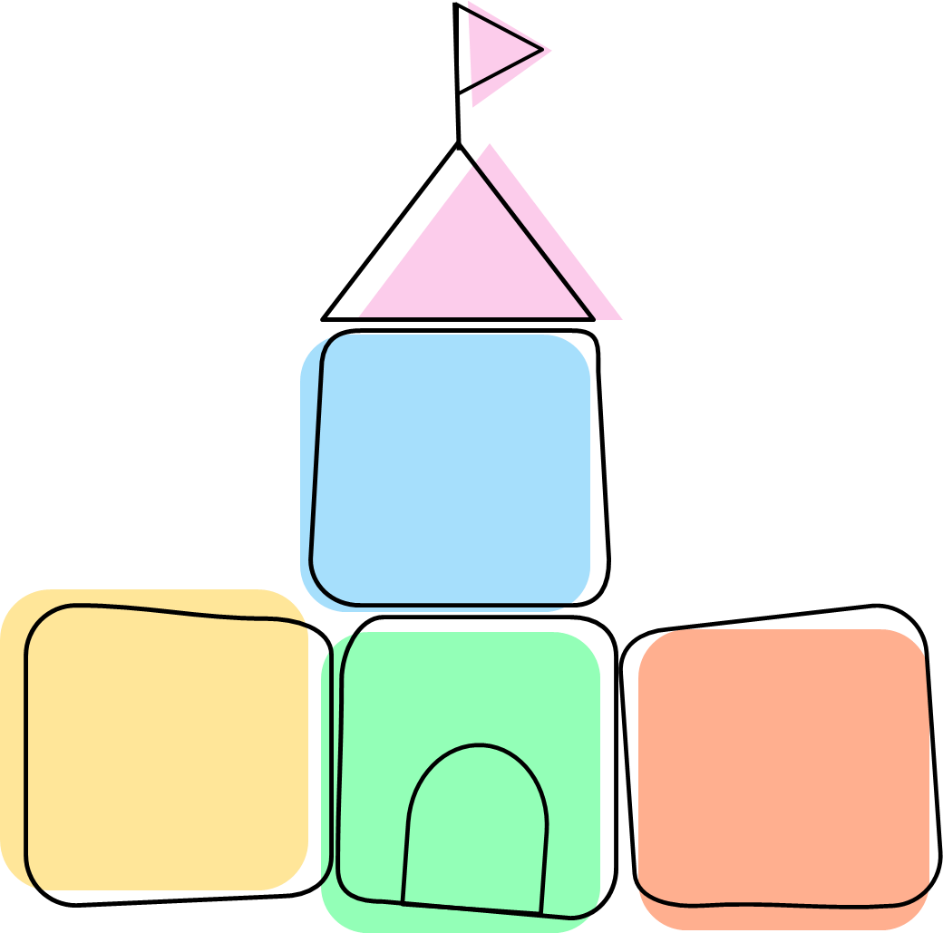
Attention & Listening
Play
Social Interaction

Contents
1
Attention and Listening 3
Useful strategies for supporting children’s attention 4
Joint Attention and Anticipation Games 5
Anticipation & Ready Steady Go Games (RSG) 6
Objects of reference (OOR) 7
Attention Bucket 8
Now/ Next Boards 10
Visual Timetable 11
Play 12
Useful Strategies for Play Development 13
Special Time 14
Sensory Play 15
Exploratory play 17
Relational and Self-Pretend Play 18
Social Interaction 19
Useful Strategies for developing Social Interaction 20
Intensive interaction 21
Offering choices 23
Gesture and Pointing 24

Attention and Listening

Attention and Listening

Useful strategies for supporting children’s attention

Top Tips:
- If you have any concerns about a child’s hearing ability make a referral for a hearing test to be completed.
- Make adjustments to ensure the learning environment is a good listening environment. Reduce distractions and loud music.

- Make yourself exciting so it’s easier for the child to move their attention to you.

- Keep your sentences short and to the point.
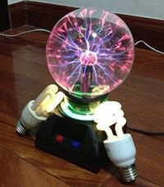
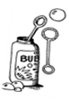
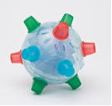

- Use toys which you know will interest the child. Take note of their interests. They may enjoy toys that make noises or have flashing lights e.g. rainmakers; LED light spinners, mesh balls. Involve the child’s interest e.g. Paw Patrol toys.

- Initially, any activities should be short. Up to 1 minutes, but frequently through the day will be more successful, gradually building up the time up to 2-3 minutes as the child’s attention increases.

- Use pictures/symbols to provide visual support, such as a now/next board, this will help the child remember, anticipate, and understand what is expected of them. Use the real objects or photos of the specific toys on the now/next boards instead symbols/photos of a similar item/cartoon representations.
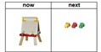

Some useful strategies for getting children to stop their activity and attend to you:

- Make it clear when the activity will finish e.g. “when sand timer is finished, the task is finished”; “two turns, then finish”, “puzzle done then story time”
- Strategies such as counting down from 3-2-1-0 and reinforcing this with praise when achieved.
- For those children with extreme difficulty focusing on an activity, consider ow the environment may be impacting this e.g. could they complete the task while standing up so they can move their body to make it more achievable?

- Have frequent breaks between tasks, to break up periods of intense focus for the child. This could be 1-5 minutes depending on the child. It might include a movement break.

Joint Attention and Anticipation Games

People Games
These activities aim to help the child develop a skill known as ‘joint’ or ‘shared’ attention. The aim is to make you (and your activity) the most exciting thing in the room, so the child cannot resist engaging and focusing on you.

What is shared attention?
- Joint attention involves two people paying close attention to the same thing, intentionally and for social reasons.
- When children play people games, they aren’t distracted by toys, making it easier to focus on the adult.

What do I need to do?
- Make the song and actions as lively as possible; this will help keep the child’s attention.
- Pause and wait for the child to indicate that they want you to keep going – they might do this with a movement, a look, a smile or a sound.
- Play games, which have the same fun ending each time, this will help the child anticipate what is going to happen

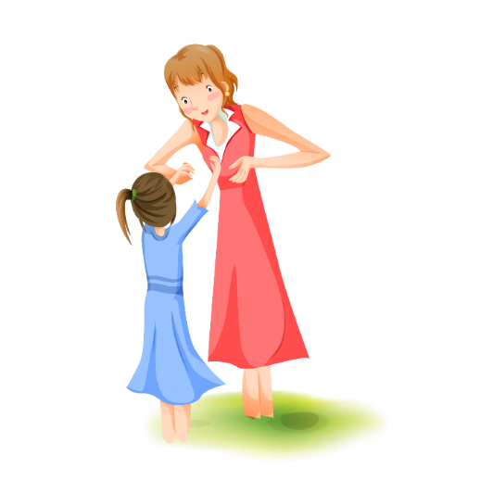
Activity Ideas
- Bounce the child up and down on your lap or play swinging and rocking games on the floor.
- Play tickle games with the child.
- Play ‘peek a boo’ or hide and seek games.
- Any games that have a song and actions e.g.
- Row, row, row your boat
- Round and round the garden
- Zoom, zoom, zoom, we’re going to the moon

Putting it into practice
- Try starting with physical people games – you want them to find out how much fun he/she can have with you.
- Choose a short activity your child enjoys and which can be done repetitively.
- Lap games are ideal to start with if the child will sit facing you, they can see the actions and your fae.
- Once the child has experienced the routine a number of times, choose a suitable point to build in a pause, “if you see a crocodile, don’t forget to… (Pause)…scream”.
For further ideas check out the videos below.



Anticipation & Ready Steady Go Games (RSG)
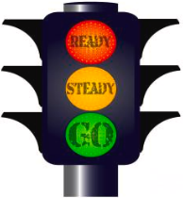
Anticipation games are a great way of interacting with children and offer a fun and positive way of engaging with the child. They also help children learn that their actions are meaningful and can have an effect on you. This can then encourage them to start requesting and communicate more!

Once you start playing these games your child will love the repetition and ask to play them on a regular basis.

What do I need to do?
- Help the child by pausing during familiar routines so they can show you they know what’s next.
- Make yourself part of the process and allow time for the expectation.
- Lead and then pause/wait for the child to respond.
- Give your child enough time to respond and leave gaps in your talking so that your child can attempt some noises, gestures or words e.g. “Ready, steady….” (wait) “go!” the blow the bubbles or “peekaaaa..” (wait) “BOO!” as you open your hands
- You can add variation to the game by increasing the length of the pause between Steady and Go to make your child wait longer and longer… remember to always follow through with the action if the child indicates ‘go’ in some way e.g. eye contact, body movement, vocalisation, word.
Activity Ideas
- Peekaboo
- Blowing bubbles
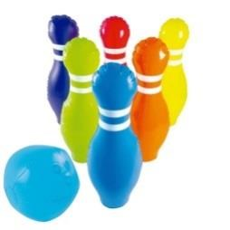
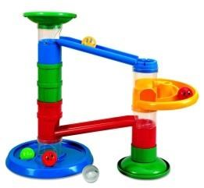
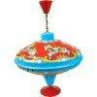
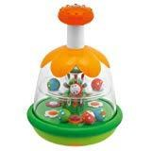
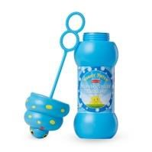
- Rolling a ball to one another

- Skittles
- Pushing a car or train along a track
- Jumping up from behind something
- Throwing bean bags in to a bucket
- Turn music on to dance to
- Nursery rhymes – “this little piggy went to market”, “row your boat” “round and round the garden”

Putting it into practice:
  - Ensure the child is motivated by the activity/ game.
  - Provide a variety of different opportunities to practice (different activities)
  - Get down to the child’s level and follow what they are interested in.
For further ideas check out the videos below.




Objects of reference (OOR)

What are ‘Objects of Reference’?
- OOR are objects that have meanings assigned to them. They can represent anything: a place, a time of day (event), a person, an activity etc.
- They are multi-sensory e.g. they may be tactile, visual, or have a distinctive smell, sound or movement.
- They can help a child to develop awareness, understanding of the environment and anticipate the routine by signalling what is about to happen as well as communicating choices
- OOR can reduce an individual’s level of anxiety, frustration, and confusion about what is happening, as they develop anticipation and understanding as they can provide the child with a clear and consistent routine.

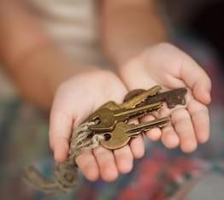
What do I need to do??
- Present the OOR when you are moving to a new activity, place, event or person e.g. keys alongside your spoken communication saying, ‘Home time’.
- Encourage the child to look and explore the OOR with both hands.
- Allow and encourage the individual to hold the OOR whilst moving to the place/ activity/person/event.
- As soon as the OOR has been presented ensure that the child is taken to that place/ activity/person/event.
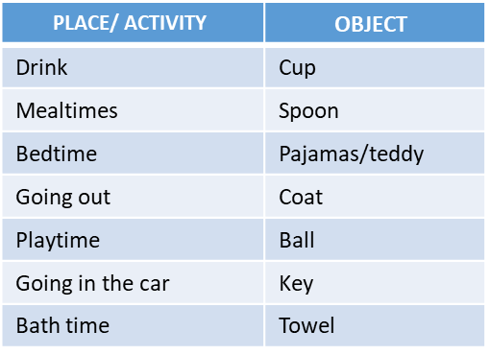
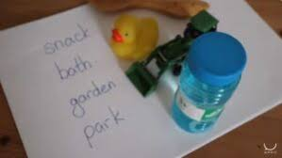

Putting it into practice:
- Use the OOR regularly and consistently - think about what activities the child does regularly.
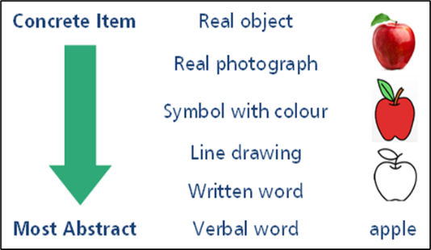
- OOR’s should be individual to the child. When choosing an OOR it is important to observe the child and note down how they interact with the environment and what things are important or meaningful to them.
- Motivating- It must be motivating to the child, e.g. if the child becomes animated during a regular game with a parachute then find an object to represent this.
- Real objects are the most concrete (easiest) to understand, such as swimming trunks for swimming. Miniatures of real objects, such as a toy bed are much harder to understand developmentally. The hardest of all to understand are words.
For further ideas check out the videos below.



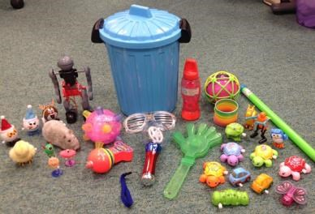
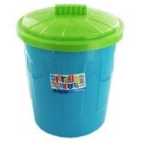
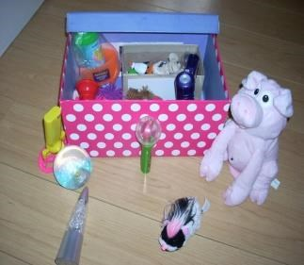
Attention Bucket

What is Attention Bucket?
- A small, interesting box containing multi-sensory toys not found in the everyday toys, which the children won’t access otherwise.
- As a group, children watch the adult play with the toys, using simple language and non-verbal communication.
- It can be used to encourage a child to join a group and focus on an adult led activity. It is the child’s choice to engage with the activity.
- Each child is different- If the child isn’t interested don’t force them to watch, if a child wants to join but attends best when they are standing, embrace their preferred attending style.
- Some professionals allow children to interact with the toys at the end of the attention bucket time, before finishing and packing the toys away.
- This information is loosely based on the formal programme Attention Autism by Gina Davies.
- There is a limited evidence base for this approach to support children’s attention skills generalising outside of these activities.
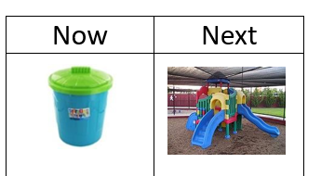

The Bucket Session:
- Remove all possible distractions. Consider using a different room to the one your child usually ‘plays’ in. Show your child a picture of bucket/ bag/box and say ‘bucket time’. A Now/Next board is a good visual here (see page 10 of this resource pack for more information).
- Sing an introduction song e.g. “I’ve got something in my bucket, I’ve got something in my bucket, I’ve got something in my bucket, I wonder what it is”.
- Show the first toy saying nothing, then show it again and add simple language e.g. ‘ball’, ‘bounce the ball’. Exaggerate your facial expressions; use a range of expressions (surprise, excitement, etc.) and use tone of voice. Initially aim to show 1-2 toys, with a maximum of 3 toys in the bucket.
- When the session has finished, draw a line through the bucket/ bag and say ‘Bucket time is finished’.

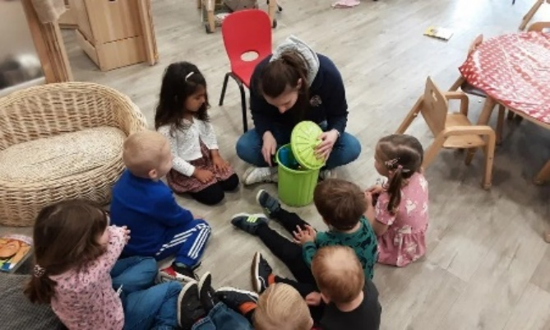

Toy ideas
It is a good idea to have a range of toys that you can switch between at different sessions and make sure you have prepared different things you can do with each toy in order to hold attention for increasing lengths of time. e.g. rainmaker – can tilt up and down, can roll on the floor, can twist around, can shake and dance with it.

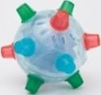  Bumble Ball |   Pull-string animals |   Flashing windmill |   Balloon
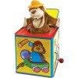  Jack-in-the-Box toys | 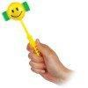  Giggle stick | Musical spinning top | 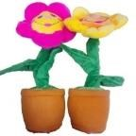  Singing/Dancing toys
  Light toy | 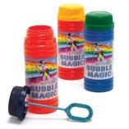  bubbles |   Jumping man | 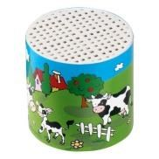  Noise maker
  Mesh ball | 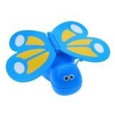  Wind up toys |   Maraca | 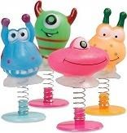  Spring toy

Putting it into practice:
- Use the Now/Next Board to help the child understand what is expected of them.
- Avoid talking directly with the child during the activity, don’t ask them questions. Keep language simple – single words and short phrases e.g. “a jumping man”.
- If your child begins to get very excited, slow down the activity, the rate of speech and quieten your voice.
- If your child does leave the area, DO NOT stop – continue with the session enthusiastically as it may draw them back!
- Your child should not try and touch the toys during the session. You may allow them to explore them at the end
- Avoid showing one toy for too long, as your child may become bored.

For further information and where to go next research Attention Autism.




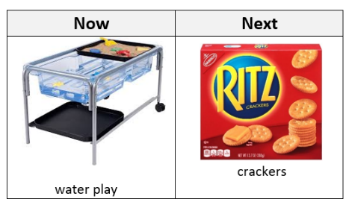
Now/ Next Boards

What is a ‘Now and Next’ board?
- A now and next board is a very simple visual aid. It is a visual with now on the left and next on the right and space for a picture of what is happening now and next.
- Children who have communication or attention difficulties will find it helpful to understand what is happening. Using the Now and Next strategy can reduce the pressure of communication on a child as they are able to use visual information, rather than just speaking.
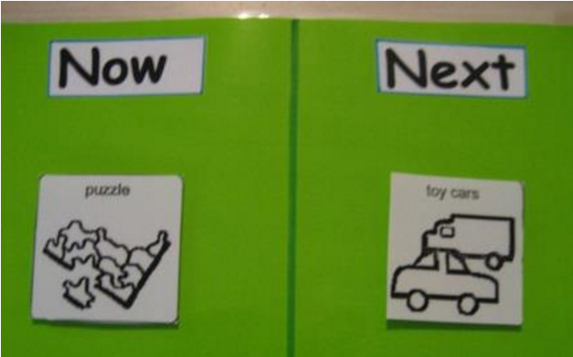
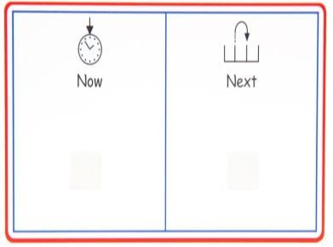
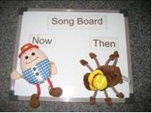
- ‘Now/Next’ boards are a way of helping the child to understand what is expected of them, at times of transition across the day.

What do I need to do?
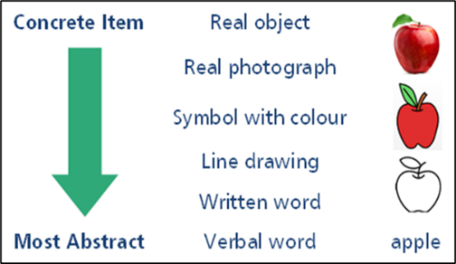
- When making the board, ensure it is as plain as possible, using only simple, bold colours. Laminate the board, adding velcro or blue tack dots to both sections. Collect objects, photographs or symbols of a range of activities available to the child within the setting. Start with objects or photos before moving on the symbols, as they are easier to understand the meaning of.
- When using the board, place one object/photo/symbol on each side of the board.
- Show the child the board, take it to them rather than leading them to the board (as this is already a transition). Point to each section individually and support the child by saying “water play now, crackers next”. Make your voice interesting and keep language simple.
- When the child finishes a task, reinforce this, again pointing to the board and saying “water play finished, time for crackers”. Help the child to physically remove the completed activity to support their understanding that this is finished. You will need to show the how to do this the first few weeks.

Putting it into practice
- Persevere by using this daily until the child fully understands the concept of the Now and Next board. You can then build on this e.g. adding “Now, Next, Then” board or visual timetable (page 11).




Visual Timetable

What is a visual timetable?
- A visual timetable is a visual routine. You can use the timetable to show the activities that your child is going to complete as part of their routine. This includes activities further in the future than Now and Next boards.
- This may help their understanding of what is happening throughout the day and encourage them to anticipate and engage in routines.

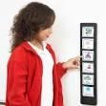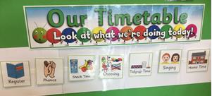

What do I need to do?
- Place the timetable in a clear place that your child can easily see. Ensure it’s at the child’s eye level, rather than the adults.
- Place a small number of photos or symbols down the strip which illustrates which activities your child is going to do. You can increase the number of activities as the child becomes more familiar with the visual timetable.
- Show them the symbol as you begin an activity. You can do this as a group, or on an individual level.
- When the activity is finished, remove it. You may need to do this for your child initially, but with time, they may begin to do this more independently.

Putting it into practice
- It may be helpful to take the timetable and a bank of symbols out with you, so that you can always show your child what is coming next.
- It does not matter whether the timetable is horizontal or vertical.
- You may be tempted to take away the visual support as the child is now able to follow the routine. However the visual timetable should grow with the child, and increase in complexity as the child is expected to achieve more.
- As a child, we start by understanding objects, pictures/photographs, then symbols, then words. Consider this when designing your child’s visual timetable.



Play

Play

Useful Strategies for Play Development

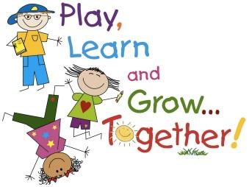
What is play and why is play important?
- Play is one of the foundation building blocks for language development.
- Play allows children to learn about the world and to make sense of it. Children learn through enjoyment, having fun and interacting with the world around them.
- Play enables children to learn about and experiment with speech, language and social skills as they learn to interact with their peers.

Strategies to try when playing with the child:
- Think about the impact of the environment. Try to limit the number of distractions by reducing the amount of toys you have out at one time, don’t leave the TV/music on in the background if it’s not part of the play.
- Try and get down on the floor with the child or to their level, so that you can be face-to-face for the activity.
- Watch what interests the child and join in. Don’t worry if the child doesn’t want to do what you had planned.
- Praise and recognise all attempts on the child’s part e.g. “good building”, “good drawing”, “good lining up”
- Don’t ask too many questions. Instead, comment on what the child is doing rather than interrupting their play by asking questions e.g. ‘dolly’s having a drink’ NOT ‘what is dolly doing?’
- Play alongside the child. Copy what they do, this will show the child that you are interested in what they are doing. Your child may start to include you in their play. Don’t try to lead the play or force the child to do something different.
- After some time copying the child, you can start to suggest new ideas to extend their play further e.g. the child is pushing a train up and down; the adult gets another train and makes this go through the tunnel. The child is more likely to copy if they don’t feel forced to change what they are happy doing.
Remember!

All play is okay! Toys are not essential for play. Play is a form of communication. Toys can be used to extend and develop this communication. Many types of play involve no toys; for example, people games – songs, action and finger rhymes, or hide and seek. Real objects are also fun - a wooden spoon and saucepan lids make a great instrument.

Special Time
What is special time?
‘Special time’ is a time for you and a child to play together in addition to the times you already have,
and not instead of. It is a time for you to help your child develop their speech and language skills through play. Special time is a time where all distractions are minimised, and the adult focuses on playing with the child with 6 specific strategies focused on the interaction between the child an adult. You must let the child leas the play, show an interest in what they are doing and model communication for the 5 minutes.

What do I need to do?
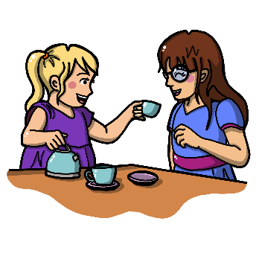
The strategies implemented in special time are:
- Be on the child’s level/ face to face.
- Follow the child’s lead in play.
- Observe, Wait, Listen (OWL).
- Use more comments than questions.
- Copy the child’s actions and sounds during play.
- Use short, simple sentences (appropriate for child’s understanding).
Before you start:
- Allow the child to select the activity, toy or game e.g. cars, dolls, puzzles. Note, this should not be reading a book, watching TV or playing a lively outdoor game as these types of activity can be difficult to practice language strategies.

During special time:
- ‘Special time’ lasts for 5 minutes only and should not be extended.
- When the child has chosen what to do, go to a room or space where you will not be disturbed.
- Remove any obvious distractions such as radio or TV.
- The adult should follow the child’s lead, commenting on what they are doing with short simple sentences and adding ideas to their play where appropriate.
- Play for five minutes, giving the child your undivided attention.

When you have finished:
- At the end of the special time make it clear to the child that ‘special time is finished’.
- The child can carry on playing if they wish, however this is no longer ‘special time’.

How often do I do ‘special time’?
- Try to do at least four ‘special times’ a week. Don’t do more than 6 in a week. Don’t try doing more than one a day.
- It is important to keep to only 5 minutes because it makes it more achievable for you to have the ‘special time’ more often. If you spend a long time on it, you are more likely to miss a day when you are busy.





Sensory Play

What is sensory play?
Sensory play is any activity that stimulates at least one of your child’s senses. This could be hearing, sight, touch, smell, or taste. It also includes play that involves movement or balance.
You might have experience of sensory play using play dough, cold pasta or making a sensory box. But sensory play can be a lot simpler than that.


Children have unique sensory profiles. Understanding and supporting a child's sensory needs is crucial in fostering a positive learning environment in preschool. Every child experiences and processes the world differently. For some children, sensory stimuli can be either overwhelming or insufficient. Recognising these unique sensory profiles allows us to create inclusive, supportive spaces where all children can thrive. A child may be hypersensitive, hyposensitive, or both! Hypersensitivity, known as over-responsiveness, is when a person experiences stimuli more intense than others. They may avoid or become distressed by sensory stimuli others find tolerable. Whereas hyposensitivity, under-responsiveness, is where a person has a reduced or underwhelming response to stimuli, they may seek out more intense sensory experiences because they don’t feel sensory stimuli as strongly. Understanding whether a child is hypersensitive or hyposensitive in various sensory areas helps in creating an environment and activities that support their sensory needs effectively.
Activities to encourage sensory play
Sensory play is not just about fun; it’s a vital tool that helps children explore and understand their senses in a safe and controlled way. By integrating sensory play tailored to individual needs, we empower children to regulate their emotions, enhance their learning, and build the confidence to engage with the world around them in their own unique way.

Next is a table of activity ideas for sensory play. Always tailor activities to the specific child, as we know, each child has different sensory experiences and preferences. Observe for cues that indicate whether a child is becoming overwhelmed or is enjoying an activity. Adjust activities based on your observations of their response.

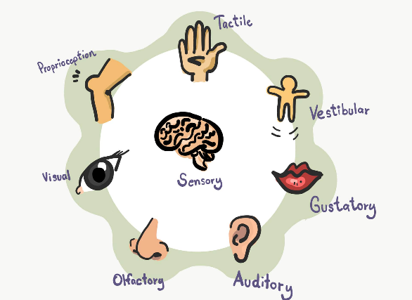



Senses |  | Activity Ideas
Visual | Sight | Colour sorting – Provide different coloured objects (block, cars, pomp-pom etc) and sort by colours  Mirror play – making faces, peekaboo with blankets  Shadow play – use a torch to create shadows in the wall with body parts and objects
Auditory | Hearing | Musical instruments – exploring different instruments and everyday items to make noise! Introduce concepts like quiet/soft or loud noises, monitoring what the child is comfortable with  Sound matching games – clap, use different instruments, or containers of different items (rice, beans, coins) and encourage the child to match the patterns  Listening walk – explore outside areas and encourage the child to identify the different sounds
Tactile | Touch | Playdough Fun - Encourage the child to mold, roll, and squish playdough to develop their sense of touch.  Textured Sensory Bins - Fill bins with different textures and weights of items like rice, sand, or water beads, heavy blankets and let the child explore them with their hands.  Feather Play - Use soft feathers to lightly brush against the child's hands, arms, or face, talking about how it feels.
Olfactory | Smell | Scented Playdough - Make or buy playdough that has been scented with essential oils like lavender or lemon.  Baking Together - Involve the child in baking activities where they can smell ingredients like cinnamon, vanilla, or chocolate. Introduce scents slowly.  Smell Matching Game - Use small jars filled with different scents (e.g. coffee, soap, lavender, vanilla, lemon) and match them.
Gustatory | Taste | Taste Testing – provide small samples of different tastes at snack time. Introduce something new, alongside something safe and familiar. Remember not to pressure any child to try foods.  Make Your Own Snack – involve children in snack preparation, such a fruit salad or sandwiches – let them taste as they go.  Flavoured Ice Cubes – freeze different flavoured juice, or purees and let the child taste different flavours as they melt.
Vestibular | Balance and Movement | Swinging - Allow the child to swing in a playground or a hammock, focusing on the movement back and forth.  Obstacle Course - Set up a simple obstacle course where the child has opportunities to crawl, jump, bounce, rock or balance on different surfaces.  Spinning Games - Play gentle spinning games where the child can spin in circles and then try to regain balance.
Proprioceptive | Body Awareness | Pushing/Pulling Activities: Encourage activities where the child can push or pull objects like a pram, wheelbarrow, or large blocks.  Animal Walks: Have the child imitate different animals, like walking on all fours like a bear or hopping like a frog, to develop body awareness.  Heavy Work Play: Provide opportunities for the child to climb on soft play equipment, carry or move heavy objects (like a weighted backpack or a box filled with toys).


Exploratory play

What is exploratory play?
Exploratory play is a type of play where children actively engage with objects materials or their environment to learn through discovery. It involves using their senses to investigate and understand how things work. In exploratory play children experiment with different actions such as banging, stacking, dumping, throwing, mouthing, spinning, inspecting or sorting without a predetermined goal or outcome. This form of play encourages curiosity cognitive development and problem-solving skills. It is a key way children make sense of the world around them and build foundational knowledge.

Activity ideas to encourage exploratory play:
- What’s in The Bag?
Collect items such as: spoons, shiny paper, ribbons, bricks, empty pots. Put the materials in boxes or drawstring bags and take out one at a time to explore. Crumple up the bits of paper to make interesting noises.
- Put-in activities
Make a range of containers and small items available for children to fill and empty. You could use clear containers and small blocks, DIY tissue/shoe boxes and small cars, or long tubes as well as toys like piggy banks!
- Pull-out activities
Pulling reusable napkins out of a tissue box, items out of a bag/pillow case, or pom poms out of inside a whisk!
- Ball Games
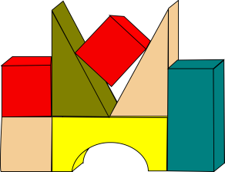
Rolling back and forth, throwing/kicking the ball to another person.
- Construction Toys
Stacking bricks, toys or beakers. Putting in and taking out of boxes – small objects and containers.

Noisy Toys
Introduce some interesting noisy toys such as mobiles, chime toys, rolling balls with bells in. Boxes, pans, and spoons make great drums.

Hiding Games
Wave a scarf up and down over the child, so that the child can feel the breeze. Lift it high and let it fall over your head. Encourage the child to pull it off your head. Cover a toy with the scarf and encourage the child to pull it off.

Sand Pits and Water Trays
Let the child explore the different textures with their hands. Introduce different containers, sieves and pouring jugs and encourage them to fill and empty them.
- Messy Play
Painting with hands, fingers, and feet; or large wax crayons for mark making.


For further ideas check out the video below.

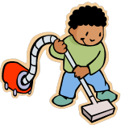
Relational and Self-Pretend Play

What is relational play?
Relational play involves children interacting with objects or toys in ways that demonstrate an understanding of how they relate to one another. For example, a child might place a cup on a saucer or stack blocks in a specific order. This type of play helps children explore cause-and-effect relationships and develop problem-solving skills. It is often seen as a precursor to more complex pretend play as children learn the function and connection of different objects. Relational play supports cognitive development and fine motor skills.
What is self-pretend play?
Self-pretend play occurs when a child pretends to engage in actions typically associated with themselves, such as pretending to sleep, eat, or brush their hair. This type of play reflects a child’s understanding of daily routines and helps them explore their sense of self. It is an early form of symbolic play, allowing children to practice and reinforce familiar actions. Self-pretend play helps build communication and social-emotional skills, as it involves taking on roles and understanding their own actions in a playful context.
Activity ideas to encourage relational and pretend play:
- Use the child’s interests!
Provide several, similar items according to the child’s interests and allow children opportunities to explore these in relation to each other, e.g. if interested in building, use blocks, nesting cups and carboard boxes.

Everyday objects

Use everyday objects to simulate everyday activities to pretend with e.g. an empty cup, brush or flannel. Model carrying out actions such as pretending to have a drink, brushing your hair, brushing teeth, drying hands. Offer the items to the child, don’t pressure them to copy you. Make silly mistakes, pretend to brush the dolls hair with a spoon, then Observe Wait and Listen to how the child responds.

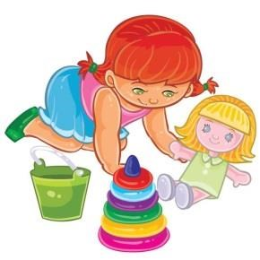
Dress-up corner
Create a space with costumes and props where children can explore different roles, like a chef, superhero, fireman etc. Children may act out scenes from TV shows, or books before they have the skills to independently develop imaginative scenarios.
- Miniature play sets
Use small figures and playsets, like farms and houses, that children can use to act out familiar stories, or create their own. Try to include the child’s interests e.g. Peppa Pig, Bluey etc. Model different actions with the characters.

Putting it into practice:
- Encourage the child to help you with everyday activities.
- Show the child an action, WAIT and OBSERVE to see if they will imitate you.
- Hand under hand support e.g. encourage the child to put their hand on yours while you carry out the activity, e.g. pouring the tea pot into the tea cup. Reduce these prompts as soon as possible.
- Backward chaining; adult models all of the sequence and encourages the child to complete the last action, slowly encouraging the child to take on more and more of the sequence independently.
- Repetition of familiar actions in different places and with different toys.

Social Interaction

Interaction

Useful Strategies for developing Social Interaction

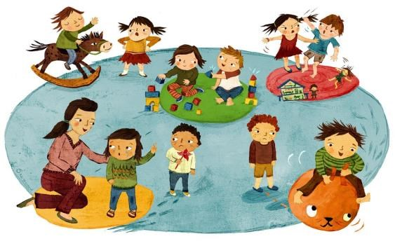

What is interaction and why is interaction important?

Interaction is a vital part of communication. For communication to work it needs to be a two-way interactive process, but for some children, this interaction is difficult. Remember the double empathy problem, covered in Booklet 1.

- Children do not need to talk in order to share experiences and interact with others, they use early non-verbal interaction skills e.g. facial expressions, gestures, hand leading.
- Interaction skills develop from a very young age e.g. making vocalisations in response to a care giver.
- Children learn language and social rules by copying what they see and hear.

Strategies to try when interacting with the child:
- Try and get down on the floor with the child or to their level so that you can be face-to-face with the child.
- Follow their lead, don’t put lots of demands or expect a child to come to what interests you – follow their lead instead to make yourself more interesting to them
- Model the behaviour you are expecting, with expectation from the child such as spoken language, pointing, waving good bye etc. Do not put pressure on a child to copy.
- Don’t ask lots of questions. Again, avoid putting pressure on the child to interact. With less pressure they are more likely to interact with you. Make comments on what they are doing/are interested in instead.
For more on the importance of interaction,
watch the videos below


Intensive interaction

What is Intensive Interaction?
Intensive Interaction is an approach that works on early interaction abilities. The strategy is designed to help children who are in the early stages of developing communication and social skills. It’s about watching closely how a child responds to different situations through their body language, voice and facial expressions – and responding to this. It is a fun approach that follows the child’s lead. It’s individual and focuses on the interaction that the child can already do. The aims are to support understanding and enjoyment in interacting with others.

What do I need to do?
- Copy the sounds, movements and faces the child makes. Get down and position yourself at their eye-level. If they are sitting, sit opposite them, if they are lying down, lay next to them.
- Let them lead – be completely attentive to the child, wait for them to start the interaction. Don’t rush, make the experience relaxed and enjoyable. If the child has an item, get a similar one, avoiding sharing one item.
- Look for changes to the child’s voice, gaze, body movements or body language such as:
  - Vocalisations
  - Other noise made with the mouth (e.g. blowing, tongue waggling).
  - Other noises (e.g. tapping parts of the body, slapping or tapping furniture or walls, foot tapping or stamping, clapping or hand rubbing).
  - Movements (e.g. hand movements, rocking, swaying, movements of the legs and feet, head bobbing, reaching out).
  - Facial expression changes.
  - Physical contacts (e.g. pats, taps, reaching to hold you).
- Respond instantly to the child. Copy them, make a comment “that’s a good noise”, smile. For example, they might flick their fingers in a certain way, but if you respond to this by imitating them then this has become a form of communication.
- Pause and wait for the child to interact with you, before you join in again – let them lead.
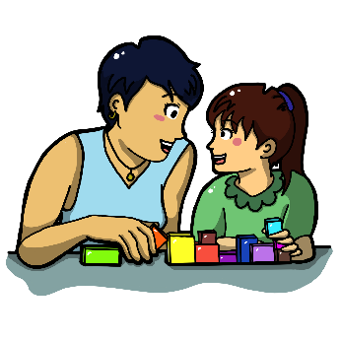
- Continue until the child signals they have had enough.
Use this strategy regularly to build up shared knowledge of things that you and the chid do together. When repeating familiar interactions, new things happen! The child may experiment, to which you can extend the interaction. As you start to notice the child becoming more aware of you joining in with them, change the way you respond to extend the interaction and see if they respond to this e.g. you could vary your vocalisation, you could do something different with the toys your might have been playing with.

Putting it into practice
- Choose a time to play without distraction. Be relaxed and take time to enjoy sharing this space with the child

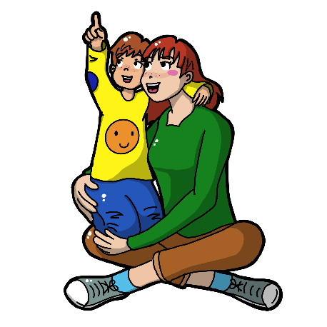
- If your child shows no interest in toys make yourself exciting – you don’t need toys!
- Respond instantly to signals of negativity – If you feel the child is not enjoying what you are doing or moves away or reacts negatively, interpret this communication and respond to it appropriately. Perhaps you were too close to them, or they need a break from the Intensive Interaction.

- If the child doesn’t appear to respond- Try doing less of everything. Respond with less behaviour (reduce the noise, excitement or intensity). Go back to a ‘quiet’ period, spending time sharing space to help the child to become more comfortable.

- If the child is highly active- Join in with them and move around with them in order to create shared activities.

- If the child is interested for a short amount of time- Try doing less, you may be putting too much into the interaction.

- If the child keeps moving away. The child may not be ready to take part in interactions yet, may need to share space and time instead to build a sense of security. Increase the distance between you and the child.

Play ideas and toys
When a child is familiar with Intensive Interaction, they may be ready for you to introduce some games or toys to extend the interaction. Always follow the child’s interests, some ideas you could try include:
- Play tickle games with loud with loud noises and see if the child anticipates the tickle.
- Blow raspberries on their cheeks, clap their hands and rub their hair.
- Place toys listed below around the floor and let the child explore, when something has their attention join in by copying what the child is doing.
- Toys like water mats, instruments, shiny objects, wind up, pop up and light up if they are motivating for the child.



Offering choices

What is offering choices?
Often as adults, we are prepared and able to interpret child’s needs. However, this takes away the need for a child to communicate. Offering choices is an easy way to create situations for the child to need to communicate. It not only encourages them to express preferences, which develops their communication skills but also fosters a sense of independence, motivating them to engage more actively in interactions.

What do I need to do?
Start with offering a choice of two using objects, you can then introduce photographs. As you ask “orange or grapes?” hold out each item, pause and wait for the child to look, reach or label the one they want. If the child does not respond, repeat the choice.
If the child reaches for both items, release and name the item you think they would prefer. If the child persists with reaching for both, offer them one you think they would prefer and say ‘First grapes and then banana’.

Some children can find it tricky to choose between two preferred items. If this is the case, start by offering a preferred and non-preferred item e.g. one snack and a plain piece of paper or a tissue “grapes or tissue?”. Again, pause and wait, allowing the child at least 8 seconds to decide and show a response.

Activity ideas
There are limitless opportunities to offer a child choices throughout the day, in the routine at home and in settings. Some examples that can be used across the day include:
- Mealtimes e.g. cereal or toast, triangle toast or rectangle toast, butter or jam, plate or bowl, milk/juice or water, desert or play time, snack or drink
- Clothing e.g. offering different items to wear, offering dress up items, offering a coat to go outside to play
- Activities e.g. pencil or crayon, white paper or coloured paper books or blocks, nursery rhymes or pop music, sit down or stand up, choices of books, ducks in the bath or letters in the bath
- Outdoors e.g. different equipment such as balls, bikes, skipping ropes or areas sand pit or climbing frame

Putting it into practice
- Don’t offer a child a choice if you aren’t able to honour it, only offer them choices you will follow through.
- Reinforce by actioning the choice as soon as possible.
- Remember to offer preferred and non-preferred items at first if a child is still working on their decision-making skills.
- If a child makes a choice that surprises you, choosing a non-preferred item, you may want to check again then honour this and follow through by giving them the non-preferred snack/toy etc. It’s important to not give the other object, even if would usually choose this as we are teaching them their communication is meaningful!
For further ideas, check out the video below


Gesture and Pointing





Some children find understanding and using non-verbal communication, like pointing and gestures, more difficult. Gestures and communication go hand-in-hand. Gestures will provide a child with a way to express themselves before they are able to use verbal language. They also act as visual supports to support a child’s understanding. By using gestures and pointing yourself, this encourages the child to use gestures, promoting their overall communication development.


Activity ideas to encourage use of pointing and gestures:
- Offering choices
Model pointing when you offer choices with objects or photos.

Nursery Rhymes

Sing nursery rhymes with the child, one’s that have actions e.g. Wind the bobbin up; the wheels on the bus, twinkle twinkle little star, if your happy and you know it etc.
- Routine songs
Support the child to wave ‘goodbye’ or ‘hello’ in a familiar song.

Putting it into practice :
- Make gestures part of your everyday interactions. No special time or place is needed to use gestures. Using simple gestures when you talk with the child throughout the day will help to build their communication skills.
- Use a range of gestures, description e.g. acting out an action brushing teeth, information e.g.
holding three fingers up to indicate ‘3’, social e.g. thumbs up for ‘good job’, holding your hands in the shape of a ball while you say “ball” or doing a throwing action while you say “ball” are helpful gestures.
- Be sure to use the gesture and the word at the same time – This helps reinforce the meaning of the word for the child.
- When the child uses a gesture, acknowledge it by copying it and saying the word that matches the gesture.




