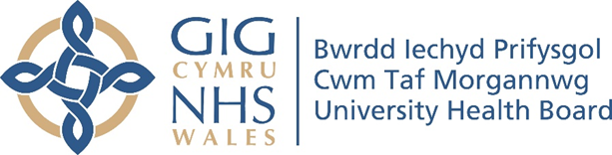

RESEARCH & DEVELOPMENT CONFERENCE 2024
POSTER PRESENTATION : 9
Are we nearly there yet? An All Wales Stroke Swallow Screen

Author/s: Curtis, S¹., Bruton, C².

Department: ¹Speech & Language Therapy, Cwm Taf Morgannwg University Health Board. ² Speech & Language Therapy, Aneurin Bevan University Health Board

Introduction:
There is an appetite within Welsh Speech and Language Therapy (SLT) services to move towards one single swallow screen for use across all health boards in Wales for patients admitted on the acute stroke pathway. There is a need to ensure the selected tool has a wide evidence base. The Yale Swallow Screen (Leder & Suiter, 2014) tool has good reusability across disciplines. A separate study in 2014 study found good (98.01%) inter rater agreement amongst SLTs and RGNs performing the Yale screen. C&V, AB and CTM UHBs have switched to adoption of the Yale over recent years. As an All Wales team of collaborating SLTs, we are now in the process of developing ONE ESR training module and a single practical training package for replicable use across all health boards in Wales

Aim:
The aim is for all 6 health boards in Wales who take acute stroke admissions to adopt the same swallow screening tool (which needs to be completed within 4hrs of hospital admission). All relevant CNS, Stroke, ED and AMU staff should be trained by SLT to carry out the Yale Swallow screen. Some health boards (e.g. CTM) may adopt a train the trainer model.

Methodology:
All 6 health boards met collaboratively in March to review the training packages and the pathways for training/administrating the Yale swallow screen across the 3 existing health boards. The 3 outstanding SLT health board teams have agreed to initiate negotiations with their key stakeholders once the amalgamated ESR module and training package is ready for circulation. CTM & AB SLT worked with the Digital & Workforce Productivity Team to finalise the All Wales ESR training module. The training protocol and resources have been updated and circulated within SLT.

Results:
SLT shared the outcome of this project at the Welsh Stroke Conference in June and demonstrated the live All Wales ESR tool and training package. It will be replaced immediately as the new tool for the 3 health boards already aligned to using the Yale. The other 3 health boards will start their journey of change. We are meeting in November 2024 to discuss progress with each of the 6 health boards.

Conclusion:
Having a single swallow screen across Wales has been an ambition strived for over many years.
We feel optimistic that we are now on the final path to achieving this. This consistency of practise will benefit both staff and patients moving across different health boards in Wales through their stroke pathway/s or their professional roles. The Yale is highly sensitive so the likelihood of successfully identifying patients who are at risk of aspiration is high. This has implications for cost savings through avoidance of (silent) aspiration and pneumonia that can prolong admission and complications to health. This project is an excellent example of SLT All Wales collaboration in action.

