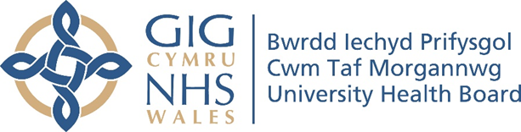

RESEARCH & DEVELOPMENT CONFERENCE 2024
POSTER PRESENTATION : 44
The Impact of PIPYN on Changing Family’s Health Behaviors in Merthyr Tydfil.

Author/s: Collings, J.
Department: Public Health Dietetics, Cwm Taf Morgannwg University Health Board

Introduction:
Pipyn is a Welsh Government funded pilot, testing a range of approaches for working more effectively with families with children in the early years to support healthy weights. PIPYN intends to affect a system change that contributes towards a reduction in prevalence of obesity in children. PIPYN is a collaborative programme between Public Health Wales, Welsh Government, and the Directors of Public Health in three pilot areas Anglesey, Cardiff and Merthyr. The PIPYN intervention works with families of children in the early years from 3 -7 years of age and covers a wide range of healthy behaviour topics, tailored to family’s needs.
Aim:
To identify whether the PIPYN intervention changes families health behaviours
Methodology:
Ran a group intervention for families which tested a wide range of approaches including; providing tailored support to each family and working collaboratively with partners to embed systems working as part of the intervention. Families who attended the PIPYN intervention completed a post evaluation questionnaire via Microsoft forms. The questionnaire explored family’s confidence, knowledge, skills and lifestyle behaviours pre and post PIPYN.
Results:
464 places taken up in a 12 month period (284 children and 180 adults), 68% retention over 8 weeks. There was high percentage behaviour change seen from pre intervention to post intervention. Results have shown that there has been a reduction in excessive screen time use (4+ hours per day) as well as a reduction in sugary drinks and eating out. Results have shown an increase in families cooking with fresh ingredients, eating fruit and vegetables and being active.

Conclusion:
Around one in four of 4-5 year olds start school each year overweight or obese. In line with the Healthy weight, healthy Wales strategy, PIPYN has been designed with families at the centre, and is tailored to their needs. PIPYN is both engaging and enjoyable for families and encourages healthy behaviours. PIPYN delivers a whole system approach with a range of partners all playing a part. PIPYN has showed positive initial outcomes, and consideration should given to whether a programme such as this could be used widely in Wales as part the weight management pathway

