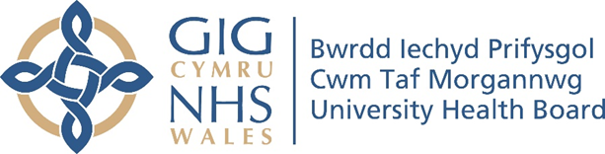

RESEARCH & DEVELOPMENT CONFERENCE 2024
POSTER PRESENTATION : 43
A Service Evaluation of Formulation-consultation in a Secondary Care Mental Health Team
Author/s: Jones, T., Morris, S.
Department: Psychology department, Cwm Taf Morgannwg University Health Board

Introduction:
Team formulation supports teams in developing a shared holistic understanding of a SU’s difficulties and support plan (Johnson & Dallos, 2013). Implementation of the plan often needs to be followed up (Kramarez et al., 2022), with psychologists reporting that formulations are a meaningful use of time if plans are implemented (Wood, 2016). The psychologist can offer consultation sessions to address non-implementation and psychological mindedness within teams to further reduce pressure on psychological practitioners.
Aim:
The project aimed to:-
- Evaluate if the initiative is a resourceful way to allocate psychologists’ time.
- Inform the psychologist on the staff’s experiences of team formulation and consultation sessions and its effect on relational factors.
- Identify if team formulation and consultation sessions increase staff & psychologists' job satisfaction, and increase positive service user experiences & satisfaction.
Methodology:
Self-report questionnaires with Likert scales and open-ended questions, developed internally as guided by the Team Formulation Quality Rating Scale (Hollingworth & Johnson, 2014), were utilised. A mixed methodology was used, with descriptive statistics and qualitative summaries presented.
Results:
The data corroborated previous research findings on formulation with consultation sessions, potentially enhancing its impact on interdisciplinary working, psychological mindfulness, and SU experience. Staff and psychologists reported that service use engagement was the most significant barrier impacting psychologically informed working. The SU reported an overall positive experience with acknowledgements towards barriers to engagement.
Conclusion:
The preliminary quantitative and qualitative findings suggest that a formulation-consultation model is a resourceful, effective, and positive way of working. The richness of the data has been considered in terms of its impact on the reliability and validity of findings. The need for further evaluation with the possible improvement of the qualitative methodology was also considered.

