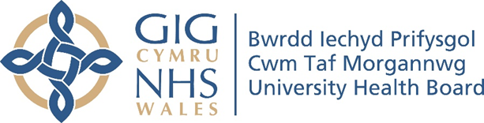

RESEARCH & DEVELOPMENT CONFERENCE 2024
POSTER PRESENTATION : 41
Reducing Falls Across Older Person Mental Health NHS Wards using a Collaborative Approach.

Author/s: Macchiavello, D¹., Basset, S²., Humphreys, C².
Department: ¹Patient Care & Safety, Cwm Taf Morgannwg University Health Board. ²Older Adult Mental Health, Cwm Taf Morgannwg University Health Board

Introduction:
As well as the individual impact, falls in older adults represent a substantial burden to the NHS. Falls in hospital inpatients are common, with reported rates ranging from 3 to 14 per 1,000 bed days in observational and intervention studies. Inpatient falls are one of the most frequently reported incidents in CTM UHB.
Aim:
The aim of the collaborative was to reduce the incidence of in-patient falls rate per 1,000 bed days within five Older Adults Mental Health Wards in CTM UHB and to support the reliable implementation of evidence-based multifactorial falls prevention assessments and interventions delivered as a care bundle

Methodology:
The Falls Collaborative was structured around 5 learning sessions with action periods between each session. Each ward participating was formed by a multidisciplinary team of people who were part of the daily work on the wards for falls prevention. Local teams were tasked with implementing specific changes to standardise the care provided for falls prevention based on the agreed actions on each learning session, and regularly measure its implementation using the AMat tool developed, this ensure the continous and shared learning through the use of PDSA cycles.

Results:
Although the collaborative didn’t evidence a reduction in falls, it was evident a stabilization of the falls prevention process with more data points gathering around the median (falls rates were significantly different before the collaborative and the 5 wards started to report similar values after). Two participating wards did in fact evidence a reduction in the number of falls reported before and after (ward 1 and ward 3). There was an astronomical point (a point outside the process control limits) in October 2023, which was related to shortage in staffing levels across the 5 sites.
Moreover, the care bundle for falls prevention was measured before and after, and the five participating wards were successful in implementing all the relevant process measures.

Conclusion:
The falls collaborative project has resulted in substantial improvements in care, including an increase of patients receiving lying and standing blood pressure assessment, medication review and delirium assessments. Whilst reported falls rates stayed the same for the five wards, when each ward individually was factored in, we saw a reduction in two wards and estimated that the increase in falls for the remaining of three wards was related to a previous state of underreporting, considering the numbers stayed leveled throughout the collaborative.

