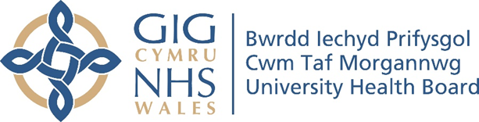

RESEARCH & DEVELOPMENT CONFERENCE 2024
POSTER PRESENTATION : 34
Should we call you Mam and Dad?

Author/s: Walsh, N¹., Al-Muzaffar, I².
Department: ¹School of Medicine, Cardiff University. ²Child Health, Cwm Taf Morgannwg University Health Board

Introduction:
Parents are central to the care of their children. Forming and maintaining relationships with parents is a maker of good practice. The way that parents/caregivers are called facilitates building rapport and maintaining trust necessary for a successful relationship.
Aim:
The aim of the project was to evaluate the preference of parents and carers of babies who received care at Prince Charles Hospital neonatal unit on how they were called by healthcare professionals.

Methodology:
We designed a survey to evaluate parents/caregivers’ greeting preference and perceptions of how doctors and nurses called them. The 11-item Microsoft Forms survey consisted of multiple choice, Likert scale and demographic measures. The survey was conducted from 27th of May to 14th of June 2024.

Results:
24 responses were received. 28% of parents reported that it is important/very important for them that healthcare professionals ask how they would like to be called. 79% of parents expressed preference to be called Mam or Dad. 83% of parents stated that the name they were called by the most was Mam or Dad. Those who preferred to be called by name expressed preference to be called by their first name rather than surname. 29% of parents reported that they were always called by their preferred name by doctors and 37% by nurses.

Conclusion:
Most parents prefer to be called Mam or Dad. Parents reported that doctors and nurses were inconsistent in following parents’ greeting preference. We recommend that healthcare professionals ask parents how they would like to be called and ensure consistent practice.

