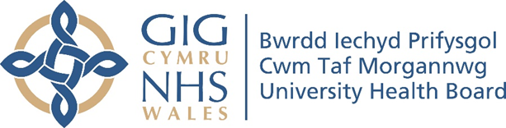

RESEARCH & DEVELOPMENT CONFERENCE 2024
POSTER PRESENTATION : 27
Setting up a Dietetic Specialist Oncology Clinic

Author/s: Hoidge Hughes, S., Richards, S.
Department: Nutrition and Dietetics, Cwm Taf Morgannwg University Health Board

Introduction:
It is known that nutritional status improves tolerance to treatment, outcome, quality of life and reduces length of stay in oncology patients. Specialist Oncology Dietitians are experts at guiding patients and care givers through nutritional process maximising nutritional status in cancer patients.

Aim:
The aim is to offer oncology patients requiring nutrition support access to a Specialist Oncology Clinic (SOC) in <4 weeks from triage with the option of face to face (F2F), attend anywhere (AA) or virtual telephone clinic with a Specialist Oncology Dietitian.

Methodology:
Oncology patients who were referred into core dietetics for nutrition support advice, are triaged into the SOC. A clinic room was secured across 4 sites, providing equitable patient centred care, enabling F2F consultations weekly. Due to the fast nature of these clinics, patients are telephoned and booked into the next available clinic slot as a letter may not arrive in time. Outcome measures were collected including Strength, Assistance walking, Rising from chair, Climbing stairs, and falls (SARC-F), Malnutrition Universal Screening Tool (MUST) and percentage weight loss to screen for malnutrition and sarcopenia risk.

Results:
With the first 6 months, 42 patients were seen in the SOC with an average of 4 patients per week. The majority of the patients were gynaecological, with upper gastrointestinal, lung and colorectal cancers closely behind. 45% of referrals came from cancer nurse specialists (CNS), 26% from general practitioners (GPs), 26% Dietitians, 3% consultants. 81% of patients scored a MUST of ≥1 which indicates a medium risk of malnutrition, with 62% of these scoring ≥2 indicating a high risk of malnutrition. 25% of patients scored 4 or above on the SARC-F screening tool, indicating a high risk of sarcopenia. 71% of patients had experienced over 5% weight loss which is classed as significant with an average weight loss of 11.7%.

Conclusion:
The data has shown that overall, 26% of the patients seen in the SOC were at high risk of sarcopenia and 81% were at medium to high risk of malnutrition. Therefore, it is important that these patients are seen for nutritional intervention promptly to maximise their nutritional status and improve their outcomes. The SOC has a much shorter waiting time than our general clinics, with an average of 9 days.

