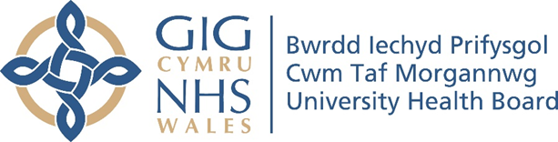

RESEARCH & DEVELOPMENT CONFERENCE 2024
POSTER PRESENTATION : 23
Emergency Cancer Diagnoses - Impact on Healthcare Staff. Initial Analysis

Author/s: Wingfield, K¹., Fry, S²., Kelly, D².
Department: ¹Acute Oncology, Cwm Taf Morgannwg University Health Board. ²School of Healthcare Sciences, Cardiff University.

Introduction:
There is no unified clear definition or terminology available to define patients presenting with cancer as an emergency, and a scoping review conducted in 2022 identified research gaps in both the impact of the diagnosis on patients and Healthcare Professionals (HCPs). These research gaps are: - a dearth of UK based studies; a lack of research on the experience and impact on HCPs of working with patients who have received an emergency cancer diagnosis. Research into understanding the HCPs and ancillary health care workers experiences is needed to inform the patient emergency diagnostic cancer pathway and the future development of Acute Oncology Services (AOS). This study will focus on the impact on a range of District General Hospital (DGH) healthcare staff who are involved with patients with emergency cancer diagnoses.
Aim:
- To develop an in-depth understanding of healthcare staff experiences working with patients diagnosed with cancer in emergency settings.
- To inform and contribute to the future development of AOS and the patient emergency diagnostic cancer pathway.

Methodology:
A qualitative narrative inquiry methodological approach and emotional labour theory are being used to undertake this study. The study is set in two contrasting University Health Boards (UHBs) in Wales. UHB A has three acute hospitals with Emergency Departments (ED) and Same Day Emergency Care Units (SDECs) whereas UHB B has ED, SDEC and Medical Emergency Assessment Units across two acute hospital sites. Prior to this research a pilot study was based in one of UHB A's hospitals. This hospital has been excluded from the study. Based on findings from the pilot study, a sampling framework has been used to confirm the sample population that this study will target (Trochim 2022). Individual, single informal recorded interviews (F2F or online) using a conversation guide have been held which are being transcribed verbatim. Data collection has been completed with 13 participants -five doctors, seven registered nurses and one Physician’s Associate (PA).
Results:
A rich pool of data was collected from the 13 participants with a range of experiences of working with this cohort of patients. Initial narrative analysis highlights these preliminary themes: -
- Preparing for a serious conversation.
- ‘Passing the baton.’
- Learning to manage myself.
- How can I do this better?
- Impact of my own cancer experience or loved ones on my job.
Ongoing data analysis will clarify the themes.
Conclusion:
Participants described preparing themselves mentally, physically and logistically to break bad news, the benefit of self-care with exercise and having supportive partners at home, especially those who also worked in frontline services. Being involved with a patient from their first interaction in the emergency setting, developing a rapport and management plan was easier than becoming involved with a case when investigations had started. Having a ‘follow up watch list’ on NHS electronic clinical systems was helpful to some participants to learn what happens to their patients when they were referred onto other medical teams, others did not find this helpful. Participants were keen for communication training around breaking bad news.

