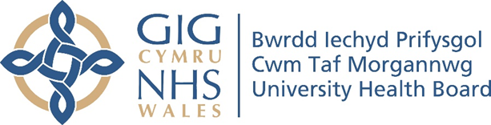

RESEARCH & DEVELOPMENT CONFERENCE 2024
POSTER PRESENTATION : 18
Evaluation of On-Call Training Redesign- Pilot
Author/s: Anderson, D., Murphy, A., Thomas, C.
Department: Therapies, Cwm Taf Morgannwg University Health Board

Introduction:
The current on-call recruitment strategy within CTM has highlighted issues such as delays in upskilling Band 5 staff, infrequent recruitment cycles, and risks of unstable rota staffing levels. Subsequent benchmarking against other trust services identified areas for change.
Aim:
This study aimed to develop and evaluate a fast-track training programme to expedite staff onboarding, enhance readiness for on-call duties, and improve service quality. The objectives were to assess the programme’s impact on staff competence and confidence and to determine potential cost savings compared to the traditional rotational training route.

Methodology:
The fast-track programme comprised self-directed e-learning, three days of face-to-face (F2F) training, and five mandatory clinical sessions on acute sites. Metrics for evaluation included the percentage of staff achieving competency thresholds, the number of new joiners, staff confidence and wellbeing, and financial implications.

Results:
Confidence and competence improved significantly after the F2F training, though delays between training and rota participation did not reduce stress or anxiety significantly. Six of seven trainees achieved competency, increasing annual rota joiners to 19, compared to 12 with the traditional approach. Feedback highlighted the need for more clinical simulations and better buddy system communication, as some trainees were unsure how to contact their assigned buddy. Financially, the fast-track programme showed cost savings by reducing reliance on senior staff for on-call duties.

Conclusion:
The fast-track programme effectively upskilled Band 5 staff and increased rota recruitment. Future improvements should include spreading training days, enhancing the buddy system, and optimising clinical session scheduling. Overall, the programme offers a cost-effective and efficient solution for improving rota staffing and care quality while accelerating staff career progression

