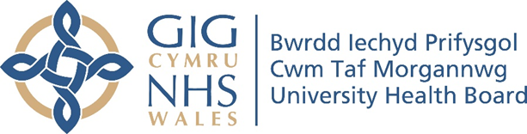

RESEARCH & DEVELOPMENT CONFERENCE 2024
POSTER PRESENTATION : 16
Taking a Population Health Management Approach to the Referral of Meddygfa Glan Cynon Patients With an Electronic Frality Index to the Community Health and Wellbeing Team

Author/s: Roberts, S., Slyne, C., Matthews, M., Morgan, N.
Department: Public Health, Cwm Taf Morgannwg University Health Board

Introduction:
Frailty is associated with adverse health outcomes and increased healthcare costs. A number of demographic, clinical, lifestyle and biological risk factors are recognised in the onset or progression of frailty (Hoogendijk et al, 2019). Further, the winter months can impact frailty; older adults with frailty have a lower capacity to cope with seasonal variations. (Dent et al, 2020). Population Health Management (PHM) can support with understanding patient populations, their need and use of health care resources to improve population health. Enabling PHM tools, such as Segmentation of frailty across the population to support effective care.
Aim:
This project sought to use a Population Health Management approach to identify and support those most at risk of exacerbation of frailty. The aims of the project were:
1) Lessen burden of frailty felt by patients by improving opportunities for preventative care closer to home.
2) Test feasibility and acceptability of using current Population Segmentation data to inform the referral of patients living with frailty to Community Health and Wellbeing Teams.
3) Understand the impact on system pressures in this cohort within Primary Care as a result of this project.

Methodology:
The Population Health Management Unit worked closely with Meddygfa Glan Cynon Surgery and the pre-existing Community Health and Wellbeing Team to develop this project and identify and contact at-risk patients. Patients were triaged by the GP lead of the Community Health and Wellbeing Team, care discussed through a “What Matters” based conversation and referral made to the Community Health and Wellbeing team where appropriate.

Results:
83 patients were successfully contacted from 99 attempted patient contacts. Of the 83 patients, 21 (25.3%) were referred to an intervention (15 to Community Health and Wellbeing Team, 2 to First Contact Physiotherapists and 4 to other services). A higher proportion of patients with severe frailty and multiple chronic conditions were referred to an intervention.
Qualitative data collected highlights the positive and lasting impact that the intervention had on patients. Exploration of partners’ views demonstrates that they saw the use of Population

Segmentation data and the resulting intervention as a proactive project that had a positive impact
on both patients and staff.

Conclusion:
Findings from this project provide insight and learning to establishing and delivering a Population Health Management approach in primary and community care and will be used to build the evidence base for Population Health Management in Cwm Taf Morgannwg and Wales. As Cwm Taf Morgannwg seeks to further integrate Population Health Management approaches to establish more patient-centred care that helps target the delivery of care closer to home, this process evaluation will feed in to a wider review of the utility of Population Segmentation data in Cwm Taf Morgannwg to date, drawing in evaluations from other local and national Population Health Management initiatives to inform the strategic direction.

