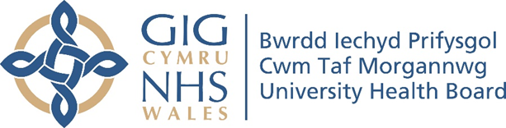

RESEARCH & DEVELOPMENT CONFERENCE 2024
POSTER PRESENTATION : 11
Does the Introduction of educational awareness improve fluid balance compliance

Author/s: Jones, V.
Department: Anaesthetics, Critical Care, Theatre and Trauma and Orthopaedics, Cwm Taf Morgannwg University Health Board

Introduction:
A recent Coroner’s inquest into the death of a patient at one of the Health Board Hospitals (May 2024) highlighted significant shortcomings in patient care. Although these shortcomings did not directly cause the patient's death, they could have impacted the patient's chance of survival. One area highlighted by the coroner was the nurses were unable to ascertain the amount of fluid given to the patient over 17 hours, and there was insufficient monitoring of the patient's urine output. Recent Health Board Outreach Team audits have shown significant variability in fluid balance charting practices and compliance, indicating a need for improvement. Inaccurate or incomplete fluid balance records can lead to poor patient outcomes, such as fluid overload or dehydration. National guidelines and benchmarks set by healthcare bodies emphasise the need for stringent fluid balance monitoring. However, these deficiencies in fluid balance documentation are not unique to the Health Board, according to Leinum et al. (2023) and Lim et al. (2021), the accuracy of fluid balance charting varied between 50-77% in the 8,848 charts reviewed.
Aim:
Does educational awareness increase compliance with fluid balance charting within CTM acute sites.

Methodology:
A standardised educational plan was developed with the use of a PowerPoint presentation and supported by educational literature in the form of ‘how to guide’ for completion. Educational sessions were delivered over a 3 week period to the acute hospital sites Prince Charles Hospital, Royal Glamorgan Hospital and Princess of Wales Hospital. The target staff group for education included both Registered and non-registered staff. Pre and Post compliance data was collected via a 10 question audit tool, results were facilitated by the Audit Management and Tracking (AMaT) system.

Results:
The results revealed overall improvement in fluid balance compliance but the target of 70% compliance was not reached for September 24. Although the overall compliance target was not reached there were areas of significant improvement noted. One acute site had 9 out of 13 areas >80% and 2>/13 areas >90% compliance. A total of 350 staff were trained in a 2-month period equating of 1/3 of eligible staff.

Conclusion:
In conclusion the service evaluation revealed that educational awareness has improved the compliance with fluid balance which will have an impact on patient care and safety. More work is required to sustain the improvement and more educational awareness is required at some acute sites.

