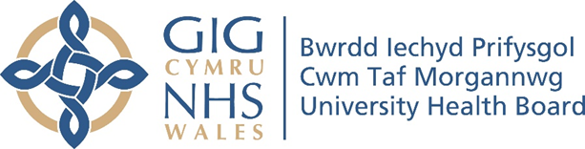

RESEARCH & DEVELOPMENT CONFERENCE 2024
POSTER PRESENTATION :
Exploring barriers and facilitators to breastfeeding infants among Gypsies and Travellers in Wales.

Author/s: Parry, S¹., Lim, J².
Department: ¹Children & Families Quality, Safety & Patient Experience Group, Cwm Taf Morgannwg University Health Board. ²Department of Public Health, Wolverhampton Univrsity.

Introduction:
Gypsies and Travellers report poorer health in all age groups and both sexes and many have a reduced life expectancy when compared to the general UK population. Yet, despite the health benefits just 3% initiate breastfeeding their infants. There are limited qualitative studies published that document the reasons for low breastfeeding rates in this population.

Aim:
This research aimed to identify and explore the barriers and facilitators Gypsies and Travellers perceive and expereince to breastfeeding infants.
Methodology:
This research presents a qualitative grounded theory interpretation of the barriers and facilitators Gypsies and Travellers in Wales perceive and experience to breastfeeding infants. The study took place in June - July 2024 and involved semi-structured interviews with seven Gypsy and Traveller women. Thematic analysis of the data identifed four main barriers to breastfeeding and four main facilitators.

Results:
This study found that in the Gypsy and Traveller population, breastfeeding in front of others, which inlcudes close family members such as a mothers older chilren, is prohibited. Gypsies and Travellers can have an aversion to breastfeeding, as well as reduced awareness of the health benefits and limited skills to breastfeed. This study found that breastfeeding facilitators are: the belief that breastmilk is healthier than formula, an awarenss attitudes to breastfeeding are outdated; determination and resourcefulness to breastfeed; and a new theoretical concept: that partners will support women to breastfeed or express breastmilk, as long as privacy is ensured.

Conclusion:
Recommendations for practice include: Ensuring each woman and her partner are offered an antenatal contact with a midwife and health visitor to discuss the health benefits of breastfeeding and how to express breastmilk as well as breastfeed. Working in collaboration with Gypsy and Traveller advocates to facilitate environmental change to enable breastfeeding in the Gypsy and Traveller community, and further ethnographic research to understand the Gypsy and Traveller culture.

