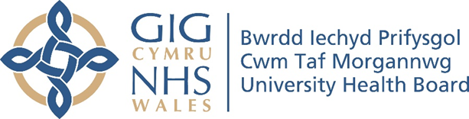

RESEARCH & DEVELOPMENT CONFERENCE 2024
POSTER PRESENTATION :
Exploring the impact of attending a psycho-educational course for individuals with a diagnosis of Mild Cognitive Impairment.

Author/s: Hook, L., Richards, C.,
Department: Older Adults Mental Health – Psychology, Cwm Taf Morgannwg University Health Board

Introduction:
Mild Cognitive Impairment (MCI) is an early stage of cognitive loss. Following diagnosis, individuals may experience emotional difficulties and uncertainty. Certain health behaviour changes may prevent an MCI from developing to a dementia. Despite this, individuals are often discharged following diagnosis without further practical or emotional support

Aim:
This evaluation aims to explore whether attending a psycho-educational “Life with a Mild Cognitive Impairment” course has an impact on the wellbeing of individuals with an MCI and their loved ones.

Methodology:
Based on the All Wales Dementia Standards (2022) a 6-week “Life with a Mild Cognitive Impairment course” was developed and delivered by CTMUHB Memory Assessment Service (MAS) Psychology staff. All individuals with a recent diagnosis of MCI were invited to attend. The Mild Cognitive Impairment Questionnaire (MCQ) was used to assess practical and emotional concerns of individuals and their friend or relative before and after attending the course. Attendees were also asked to complete a written feedback form following the course.

Results:
Average scores on both practical and emotional concerns reduced for both service users and friends/relatives following attending the course. The quantitative feedback data suggested that people enjoyed attending the group and gained knowledge about their diagnosis.These results are promising and suggest that attending a psycho-educational MCI course helps individuals and their loved ones to understand their diagnosis, manage their symptoms and take control of their own wellbeing. As the course has been designed to host a large number of attendees, the intervention provides a relatively cost-effective solution to the current gap in memory services.

Conclusion:
This course is the first of its kind in Wales and has shown promising preliminary results on the wellbeing of individuals with an MCI and their loved ones. The course will continue to be the main pathway for individuals with a newly diagnosed MCI.

