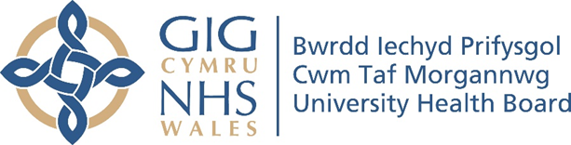

RESEARCH & DEVELOPMENT CONFERENCE 2024
POSTER PRESENTATION :
Developing the concept of family resilience in India using Group concept mapping.

Author/s: Livingstone, A¹., Singh Bhadoria, A²., David Pontin, D¹., Saxena, V²., Thomas, M¹., Mehta, A²., Wallace, C¹.
Department: ¹Faculty of Life Sciences and Education, University of South Wales. Department of Community and Family Medicine, All India Institute of Medical Sciences (AIIMS)

Introduction:
The University of South Wales and AIIMS (All India Institute of Medical Sciences),Rishikeh, came together to identify the concept of family resilience as understood by Indian community health workers. This concept will be used to develop a culturally relevant tool to measure the resilience of families with children under 6 years living in India (FRAIT India). The culturally relevant tool may be used by Indian community health workers working with families in India.
Aim:
To develop the concept of family resilience as understood by the Indian community health workers.

Methodology:
We used the group concept mapping (GCM) to develop the concept of family resilience. The GCM method is facilitator-led and uses GroupWisdomTM software for data collection, data integration, and analysis.

Results:
The concept of family resilience in India was represented in the 8 themes that were identified through the GCM -The cluster labels were: ‘Empowered Family’, ‘Discord in Family’, ’Resources and Life skills’, ‘Social and Cultural family’, ‘Resourceful Family’, ‘Health and Hygiene’, ‘Educated Family and Women Empowerment’ and ‘Gender Equality’.

Conclusion:
Using an on-line asynchronous method like GCM was very helpful to identify the concept of family resilience among the community health workers in AIIMS Rishikesh, India. The 8 clusters generated were analysed and presented to the researchers of USW and AIIMS who helped develop the FRAIT India. Using culture specific tools will allow health workers to identify culture specific measures and promote resilience among families thus better utilising available resources additionally, a tool will help child and family welfare organisations to prioritise which families need support thus adopting a strength based approach as opposed to a problem solving approach.

