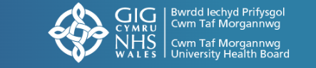


Neurodevelopmental Services

Welcome to our Sleep Support Guide!
We understand that sleep can be especially challenging for children with Autism Spectrum Disorder (ASD) or ADHD—and we know how much it affects the whole family. Sleep is essential for everyone’s health and well-being, and we’re here to help you navigate these challenges.
This guide includes simple tips and advice to help with:
- Bedtime routines
- Sensory sensitivities
- Reducing night-time worries
You’ll also find QR codes that link to, guides, leaflets and tools designed specifically for children with ASD and ADHD. Just scan them with your phone or tablet for quick access.
Let’s work together to create better sleep habits and make bedtime easier for everyone!

Helping Your Child Sleep Better: Tips for Children with ADHD and Autism
Getting a good night’s sleep can be tough for children with ADHD or autism, but small changes can make a big difference. Here are some simple tips to help your child settle at night:

Create a Calm Bedtime Routine
- Follow the same steps every night, like a bath, reading a book, or listening to soft music.
- Start winding down an hour before bedtime to signal it’s time to relax.
- Consider white noise for children with a preference for background sound.

Set a Consistent Schedule
- Try to keep bedtime and wake-up times the same every day, even on weekends.
- A regular routine helps your child’s body know when it’s time to sleep.

Make the Bedroom Sleep-Friendly
- Keep the room dark, quiet, and cool. Use blackout curtains or a sleep mask if needed.
- Consider soft bedding for comfort.
- Remove distractions like toys, screens, or noisy devices.

Limit Screens before Bed
- Avoid TVs, tablets, or phones for at least an hour before bedtime. The blue light can make it harder to fall asleep.
- Instead, encourage calming activities like drawing or reading.

Encourage Relaxation
- Try calming techniques like deep breathing or gentle stretches before bed.
- Soft, repetitive sounds (like white noise or gentle music) may help soothe your child.

Watch Food and Drink
- Avoid caffeine (found in tea, coffee, or chocolate) in the afternoon and evening.
- Offer a light snack before bed, like a banana or warm milk, to prevent hunger during the night.

Be Patient with Changes
Improving sleep takes time. Introduce one or two tips at a time and see what works best for your child. If sleep struggles continue, consider keeping a sleep diary to share with a doctor or therapist for further advice.
Remember, good sleep is a journey, and every small step counts!
Cerebra
Cerebra offer one-to-one support. This involves completing an application form for your child and two weeks’ worth of sleep diaries which they will send out to you as long as you come under the criteria for support. Please scan the QR code for access to the website.

Cerebra Sleep tips booklet
Please scan QR code to access the webpage to download this helpful booklet.

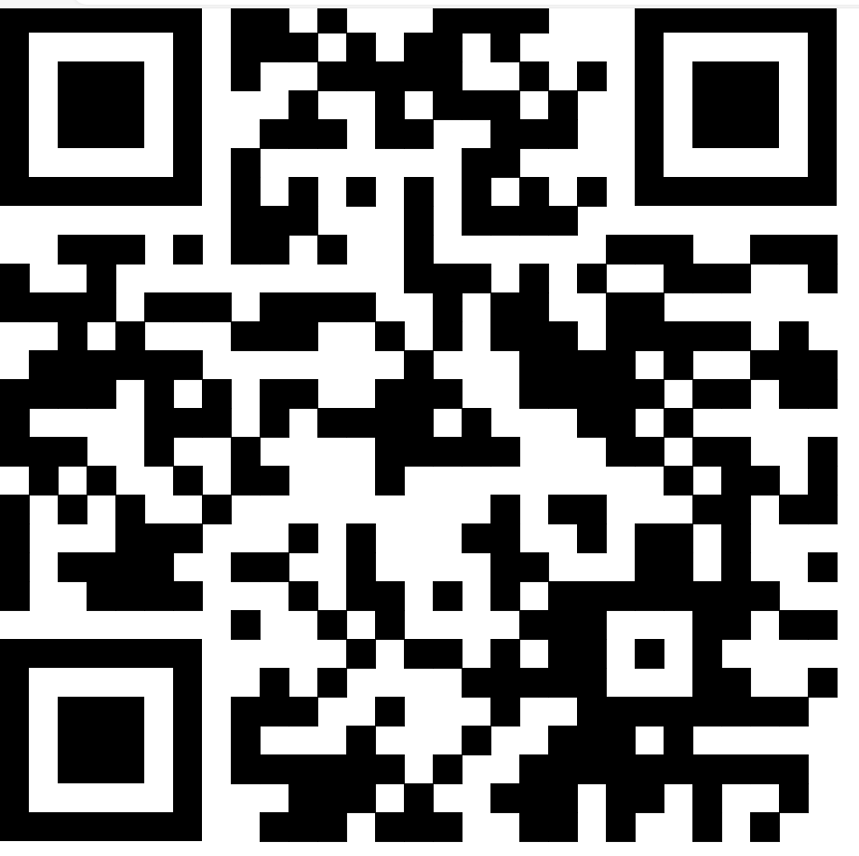
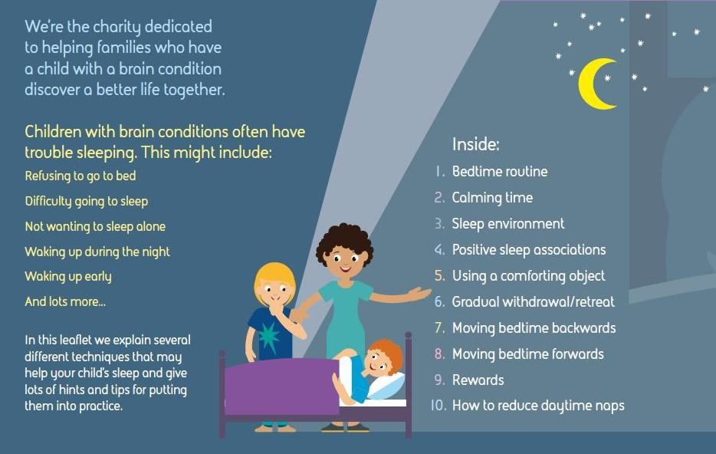

Sleep difficulties in children with Autism

Sleep difficulties occur in 50-80% of children with autism and are often accompanied by child and family distress.
Disordered sleep may also worsen symptoms of autism including social interactions and repetitive behaviours. Therefore, interventions that target sleep may not only improve your child’s health, and reduce whole family distress, but may also improve the core, and related, symptoms of autism. (Flynn, Pharma).

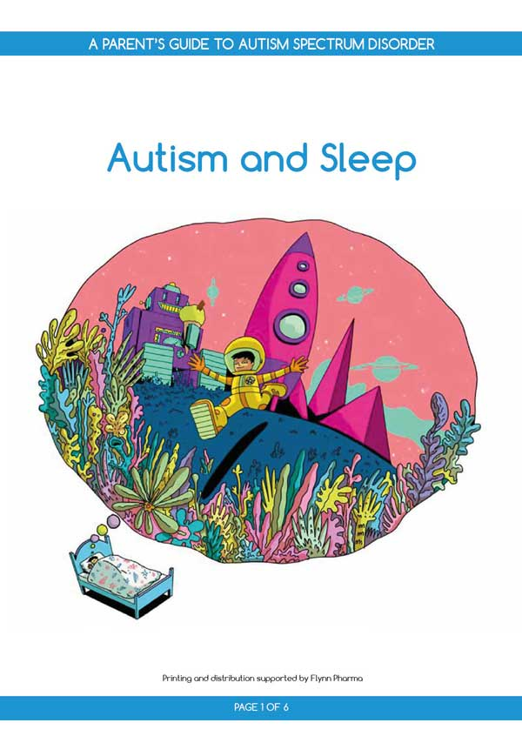

A guide for parents and carers of children with autism experiencing difficulty sleeping. This leaflet describes why sleep is important for children with ASD and provides tips on what can be done to improve sleep behaviour and hygiene. Please scan QR code for free download.

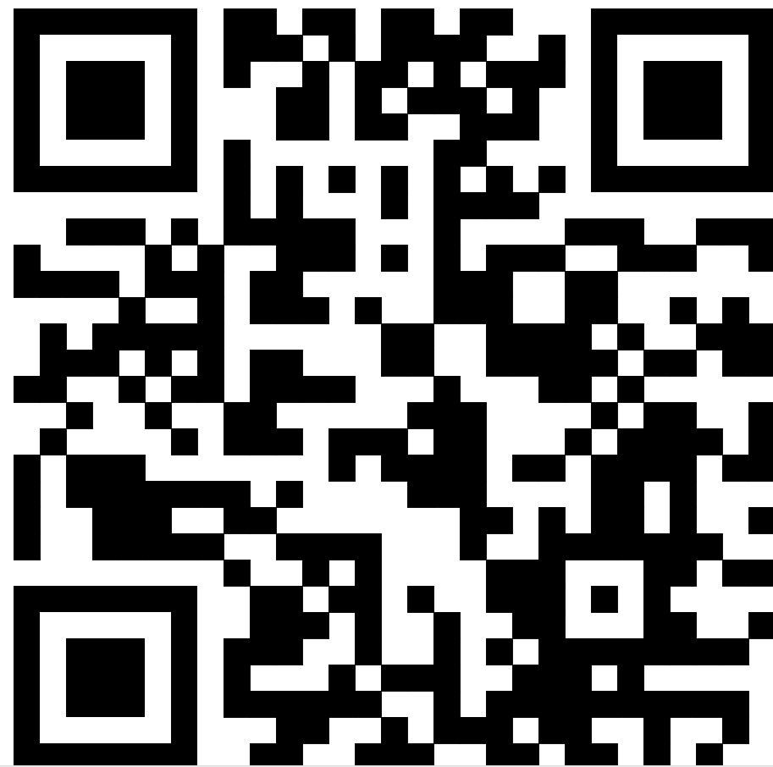

Teach your child about sleep
Children can have difficulty understanding the need for sleep. Please scan the QR code below for a story written by a consultant neurodevelopmental paediatrician, Dr Susan Ozer, which explains the importance of sleep and is aimed at children with autism and/or ADHD aged 7-11 years.

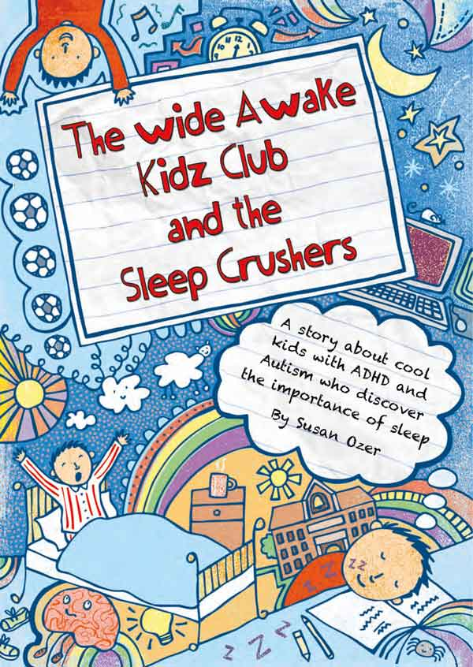

A fictional story about the importance of sleep aimed at children with ASD and ADHD aged 7–11 years.

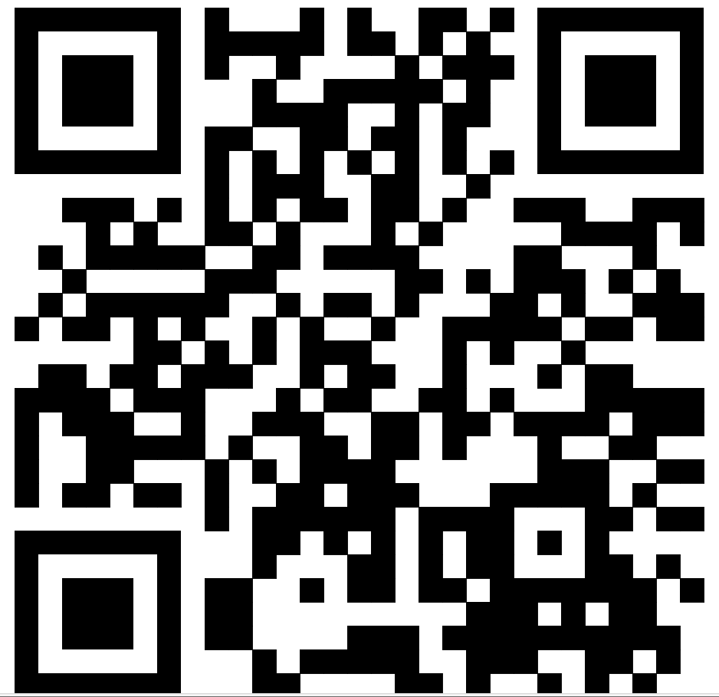

The World of Sleep eBook – The Sleep Charity

A helpful guide that shows how common sleep issues are, that parents are not alone and that help and support is available.

When we have children, we expect there to be some disrupted nights. Unfortunately for some families the sleepless nights can continue for months and even years. Parents can feel isolated, lonely and often judged. This book helps to reassure those who are affected with children’s sleep difficulties that there is help available, and that things can change.

Around 4 in 10 children will experience a sleep problem at some point and this rises to 8 out of 10 children where there is a diagnosis of Special Educational Need or Disability (SEND). These problems are typically persistent and do not resolve themselves without intervention.



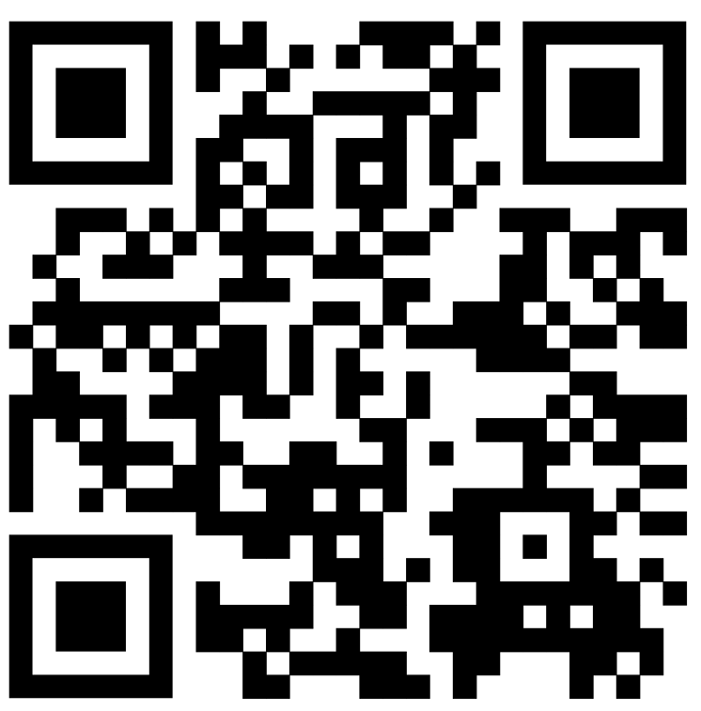

Helpful advice sheets for Parents
Please scan the QR code below to access the webpage containing advice sheets for a variety of sleep issues.

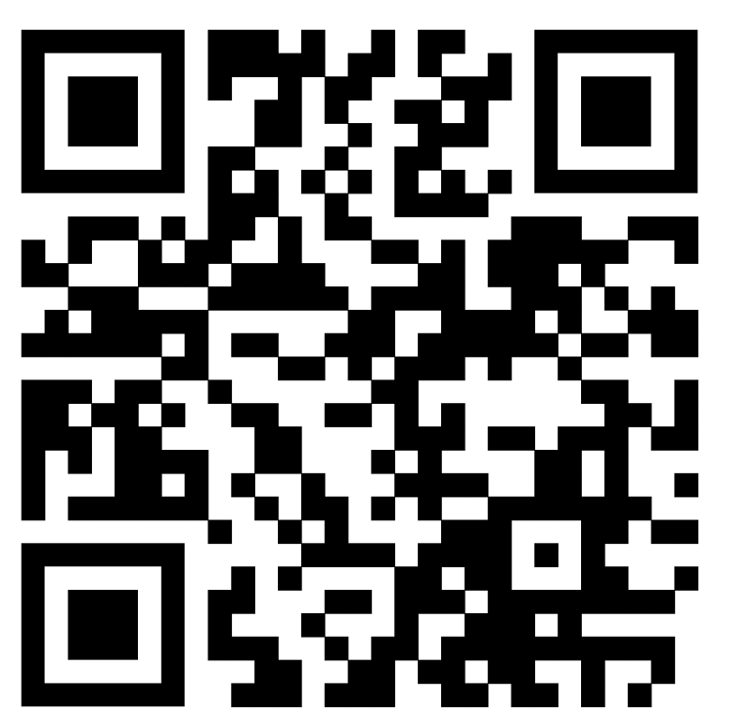

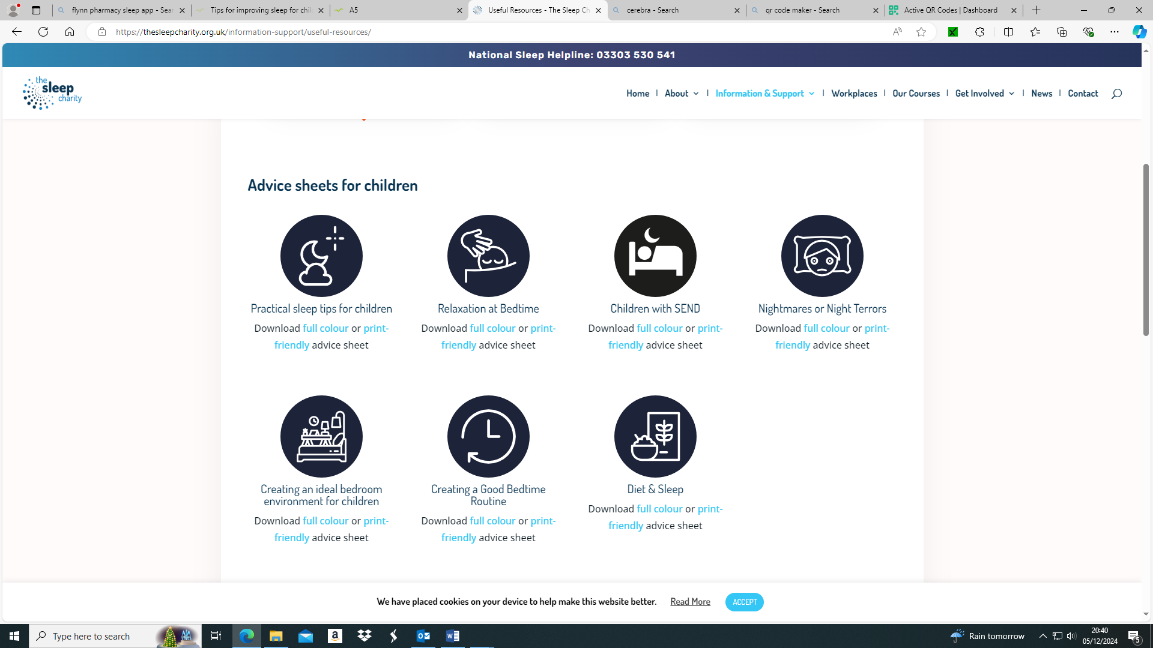

My Sleep Card- For children who seek night-time comfort

The sleep card is a tool to help children learn to fall back to sleep on their own.
Your child can present this card to you if they wake up in the night. They can exchange it for something brief, like a small hug, a kiss, or a glass of water. You can decide with your child what to exchange and write this down on the sleep card.

The card can only be used once per night. As soon as your child uses it, they should pass the card to you. You can return it to your child the following night so that they can reuse it, if necessary.

If your child does not use the card all night, they can win a “sleep point”. If they collect a certain number of points (five for example), they are rewarded with a special gift.
Rewards can be small gifts or a special outing with you and can be written on the reward card.



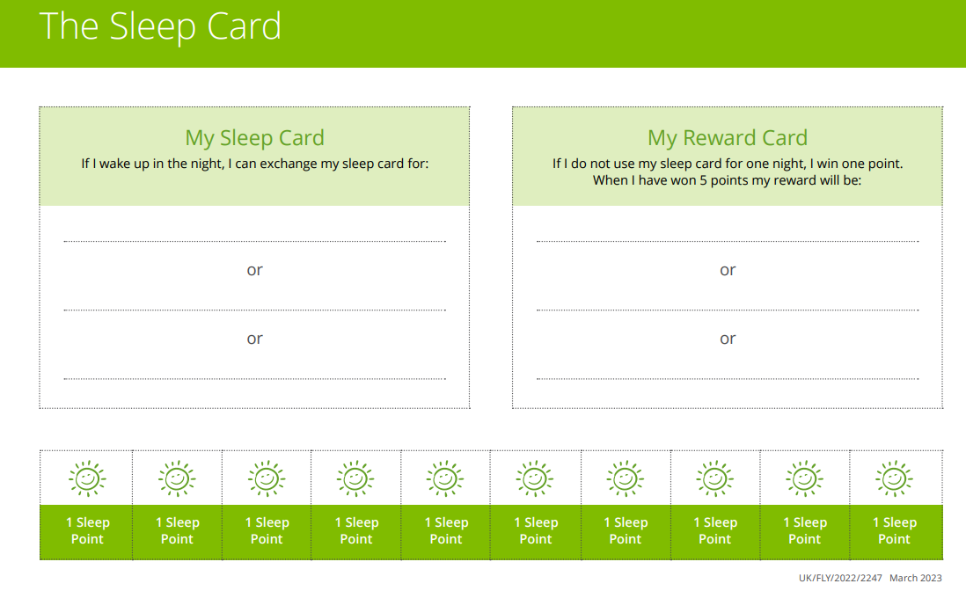

Sleep Diaries
The Benefits of Sleep Diaries for Children with ADHD and ASD
Sleep diaries are a valuable tool for understanding and improving sleep patterns in children with ADHD and ASD. These diaries help track bedtime routines, the time it takes to fall asleep, night awakenings, and morning wake-ups. By identifying patterns or triggers—such as overstimulation, anxiety, or irregular routines—parents and caregivers can implement targeted strategies to improve sleep quality. Sleep diaries also provide healthcare professionals with a better understanding of the child’s sleep difficulties. Please scan QR code for Sleep diary template example.

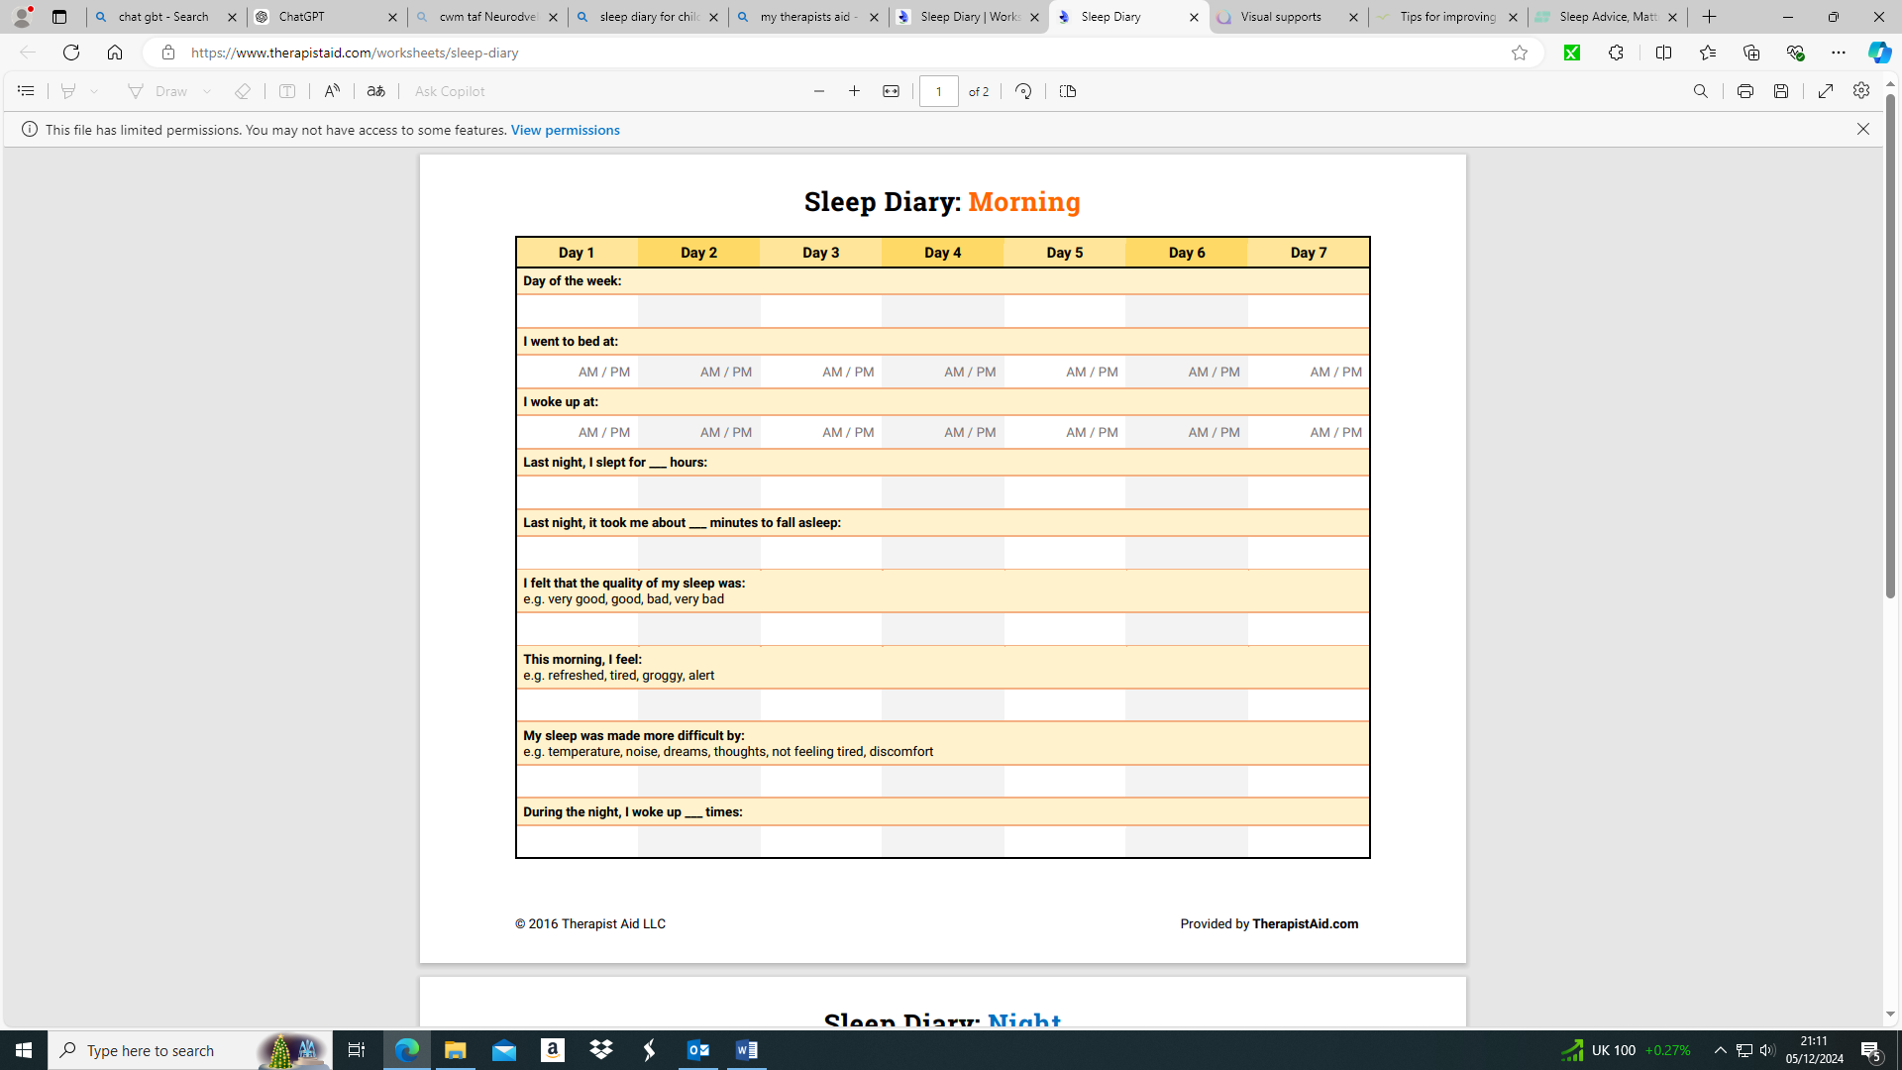

Other helpful resources and services

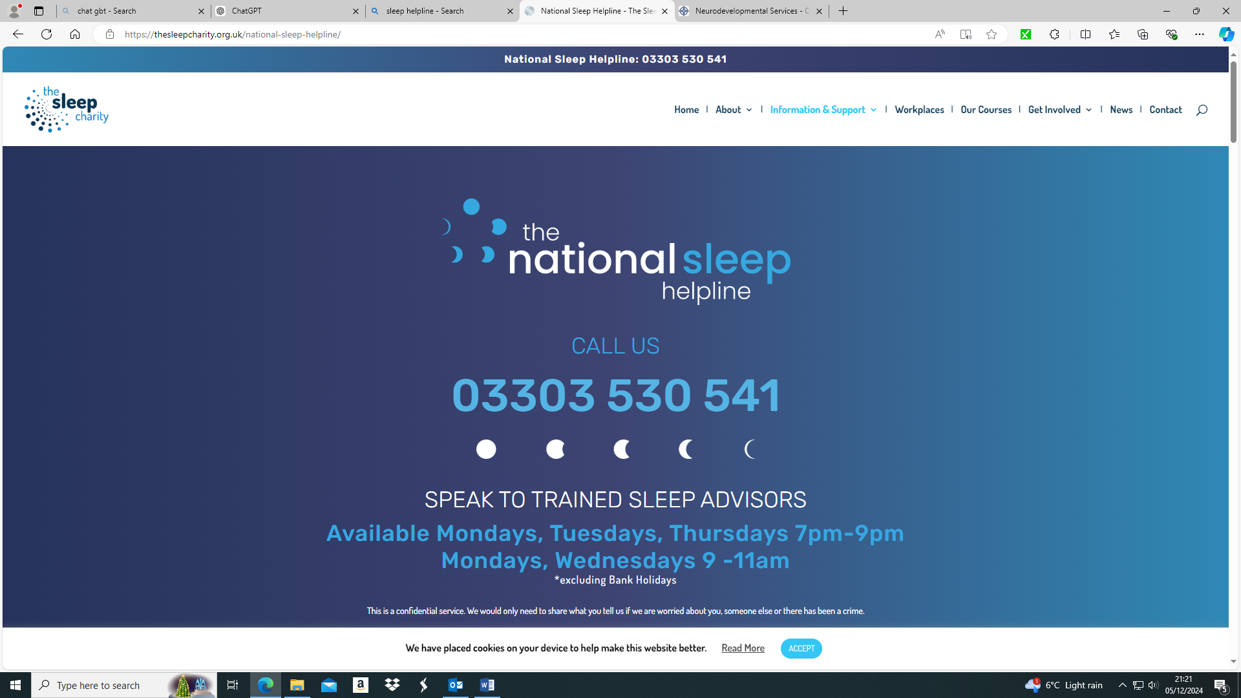

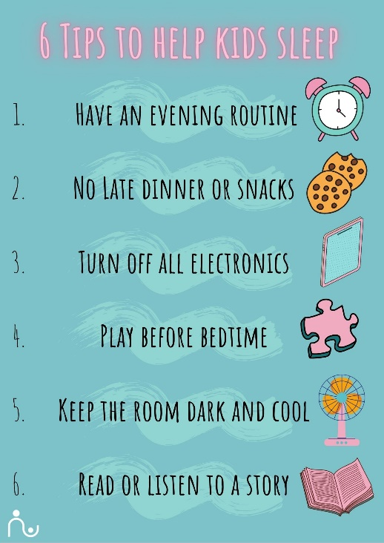

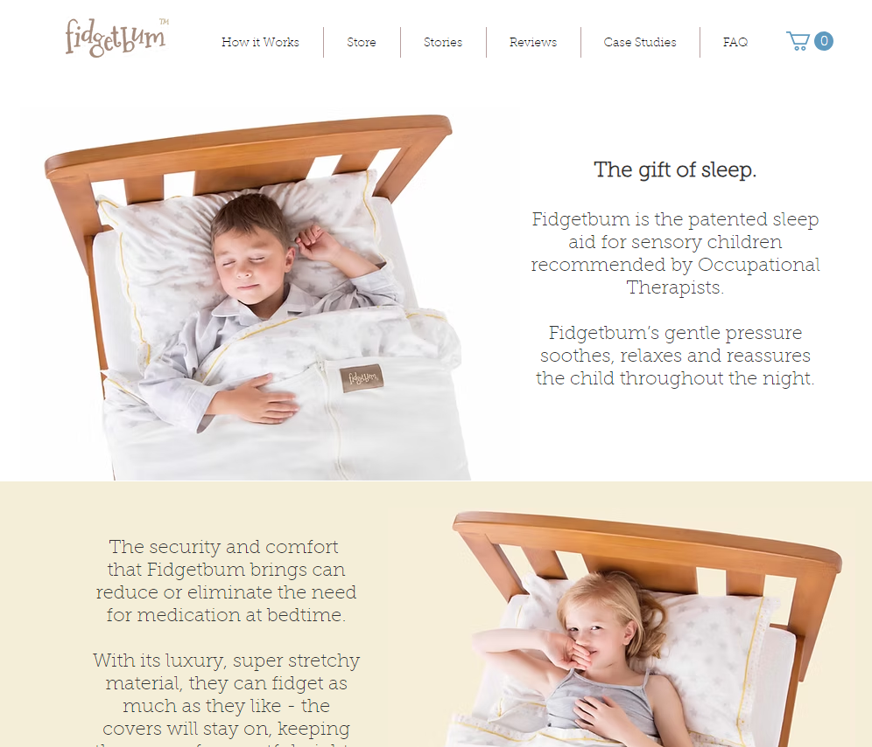
Please Scan QR code to access FidgetBum website.



