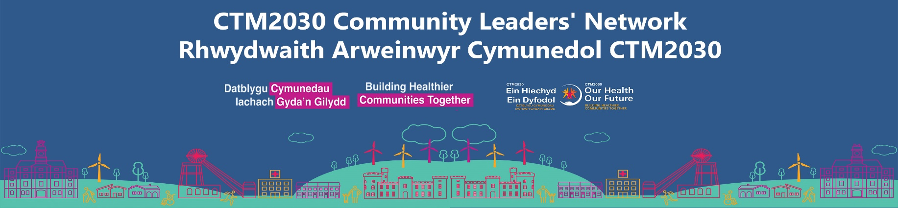
CLN session summary - 24 April 2026

This is a summary of our important conversation at the Community Leaders’ Network (CLN), 24 April 2026.
Workshop conversations were organised by:
- Part 1: What CLN success looks like
- Part 2: CLN 2026/27 priorities
- Part 3: CLN future direction
- Part 4: General feedback on the workshop

Summary of workshop feedback
The CLN is a trusted and valued space that brings people together and helps ensure community voices are heard. It plays an important role in connecting partners and sharing insight across the system.
The next step is to build on this by becoming more joined-up, focused and action-driven. This means moving beyond discussion to working together to deliver real, measurable change.
A strong and sustainable third sector is essential to this. Without stable, long-term funding for community organisations, it will be difficult to deliver prevention, local support and integrated services.
There is a clear need to make the system easier to navigate. Services can feel fragmented and hard to access. The CLN can help by connecting organisations, improving signposting, and supporting clearer pathways, so people can get the right help at the right time.
Listening to and involving communities must remain at the heart of the CLN. Lived experience and community voice should shape decisions, alongside data and evidence, to ensure services meet real needs.
The CLN should continue to support a shift towards prevention and early intervention, in line with Marmot principles. This means focusing on community-based support and the wider factors that affect health, such as housing, education and poverty.
Stronger collaboration is also key. The CLN already connects partners well - now the focus should be on taking shared action, including joint projects and clearer ways of working together. Setting a baseline and tracking progress will help demonstrate impact.
Better sharing of information and communication will support all of this. Improving how knowledge, data and insights are shared will reduce duplication, strengthen partnerships, and improve decision-making.
Finally, the focus should be on making the most of what already exists. Investing in community organisations, local assets and shared spaces is more efficient and sustainable than creating new services unnecessarily.

Part 1: What success looks like for the CLN
People recognised the CLN as an important leadership forum, with distinctive value in:
- Bringing the right people together
The Network connects organisations across statutory, third sector and grassroots levels, including people who “wouldn’t normally bump into each other,” creating added value beyond existing partnerships.
- A bridge between communities and decision-makers
The CLN provides a two-way flow of information (community ↔ system), helping ensure community voice, lived experience and frontline insight influence planning and decision-making.
- A safe space for honest discussion and reflection
The Network supports open, reflective conversations, including sharing challenges, learning and good practice without duplication.
- Strengthening relationships and trust
Face-to-face meetings are particularly valued for building stronger relationships, trust, and collaboration, as well as maintaining existing local links.
- Supporting collaboration and co-production
The CLN enables joint working, shared learning and co-produced approaches, including around prevention, wellbeing and wider determinants of health.
- Providing a broader system view
The Network offers a regional perspective combined with local intelligence, helping partners understand wider system pressures and opportunities (e.g. cost of living, workforce, inequalities).
- Amplifying voice and insight
The Network acts as a platform to highlight community need and patient voice and share both qualitative stories (case studies) and quantitative outcomes (e.g. Community-led Vaccination success).
When asked what a successful CLN would look like in the future, people shared:
- Support the third sector to survive and grow
Funding is uncertain, demand is rising, and organisations are under pressure. Without stability, services linked to prevention and community support are at risk. This is especially important in a changing policy and post-electoral context.
- Work together better
Stronger joint working and clearer roles across organisations.
- Improve communication
Clearer ways to share information between communities, services and decision-makers.
- Focus on action
Agree priorities and deliver real change, not just discussion.
- Use data and stories better
Show what’s working and the difference being made.
- Make the system easier to understand
Clearer maps of services and support so people know where to go.
- Keep people at the centre
Use lived experience and focus on prevention and early help.
- Tackle the root causes of poor health
Keep a strong focus on wider factors like income, housing, education, work and social connection (Marmot approach), not just services.
- Keep the CLN strong
Good attendance, strong relationships, and ongoing engagement is key to the Network’s future sustainability.
- Share learning and improve services
Keep reflecting and improving together.
- Build practical tools
Directories, shared resources, and better ways to stay connected.
Part 2: CLN2026/27 priorities
CLN participants voted on CLN priorities for 2026/27. 7 priorities were identified, where the CLN could best focus its partnership efforts. Third sector sustainability and long-term funding come out as the most dominant area of feedback.
The task now, and the next stage to work on, is to refine these further, and to develop objectives and actions for the CLN aligned to the top priorities identified.
Priorities
1. Strengthen third sector sustainability and long-term funding
- Secure long-term, stable funding
- Support third sector organisations to sustain and grow frontline services
- Improve alignment with commissioning and funding models
- Recognise and evidence the impact of third sector provision
- Explore joint funding bids and commissioning approaches (NHS and third sector)

2. Improve system integration, pathways and access to services
- Create a more joined-up system across the health board, local authorities and the third sector
- Make it easier to find and understand what support is available
- Develop clearer pathways and referral routes into services
- Build shared service directories to reduce duplication and confusion

3. Use lived experience and community voice in designing services
- Make sure people’s real-life experiences shape how services are designed, delivered and reviewed
- Give communities a stronger say in decisions
- Use people’s stories as well as data to show what difference services make
4. Focus on prevention, early support and community-based services
- Act early to prevent problems rather than responding later
- Strengthen local, community-based support services
- Focus on the wider factors that affect health, like housing, education and poverty
- Develop local hubs and support that meets the needs of each community

5. Strengthen collaboration and shared action
- Move from ‘talking’ to ‘taking action together’, including delivering joint work and tracking progress over time
- Work together to plan and deliver projects
- Build stronger partnerships across organisations and communities
- Work more closely to avoid duplication and unnecessary competition
- Set up small, focused groups to get things done (e.g. community-led vaccination work)

6. Improve knowledge sharing and communication
- Share information and insights more consistently
- Make it easier to understand what support is available
- Use data and real experiences to guide decisions
- Create regular opportunities to learn and share good practice
- Improve communication between partners and with communities
- Strengthen feedback and make better use of communication channels (e.g. social media)

7. Invest in community assets and infrastructure
- Invest in existing services instead of creating duplicates
- Support local organisations, spaces and hubs
- Reduce competition between organisations
- Make better use of local resources

Part 3: CLN future direction
During the meeting, the health board highlighted how it is very keen for the CLN to evolve as a shared partnership going forward. There’s a huge opportunity now for partners to help shape and steer the direction of the CLN going forwards, from Network focus and structure to governance and reporting. If being part of that next stage interests you, please let Natasha know – Natasha.weeks2@wales.nhs.uk

Part 4: General feedback on the workshop
✅LIKED  Bringing people together and building local partnerships  Opportunity to network (inc. meeting new people through CLN)  Opportunities to grow and connect across sectors  Learning about services  Space for reflection  Focus on future focus | 💡 LEARNED  Forum effective in connecting people and ensuring voices are heard  Opportunities to grow local partnerships  Better understanding of roles and organisations  A better understanding of local support and services  Common themes shared and  shared challenges across sectors
⚠️ LACKED  More data/insight to inform decision-making e.g. pinch points  More time for discussion and networking  Name badges | ⭐ LONGED FOR  More opportunities to connect and collaborate  More time for education and learning  Larger space/venue

