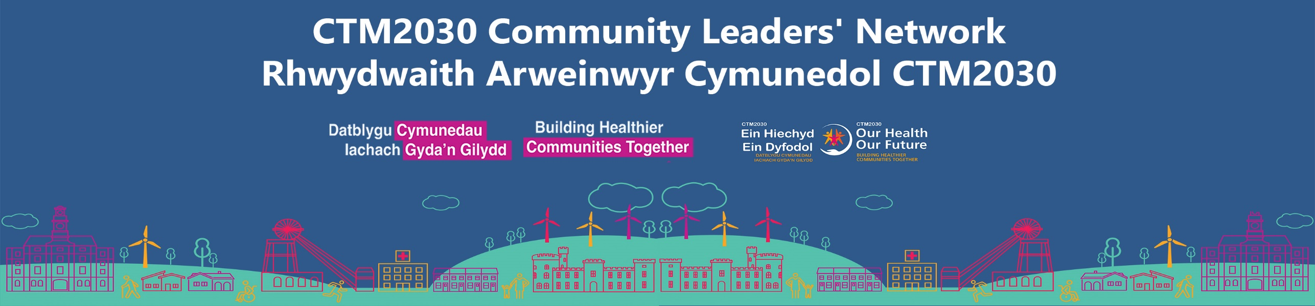

CTM2030 Leaders’ Network:
Headlines and actions
Meeting Date: 20/10/23
This briefing is to provide you with headline information and actions / next steps from the latest CTM2030 Community Leaders’ Network meeting.
Latest papers and supporting information can be found here - CTM2030 Community Leaders' Network - Cwm Taf Morgannwg University Health Board (nhs.wales)
Please send any questions or enquiries to Natasha Weeks, Head of Engagement, Cwm Taf Morgannwg University Health Board.
With any feedback or requests, please email our CTM2030 engagement mailbox - CTM.OurHealthOurFuture@wales.nhs.uk (subject: CTM2030 Leaders’ Network)

Headlines and actions from CTM2030 Community Leaders’ Network (Oct 2023)
Topic | Action required. | Contact
Progress update: Acute Services Clinical Plan (ASCP)  Victoria Wallace, Deputy Director of Strategy and Partnerships, CTM UHB, provided a progress update on developing a new Acute Services Clinical Plan (ASCP) for meeting the future healthcare needs of the Cwm Taf Morgannwg population.  Ares of focus:  - An outline of the Health Board’s approach regarding clinical service changes  - Development of a communications strategy for engaging and involving CTM staff, the public and partners in the development of the ASCP.  Key dates  Ongoing ASCP engagement (Oct-December 2023).  Next detailed update to be provided at January 2024 meeting.  Click here for presentation - CTM2030 Community Leaders' Network - Cwm Taf Morgannwg University Health Board (nhs.wales). | Meeting participants were asked:  - If they would like to be kept up to date on the ACSP; and  - If they could be contacted by CTM UHB regarding communications in support of the ASCP.  If you are were not present at the meeting, you can request to be updated by emailing Natasha Weeks - Natasha.Weeks2@wales.nhs.uk  Please use the following email subject - CTM UHB - Acute Services Clinical Plan | CTM.OurHealthOurFuture@wales.nhs.uk
Population health overview: the BIG health challenges for Cwm Taf Morgannwg and their impact on delivering services and care  Philip Daniels, Director for Public Health, CTM UHB, highlighted the biggest population health challenges across the Cwm Taf Morgannwg region.  Areas of focus:  - Life expectancy (linked to deprivation)  - Smoking prevalence  - Health eating  - Physical activity (adults and children)  - Diabetes (growing trend of increased hospital admissions through diabetes related illness)  The data informed presentation was followed by a group discussion around:  - How does CTM UHB engage people about their health?  - Who should we include?  - What should we (not) do?  Click here for presentation - CTM2030 Community Leaders' Network - Cwm Taf Morgannwg University Health Board (nhs.wales). | - To focus on some areas of existing community development (in partnership with Local Authorities and Community Voluntary Councils) for creating better health opportunities and tackling health prevention. Conversation and approach to be shaped by lived experience  - To focus on augmenting the Health Board’s work with schools - youth engagement (for e.g. education and employment) highlighted as core determinants to health.  - A review of CTM2030 Leaders’ Network membership, for ensuring all the right organisations are involved. Membership update to be provided at Jan meeting.
Information as a barrier to health  A demo of a shared technology platform by an external provider, Unite Us, for Improving care coordination across the Cwm Taf Morgannwg region.  Followed by Q&A discussion.  Click here for presentation- CTM2030 Community Leaders' Network - Cwm Taf Morgannwg University Health Board (nhs.wales). | Exploratory conversation only  CTM Strategy and Transformation team to further explore the technology platform.  Not unlimited to, but key feedback around:  - Integration and / duplication with existing systems, for example those currently used by Local Authorities and Macmillan  - Lack of integration between health and social care data systems for identifying patients in need  - Significant capacity constraints within the third sector (including community groups to support (for benefits optimisation)  - GDPR compliance  Further discussions and updates to follow. | CTM.OurHealthOurFuture@wales.nhs.uk
Networking opportunities  Due to timings, this item was postponed; it will be rescheduled for the meeting in Jan 2024 | - For this agenda item to be included in the next meeting; networking seen as a key benefit to Network membership.  - A review of CTM2030 Community Leaders’ membership for ensuring effective regional engagement and involvement | Natasha.weeks2@wales.nhs.uk

