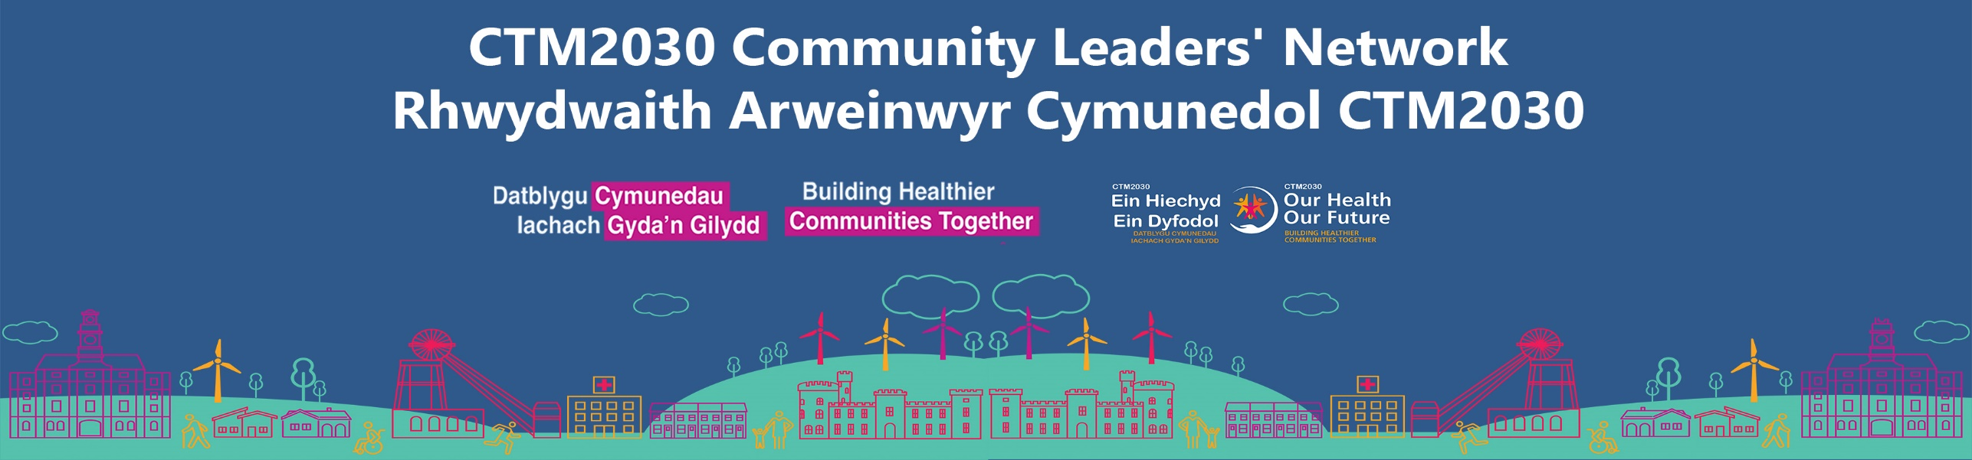

CTM2030 Leaders’ Network:

Headlines and actions from CTM2030 Community Leaders’ Network meeting (18 July 2025)

Session Materials: All the session resources, including this highlight report are available on our CTM Community Leaders’ Online Hub.

Meeting Chair: Jonathan Morgan, CTM UHB Chair
Session overview
This meeting was split into 4 key parts:
Part 1: Leaders were introduced to the Cwm Taf Morgannwg NHS Charity, which is the official registered Charity for the Health Board. The CTM NHS Charity is there to support all NHS patients, staff, and communities across Bridgend, Merthyr Tydfil, and Rhondda Cynon Taf by funding new health and wellbeing programmes, hospital improvements, and extra equipment and comforts that are over and above what the NHS can provide. The Charity’s aim is to help make NHS care even better for local people and the healthcare staff who support them. During the session, Charity Lead, Abe Sampson, highlighted the importance of community partnerships to the charity’s development. He was also joined by creative Agency, Jam Jar, who shared a current opportunity for leaders to get involved with co-designing a brand and identity for the Charity, and helping to bring it to life for our region. See below for more details.
Part 2: An overview of transformational community engagement work in the small village of Trelewis in Merthyr Tydfil, by Registered Social Landlord (RSL), Merthyr Valley Homes. The RSL is driving community development for the people of the area by taking a community asset and Appreciate Inquiry approach.
Part 3: Our new health board and health protection working group is up and running, for supporting vulnerable people this winter through vaccination protection. Over 20 community partners are working with the health board to co-design a meaningful and impactful winter vaccination campaign. It’s not too late to join the group as we are in the early stages of planning. See below for details.
Part 4: As a health board, we want to provide the best possible service at every stage of the patient’s healthcare journey. Leaders were asked to help us shape a new, exciting programme of work centred on improving ‘patient contact services’. The programme is looking at personal patient journeys with our health board, and people’s experiences along their journey. During the session we highlighted current ways in which we contact you and you us, and looked ahead to a future contact system.

Summary of discussion topics and outcomes
Part 1: Introducing the Cwm Taf Morgannwg NHS Charity
Presenters
- Abe Sampson, Head of Charity and Income Generation, CTM UHB
- Natalie Wilson, Associate Director, Jam Jar Creative Agency
Help us build a brand that reflects our communities: we’re building a new identity for your local NHS Charity – one that is of, by and for the communities we support. Community leaders were invited to be part of building a brand rooted in our community.
Help us understand the perception of NHS Charities by filling out a short two minute survey and to inform us if you’d like to be involved in the work.

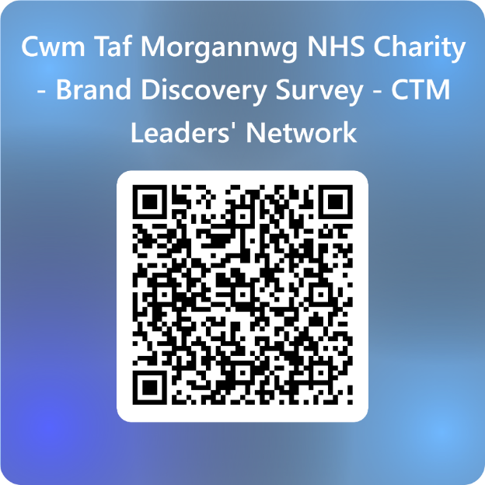

Part 2: Focusing on community assets: Merthyr Valleys’ Homes recent experiences of learning with the community of Trelewis and the impact of the work
Presenters:

- Beth Underwood, Housing Innovation Programme Manager, CTM UHB
- Ross Williams, Tenant Engagement Lead, Merthyr Valleys Homes

A copy of Ross’s slides are available on our Hub (under session materials for 18 July).

If you’d like to find out more about the approach taken by Merthyr Valley Homes in Trelewis, or would like to connect with them around other opportunities, they can be contacted at: Bethan.Underwood2@wales.nhs.uk
and Ross.Williams@mvhomes.org.uk
Part 3: Join our NEW Health Protection and Vaccination Working Group

Presenter

- Frances Samuel, Senior Health Protection Practitioner

During our April (11) meeting, attendees were asked to think about how they could support the health board to design and deliver a successful vaccination and health protection plan, to protect vulnerable people and keep people safe this winter. The *insights you’ve shared with us have led to a new vaccination and health protection working group being formed. For the first time, our health board, together with the third sector, is working together to co-design a winter vaccination digital campaign for launch this October.

*Your insights were shaped by these areas of focus:

      - Where might be the barriers to us delivering a successful winter plan?
      - As community leaders, what would help you to be part of this plan?
      - What would you need from CTM?

Several top themes of identified importance emerged from the discussions which can be read here.

It’s not too late to join as we are in the early stages of planning. Email us at: ctm.enquiries.HP@wales.nhs.uk

Stay updated with our partnership progress via our community Hub - CTM UHB and Community Working Group - Vaccination and Health Protection - Cwm Taf Morgannwg University Health Board

Part 4: Patient Contact Services
Presenters:
- Suzanne Rogers, Assistant Director for Digital Transformation, Digital and Data, CTM UHB
- Matthew Swarfield, Head of Clinical Administration Transformation, Digital & Data, CTM UHB
During the session, leaders were introduced to our new Patient Centred Contact -Transformation Programme. This work is aimed at is ensuring we provide the best possible service at every stage of a patient’s healthcare journey. For example
  - Giving patients’ a choice - personalised to their needs
  - Using technology to make communication easier/faster
  - Using technology to answer simple queries
  - Providing greater access to ‘person to person’ communication, tailored to the needs of our patients.

We looked at and discussed:
- Current ways in which patients are contacted by us, and how they contact the health board (At present: telephone | post | text| website)
- The different types of contact over the different stages of a patient’s healthcare journey; and
- We asked - how could CTM provide the best possible patient contact experience for our patients?
Please give us your feedback of these two important questions, to help us shape our Patient Contact Programme of work:
- What would make contacting the Health Board easier?
- If you could choose, what would be your preferred way of receiving information (e.g. appointment, waiting times) about your health journey from the Health Board?
Send any feedback to: Suzanne.Rodgers@wales.nhs.uk
You’ll be hearing much more about the development of this programme at future Network meetings, with many more opportunities for you to get involved in the shaping of the programme as it develops.

Other meeting highlights:
- Building connections via our Network
Verbally, many of you have shared that you’ve made new connections through your involvement in the Leaders’ Network. We’d love to hear about them. Highlighting the difference the Network has made to your organisation / group, or to the people accessing your services, will help promote the value of the Network to other organisations potentially thinking about getting involved. Send any details to Natasha.weeks2@wales.nhs.uk and we’ll get then added to the online Hub for others to access.
- CTM Wellbeing Improvement Service - WISE
At the session on 18 July, leaders were able to access FREE Mini Health Checks (Atrial Fibrillation and Hypertension). The WISE TEAM were giving Blood pressure checks mini ECGs. If you would like to find out about how WISE services can be of support in your local groups then contact them using these details below:
Email: CTM.WISE@wales.nhs.uk
Phone: 01685 351451
- Waiting well: support while you wait for treatment
One of our main health board’s priorities is to reduce waiting times for people on a waiting list for planned treatment, and to support people while they wait; by keeping people feeling as well as possible while they wait, and by keeping in touch with them. If you are a patient on a waiting list, or you have members of your community group who are, then this dedicated ‘waiting well page’ on our website will be helpful.
- Community recognition
As a Network we want to celebrate your achievements and proud moments as community leaders of our region. Keep us informed by emailing Natasha.weeks2@wales.nhs.uk and any recognitions will be added to our Community Leaders’ Hub.

Future Meeting dates
(Scan the QR codes to save to calendars)
- Friday 24 October (RCT): 9:30 -11:30am
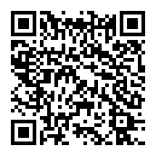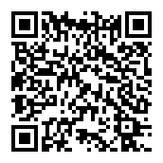

Friday 24 October (RCT): 9:30 -11:30am 23 January 2026 (Bridgend) - 9:30 -11:30am

Questions or any further questions
Please get in touch with:
Natasha Weeks
Head of Public Engagement and Involvement, CTM UHB
Email: Natasha.weeks2@wales.nhs.uk
Mobile: 07890 640585

