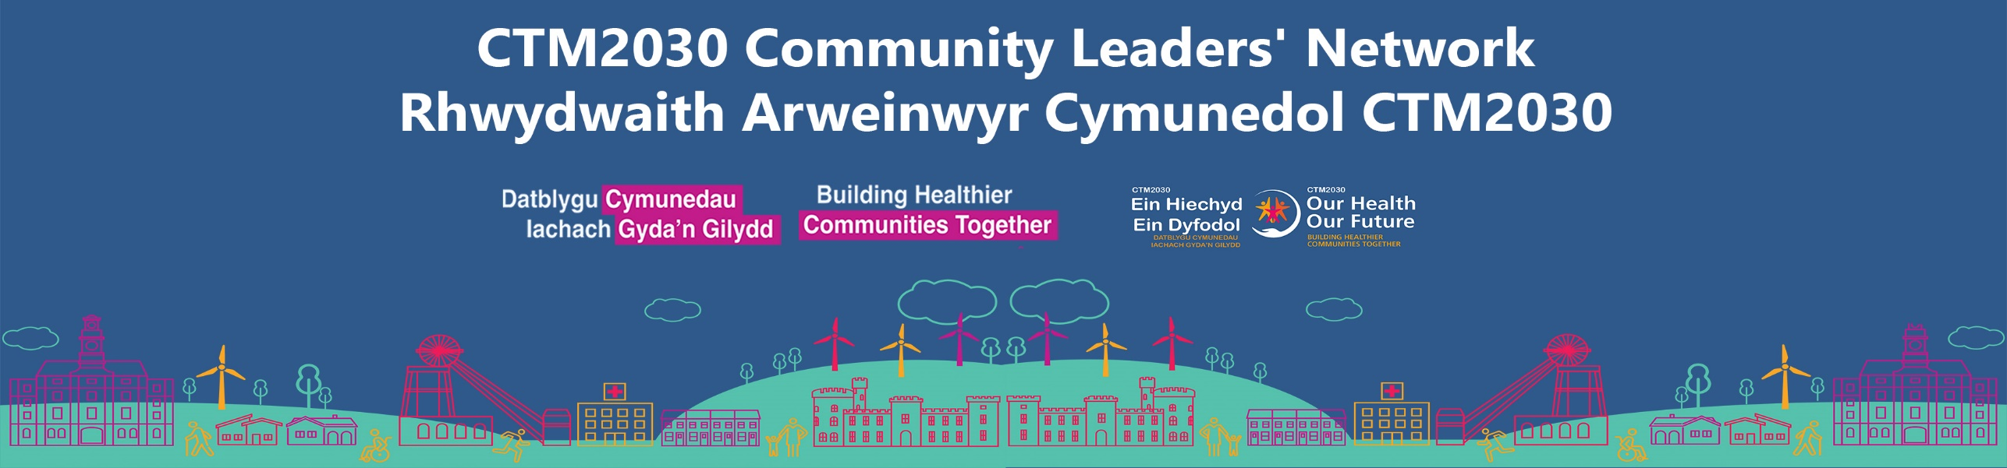

CTM2030 Leaders’ Network:

Headlines and actions from CTM2030 Community Leaders’ Network meeting (11 April 2025)

Session Materials: All the session resources, including this highlight report are available on our CTM Community Leaders’ Online Hub.

Meeting Chair: Jonathan Morgan, CTM UHB Chair
Session overview
This meeting was split into two key parts; firstly highlighting an area of partnership working in action via Network members, and secondly, exploring opportunities for wider partnership working for improving population health outcomes for people living in CTM through a targeted approach to health protection and vaccination uptake this coming winter.
Community recognition
Prior to the agenda getting underway, praise and recognition was given to Paul Bromwell, founder and leader of Valley Veterans - proud winner of this year’s prestigious St David (Senedd) Awards in the Category of Community Champion. CTM UHB is partnering with Valley Veterans, and several other Veteran Hubs across the region, for a first of its kind health and wellbeing community event during Armed Forces Week (26 June). We will be updating on this partnership at a future meeting.
Meeting Agenda
Part 1: Partnership in Action
We heard about a multi-organisational project, involving several CTM Community Leaders who effectively worked together this winter to address the gap in Pension Credit uptake among eligible individuals in Cwm Taf Morgannwg.
Part 2: Partnership for Action
Using the key principles and lessons learnt from the pension’s credit partnership approach, we discussed opportunities for applying these to influencing health outcomes in the future around vaccination and health protection.
During our January meeting, promoting the importance of vaccination and health protection across communities, via local community organisations and groups, was identified by all as a collective opportunity to change health outcomes for vulnerable people for winter 2025/26. There was recognition that success would require community leaders to have access to the right health protection information and assets, with information and support coordinated by the health board’s local public health teams. This important conversation was kick-started at our last meeting.
All the session materials, including this highlight report are available on our CTM Community Leaders’ Online Hub.

Summary of discussion topics and outcomes
Part 1: A multi organisational approach to addressing the gap in Pension Credit uptake among eligible individuals in Cwm Taf Morgannwg.
Presenters:
- Tom Powell, Head of Innovation
- Karen Taylor – Interim CEO, Citizens Advice RCT
- Rachel Rowlands, CEO Age Connects Morgannwg

Project / Partnership Background

A significant number of pensioners who qualify for Pension Credit and the Winter Fuel Allowance living in the Cwm Taf Morgannwg region do not claim these entitlements. The figure is estimated to be around 7,000 people across the region, meaning thousands of older people are missing out on much-needed financial support.
Pension Credit is also a gateway benefit, meaning that if an individual qualifies for Pension Credit, then thy will automatically qualify for Winter Fuel Allowance which opens up other support options to improve overall quality of life and wellbeing.
However claiming these entitlements is not solely focussed on reducing financial burden, it can have a major health benefit too.

Each year, the NHS spends an estimated £1.4 billion annually on treating illnesses associated with living in cold or damp housing. Living in a cold home can worsen asthma and other respiratory illnesses and increase the risk of heart disease and cardiac events. It can also worsen musculoskeletal conditions such as arthritis.
Cold or damp homes can also have a significant impact on mental health, with depression and anxiety more common among people living in these conditions.

Several CTM charities and wider regional partners worked in collaboration this past winter to target vulnerable pensioners living in CTM, who may have been eligible to apply and supporting them with relevant applications.
Local population health data was used to identify vulnerable people living in Cwm Taf Morgannwg at risk.
Project Objectives
A multi-organisational project was set up to:
- Raise regional awareness of pension credit and ‘check your eligibility’ – don’t miss out this winter messaging
- To promote a series of hyper- local community events, led by charity professionals offering independent and confidential advice to support people to make a relevant claim.
- To target vulnerable pensioners and support them to make a claim to alleviate financial burden.
- To improve health and wellbeing quality of life outcomes in the medium - through increased claims / reduced fuel poverty / increased access to housing and employment / wider support opportunities.
Read the highlights report here (with case study and wider community feedback)

Next steps for the project
Representatives from the Third Sector have been invited to meet with Jane Hutt, Cabinet Secretary for Social Justice, in early May to provide an overview of the project, and the impact on Cwm Taf Morganwg residents. Rachel Rowlands is leading this meeting and a future update will be provided in the near future.
Local media coverage
Rachel Rowlands (Age Connects Morgannwg) and Karen Taylor (Citizens Advice RCT), provided a summary of the pensions credit work, and the opportunities for help and support, with GTFM Radio in January.
Listen Again – GTFM https://www.gtfm.co.uk/listenagain/ - Interview starts at 31:00

Part 2: Working together as a leaders’ Network to protect vulnerable people through vaccination and health protection
Presenters:

- Christopher Smith, Senior Public Health practitioner
- Jane Williams, CTM Community Immunisation Coordinator

Attendees were asked to think about how they could support CTM to design and deliver a successful vaccination and health protection plan, to protect vulnerable people and keep people safe this winter.

Health protection colleagues facilitated table discussions around:

      - Where might be the barriers to us delivering a successful winter plan?
      - As community leaders, what would help you to be part of this plan?
      - What would you need from CTM?
      - You will be hearing about a new vaccination protection working group that we’d like to set up together

Several top themes of identified importance emerged from the discussions. These are being pulled together as highlights report for sharing by the CTM Health Protection Team but here’s a summary of what you shared:
Q: What were the good things about accessing and having vaccinations this winter?
You told us:
- Awareness and Promotion
- Delivery and Access: Expanding Access Points for Convenience
- Having Effective system Processes and Support
Q: What were the problems around accessing and having vaccinations this winter?
You told us:
- Support for Vulnerable Populations
- Barriers to Accessing Vaccinations
- Operational and Planning Issues
- Communication and Information Challenges
- Trust and Confidence Concerns
Q: As community leaders, how can you help us shape our CTM vaccination and health protection plan in your areas?
You told us:
- Needs A Community-Driven Approach
- Trusted Messaging and Engagement
- Develop Effective Partnerships and Community Connections - work with Local Networks
- Proactive Outreach and Education:

Q. What difficulties do you see in delivering a successful winter plan in your communities?
You told us:
- Promotion and Marketing Strategies
- Access and Logistics Challenges
- Addressing the needs of specific CTM demographics
- Barriers to Vaccination Uptake
- Data and Funding Concerns

Building our Network and delivering tangible outcomes through partnership working
Jonathan Morgan, Chair, CTM:
- Re-Invited everyone to consider who is missing from the Network – send any suggestions to Nataha.weeks2@wales.nhs.uk, and for us all to consider what direct action we can take to ensure the right people are involved, and engaged, in future meetings.
- Let us know of any new connections or partnerships your organisation has formed as a result of your involvement in the CTM Community Leaders Network Group. Highlighting the difference it has made to your organisation / group, or to the people accessing your services, will help promote the value of the Network to other organisations potentially thinking about getting involved. Send any details to Natasha.

Future Meeting dates
- 18 July 2025 – Orbit Business Centre, Rhydycar Business Park, Merthyr Tydfil, CF48 1DL – diary invite issued
- 24 October 2025 - RCT - details TBD
- 23 January 2026 – Bridgend - details TBD

Further questions
Please get in touch with Natasha.weeks2@wales.nhs.uk

